Curriculum vitae
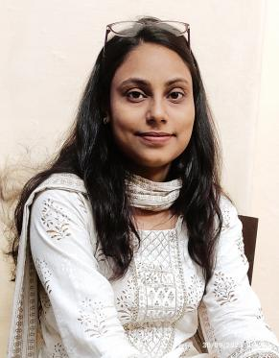

1. Name: Shail Verma
2. Designation: Assistant Professor
3. Subject: Geography
4. Academic Qualifications: M.A., NET, PhD ( Persuing)
5. Areas of interest/Specialization: Cartography, Remote sensing and GIS, Geomorphology and Resource Management
6. Date of Birth: 11-07-1996
7. Date of Joining: 2nd July 2022
8. Experience: 1 Year
9. Official Address: Department of Geography, Raghunath Girls’ Post Graduate College, Meerut
10. Contact no. : 8299582801
11. Email: shailv525@gmail.com
12. Areas of research: Land Use and Land Cover Mapping.
13. Digital Profile, if any (Research Gate, LinkedIn, SSRN, Twitter, YouTube etc):
Research Gate:
LinkedIn: shailv525@gmail.com
Achievements: Co- Coordinator of Geoinformatics, Department of Geography
Coordinator of Space outreach Centre, Department of Geography

16. Membership of Professional Bodies
S.No. | Name of the Professional Body | Type of membership | Membership no.
1 | Proctorial Board | Member | -
2 | Library Committee | Member | -
3 | Progressive Women Forum | Member | -
4 | Anti Ragging and SH Cell | Member | -
5 | Film Club | Member | -
6 | AISHE and NIRF commitee | Member | -

26. Faculty Enrichment Programme Attended:
S.No | Detail of the FDP/FEP | Date(s) of the event | Organizer &Sponsor | International/National/ State/ University
1 | Interdisplinery refreser cource | 29-08-2023 to 12-09-2023 | Teaching  Learning Centre, Ramanujan College, University of  Delhi and Raghunath Girls’  Post Graduate College,  Meerut. | National University
2 | Faculty Development Programme | 29-04-2023 to 05-05-2023 | Guru Angad Dev Teaching  Learning Centre, SGTB  Khalsa College, University of  Delhi and Raghunath Girls’  Post Graduate College,  Meerut. | National University
3 | Faculty Induction Programme | 25-02-2023 to 27-03-2023 | Guru Angad Dev Teaching  Learning Centre, SGTB  Khalsa College, University of  Delhi and Raghunath Girls’  Post Graduate College,  Meerut. | National University
4 | Faculty  Development  program | 09-12-2022 | Organized by AMITY  University Greater  Noida. | State University
5 | Faculty  Development  program | 14-11-22 to 18-11-22 | Organized by Plant Conservation Society Department of Botany & IQAC , R.G (P.G.),  Meerut | College affiliated to state University

27. Seminar/ Workshop/ Conference Attended:
S.No | Detail of the Conference/ Seminar | Organizer & Sponsor | Date(s) of the event | Venue of the event | International/National/ State/ University
1 | workshop | Organized by IQAC & Teachers’ Re-skilling cell R.G (P.G.)  College Meerut and Union Bank of India, R.G.College Branch,Meerut | 19-08-2023 | Meerut | College affiliated to state University
2 | workshop | Organized by Department of  Psychology, R.G (P.G.),  Meerut | 15-04-23 to 24-04-23 | Meerut | College affiliated to state University
3 | National Conference | Organized by R.G (P.G.)  College Meerut | 21-12-2022 to 22-12-2022 | Meerut | College affiliated to state University

- Future plans:
- Introduce job oriented and skill based courses in Geography.
- Complete PhD within 3-4 years.
- Research orientation work.

