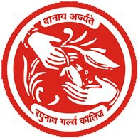Raghunath Girls' Post Graduate College Meerut

Rangers-Unit

Established in the year 1990




Rangering Motto - ‘Service’

Face book page of R. G. Rangers team
Email: rgrangersteam24@gmail.com
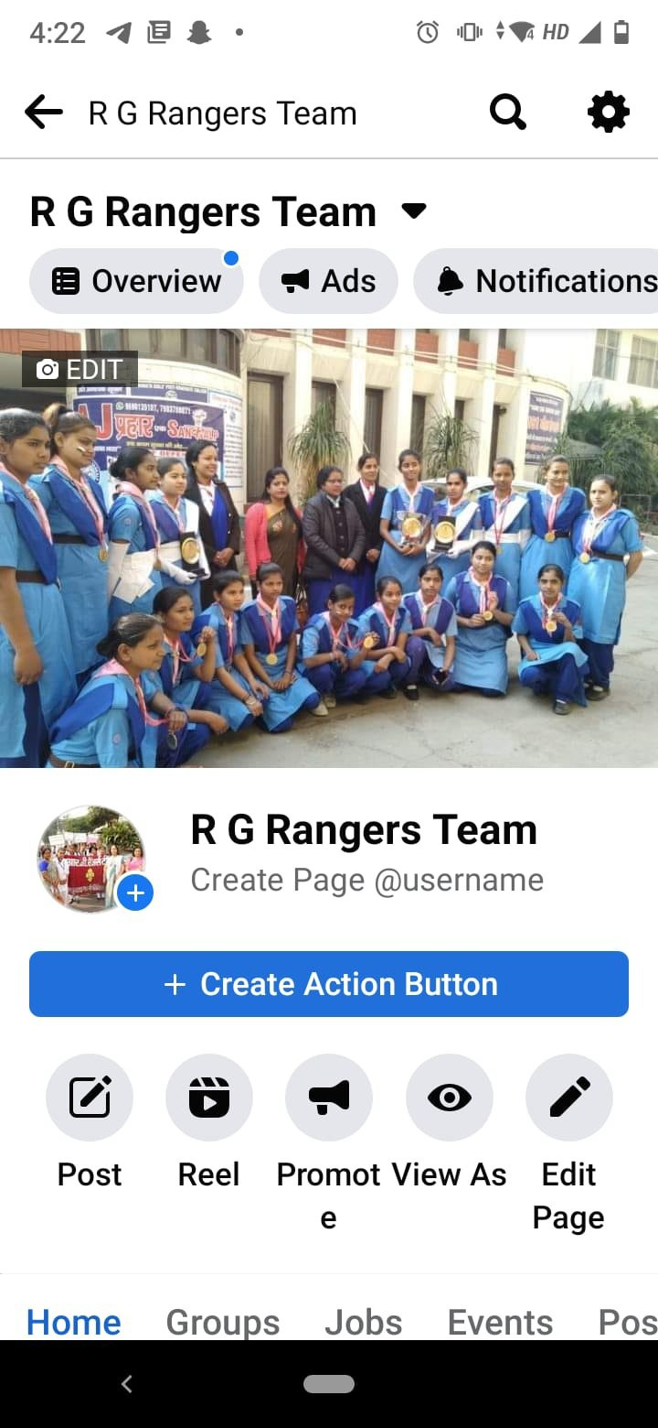

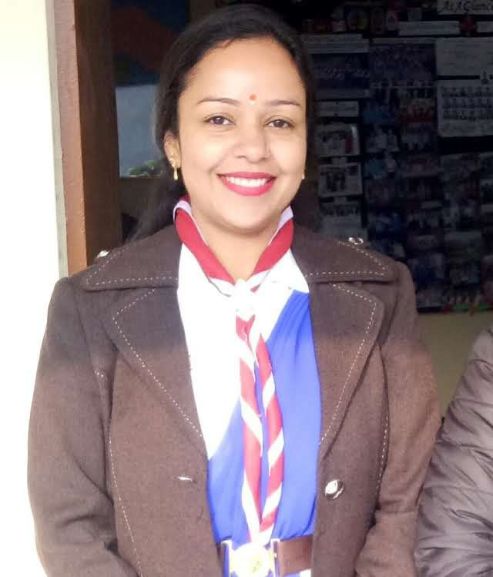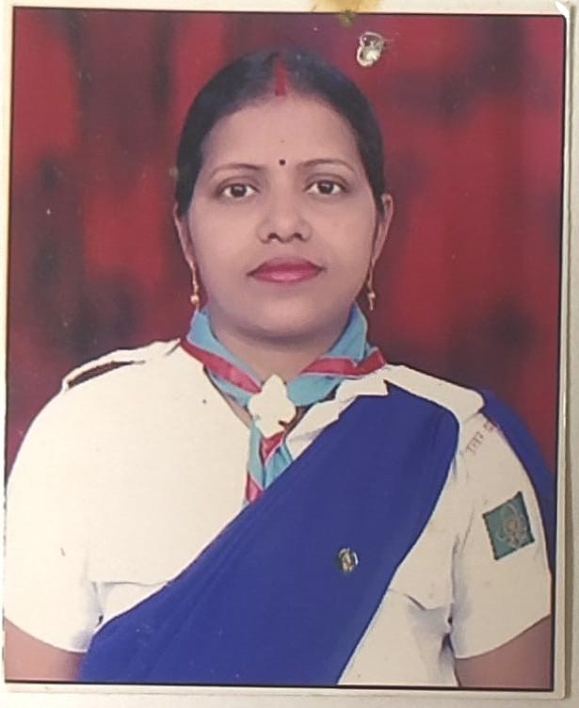
Dr. Suman Advance Ranger Leader
R. G. Rangers’ Team 2007-2020
Dr. Sunita Singh Basic Ranger Leader
R. G. Rangers’ Team 2020-onwards.
Rangers’ leaders


R. G. Rangers’ Team (2017-20)

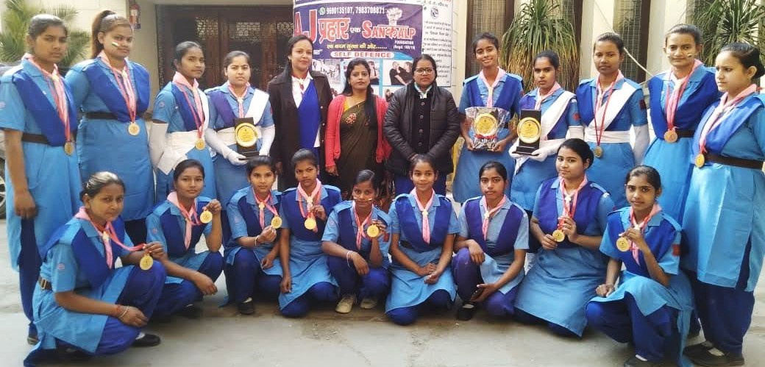

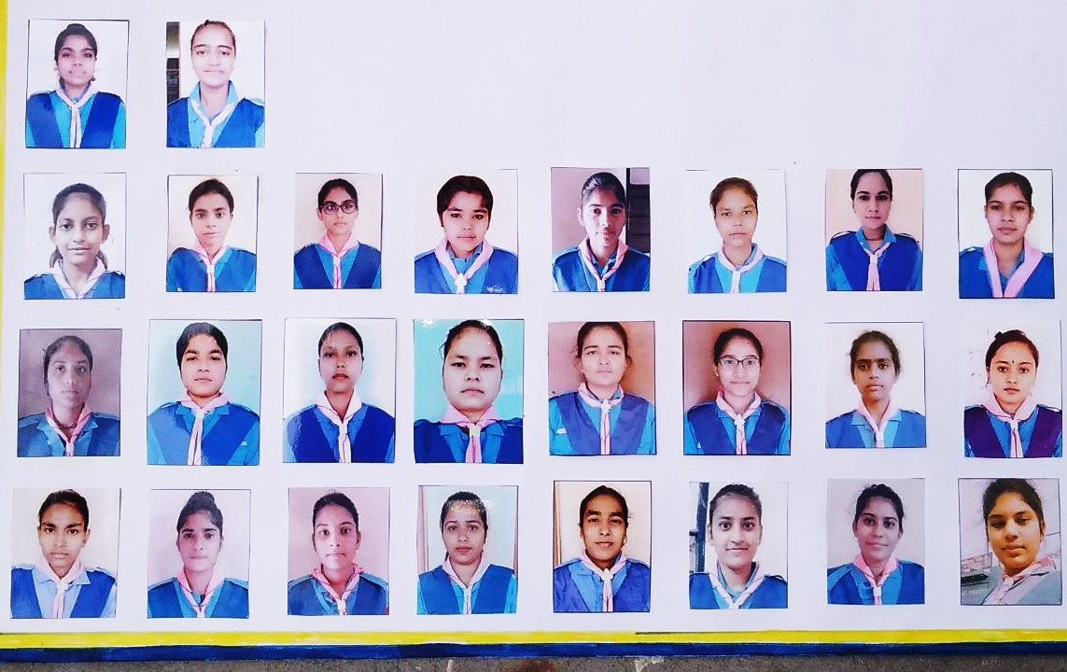
R. G. Rangers’ Team (2019-2022)

leader Co- leader

Kanchan
Chitra Sharma

Mansi Kashyap
Neha Thakur
Nisha
Dolly
Parul
Rani
Poonam
Versha

Nidhi
Nikita
Arnika
Shivani
Tanu Chaudhary
Tanu
Komal
Khushi

Bhawana
Aarti
Naina Sharma
Nisha Sakya
Gungun
Bhumika
Himani
Nisha



Criteria to be Ranger :
- A girl whether previously a guide or not, who is a citizen of India
- One who has completed 15 years and not more than 25 years of age may be enlisted as a ranger.

Rangering – A way of life

‘The aim of rangering movement is character development through happy citizenship through natural rather than artificial means.

Vision
“To develop young people in achieving their full physical, intellectual, social and spiritual potential as individuals, as responsible citizens and as member of the Local, National and International communities.”
Mission
“Providing young people with value-based, attractive and challenging youth programme, through competent leaders, effective communication, optimum use
of technology and efficient management."

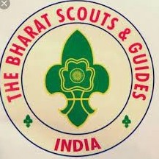
Scouting & Guiding in India

- Scouting started in India in the year 1909 in Bangalore.

- The first guide company in India was started in Jabalpur, central India in 1911.

- In independent India on 7th November 1950 organization came into existence under the name ‘The Bharat Scout and Guides’

- The girl guides association formally joined the Bharat Scout and Guides a little later on 15 August 1951.


Establishment Of Rangering

- Guiding is Universally Recognized as one of the world's largest youth movement.
- In India Rangering started in 1918.

- On 30th August 1990 Ranger Teams were formed in degree colleges of U.P.

- In Our College, Ranger Team Was Formed In 1990 And From Then Onwards Every Year Registration Of Our Team Is Done At Bharat Scout & Guide Bhawan Lalkurti, Meerut.


Benefits to Students

To get weightage in the admission in any course entrance examination from 2% to 5%.
- Get extra marks & weightage in entrance examination of B.Ed. & BTC, in government service like railways, bank securities forces and military forces.
- If ranger participate and pass in the “Rashtrapati Training Camp”, she gets lifetime
railway travel pass to anywhere in india.
- Ranger's students get opportunity to tour all over the world in international meet programs & camps.

- Ranger is the senior section in the guide wing of the Bharat Scouts and Guides. It meets the needs of young women to adjust easily to the challenges for present day life and it contributes to the positive development of the society in which they live.
- The ranger's age is from 15 to 25 years.
- Rangering is a way of life based on the guide laws and promise.
- Rangering being a part of guiding is an activity with a lot of fun and play, a wonderful adventure and a happy companionship with her peers in the team.



Rangers Made Us Proud


At National Level
Rastrapati Ranger Award Training Camp

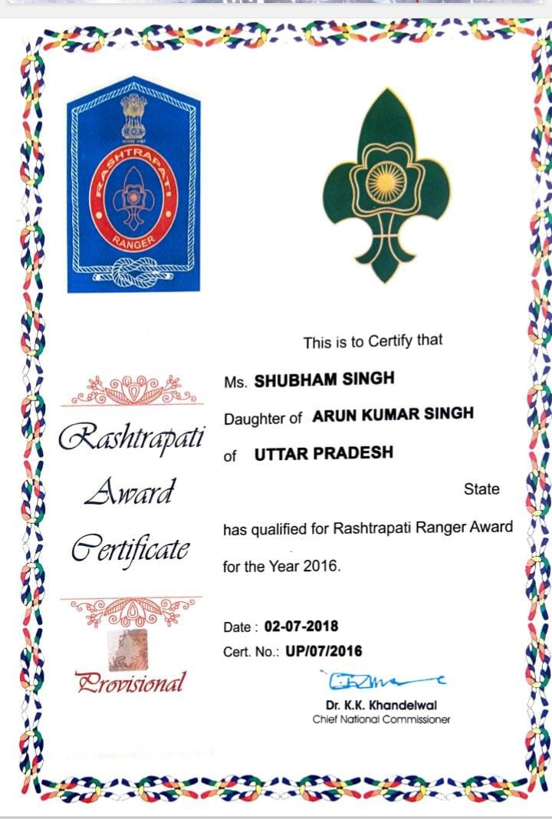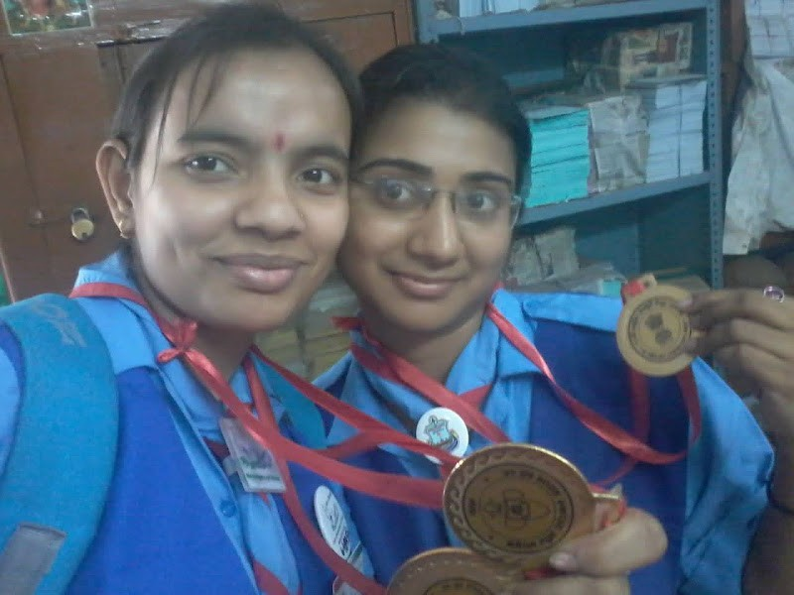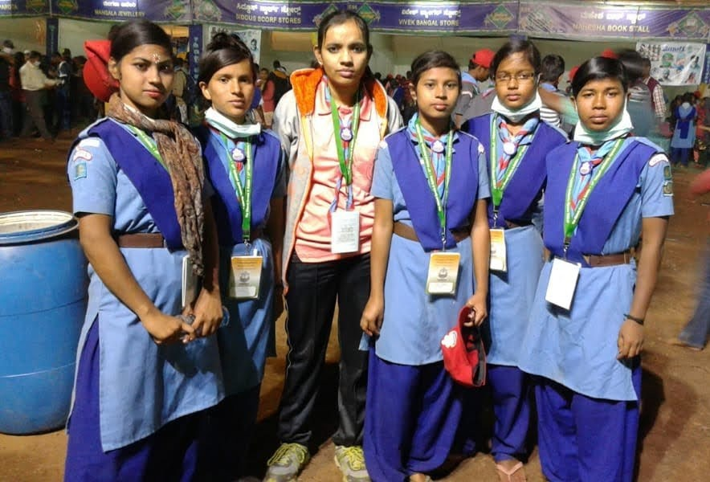
Km. Shubham Singh And Km. Seema Singh Qualified “Rastrapati Ranger Award” For The Year 2016

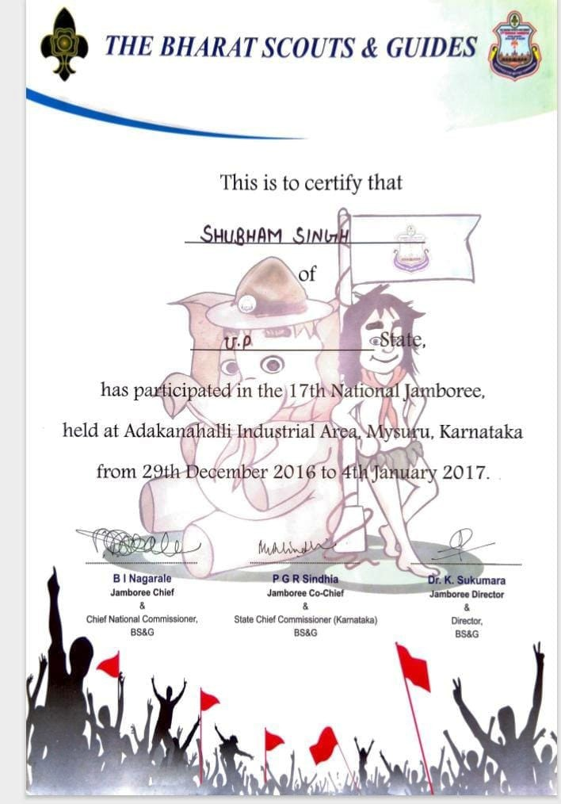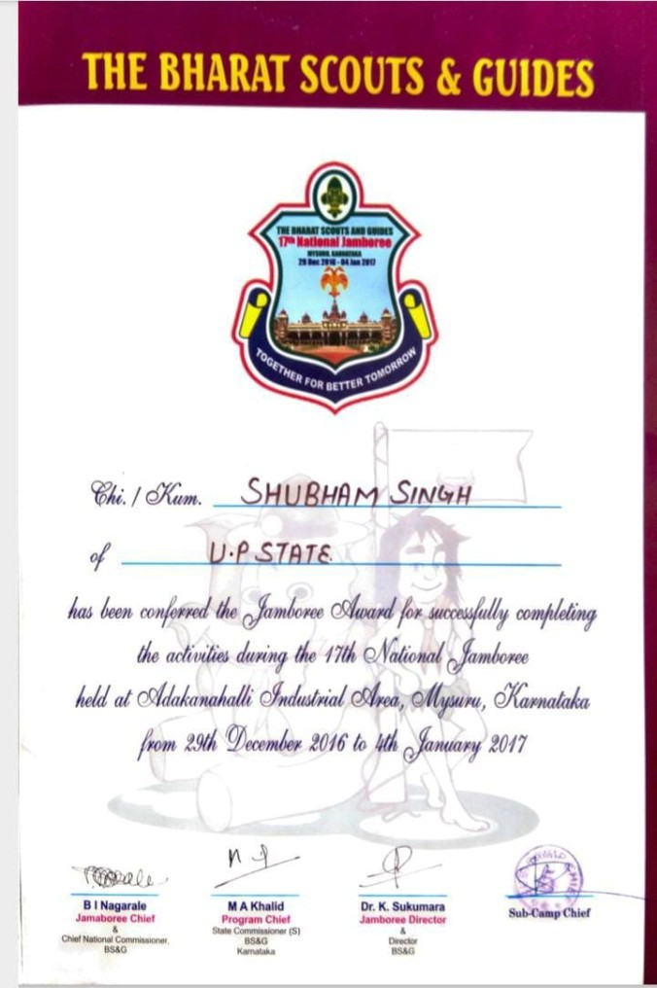National Jamboree
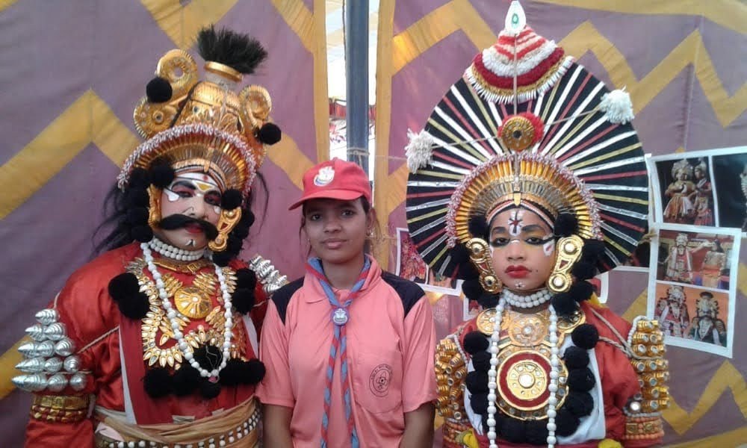Km. Shubham singh and km. Kratika participated in “17TH National Jamboree Mysure, Karnataka” from 29. 12. 2016 till
04.01.2017

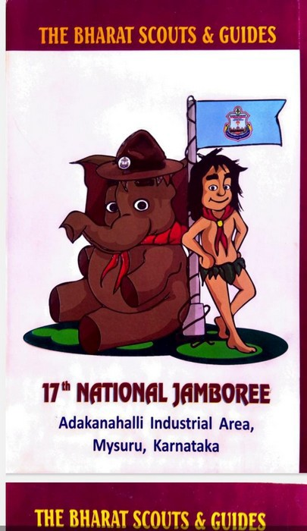

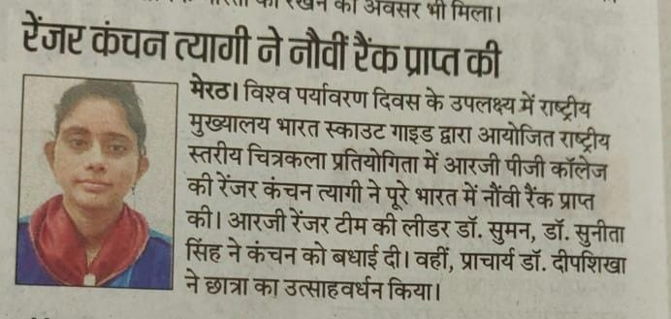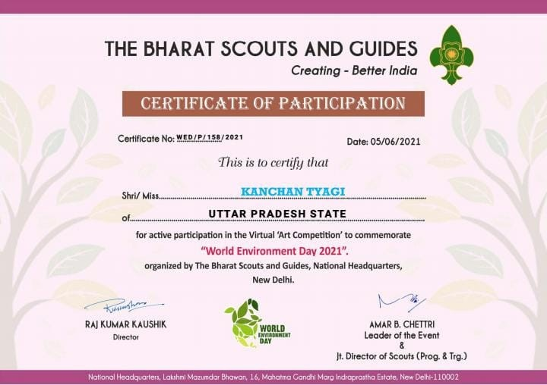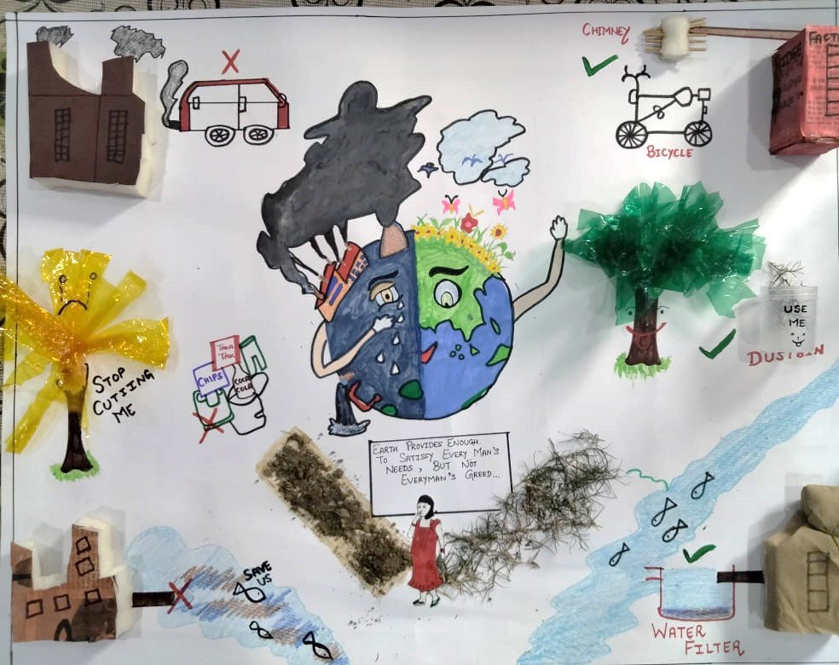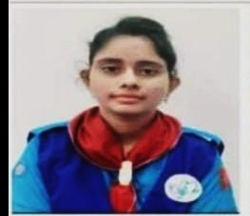
Ranger Km. Kanchan Tyagi Secured 9th Rank In National Level Online Drawing Competition
On “World Environment Day” (05/06/2021) Organized By BSG

Ranger Km. Meenakshi got Selected for Primary Education Teacher in 2021
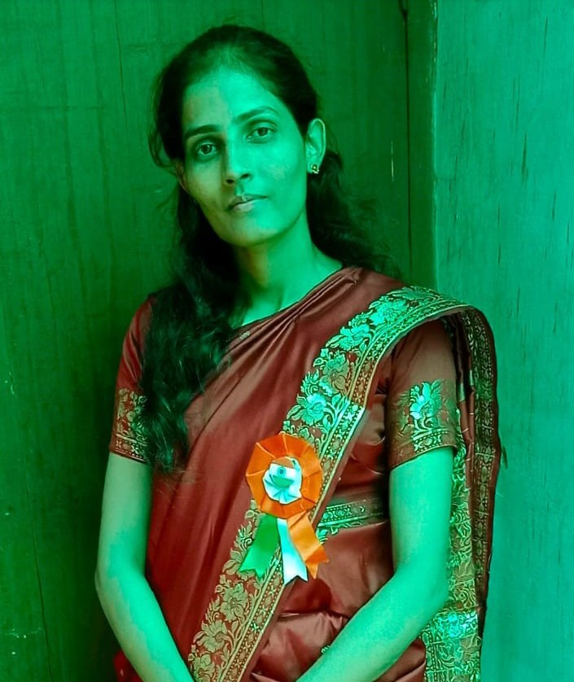

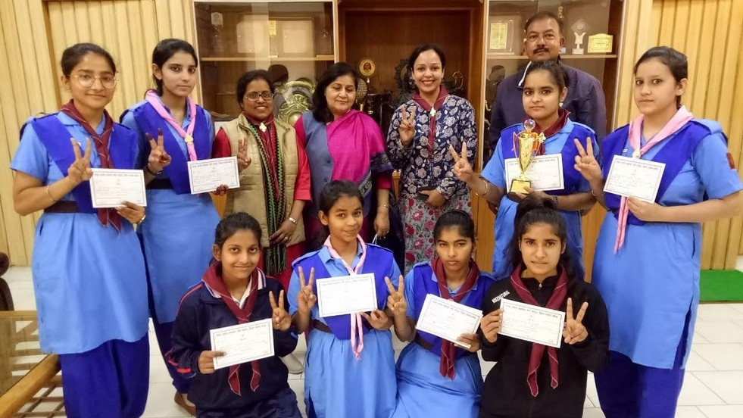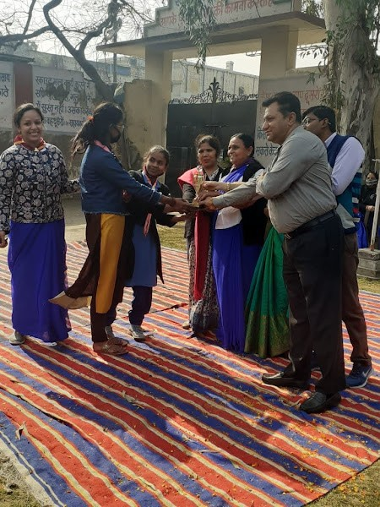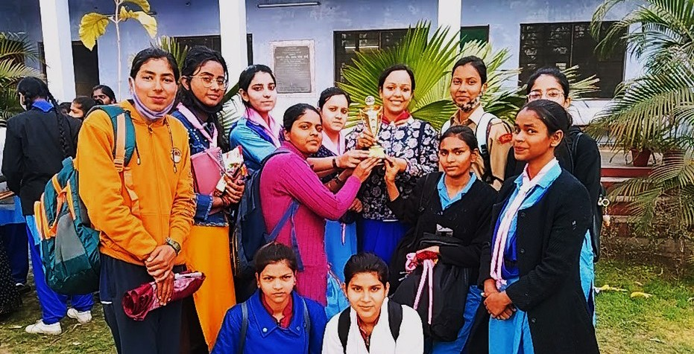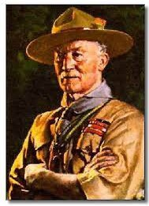
Thinkng Day is celebrated every year on 22 Februry at
Bharat Scout & Guide Bhawan Lalkurti Meerut.
22.02.2021

R. G. Rangers Team got first prize in Rangers category

Media Coverage

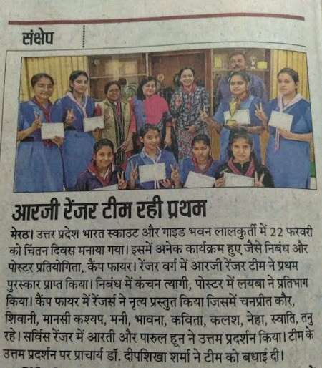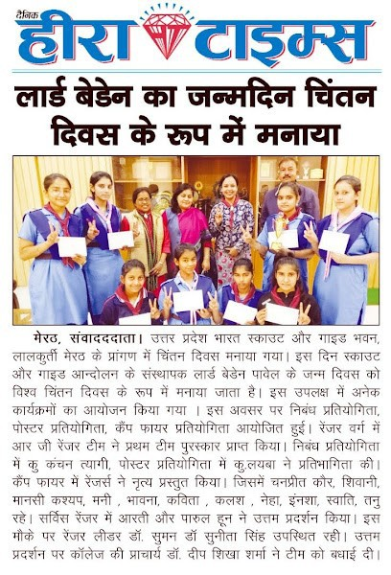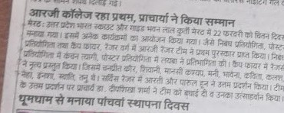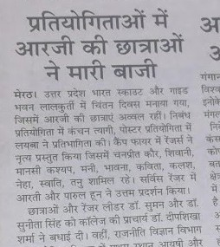


Thinking Day Celebration On 22.02.2022
18 Rangers participated in the event.

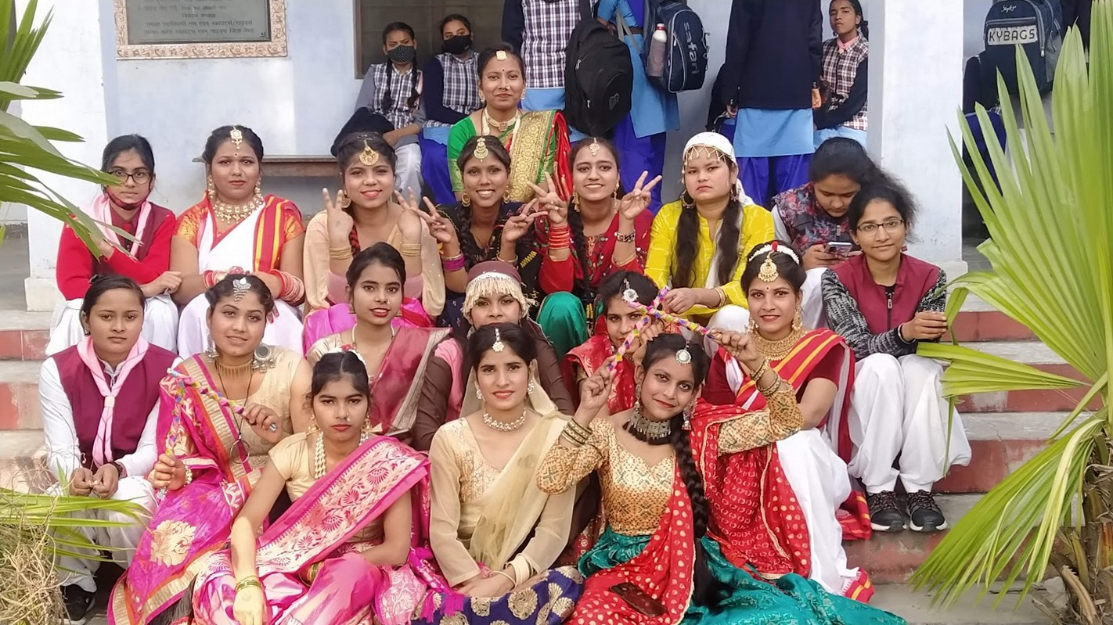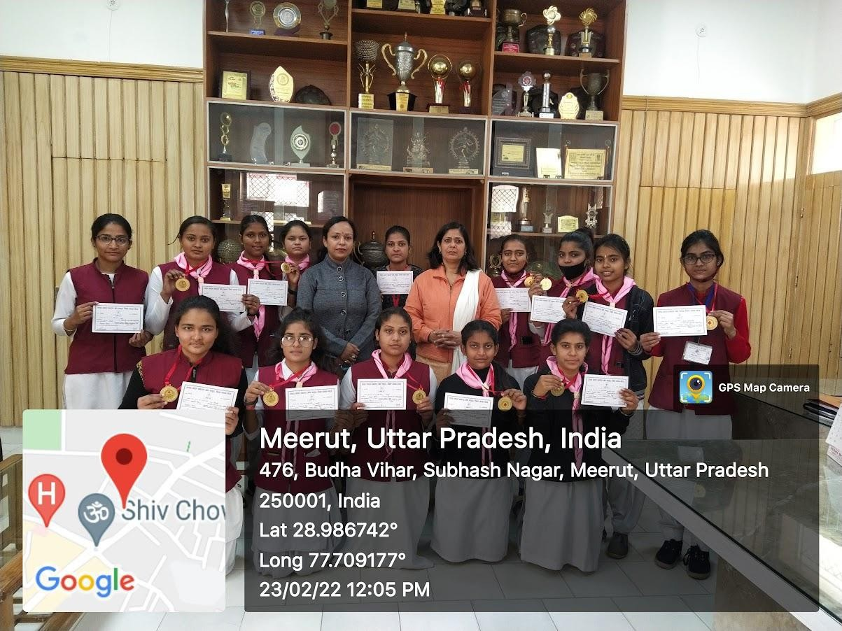

R. G. Rangers Team Got First Prize in Rangers category

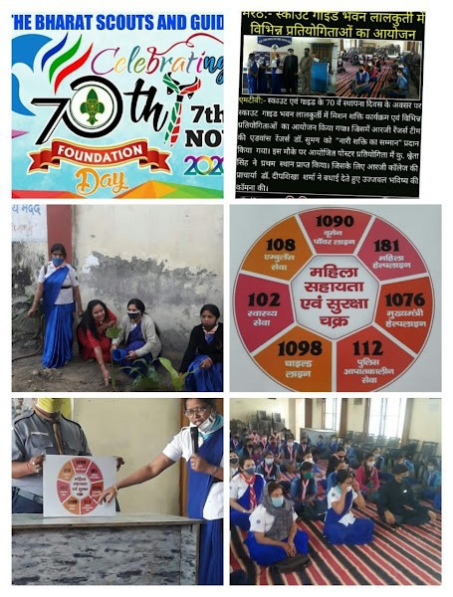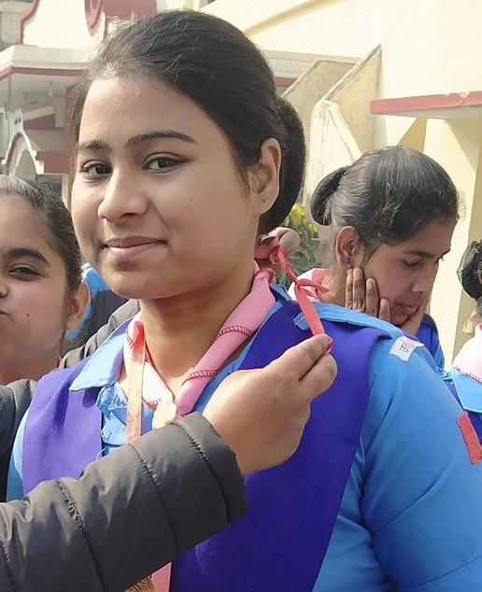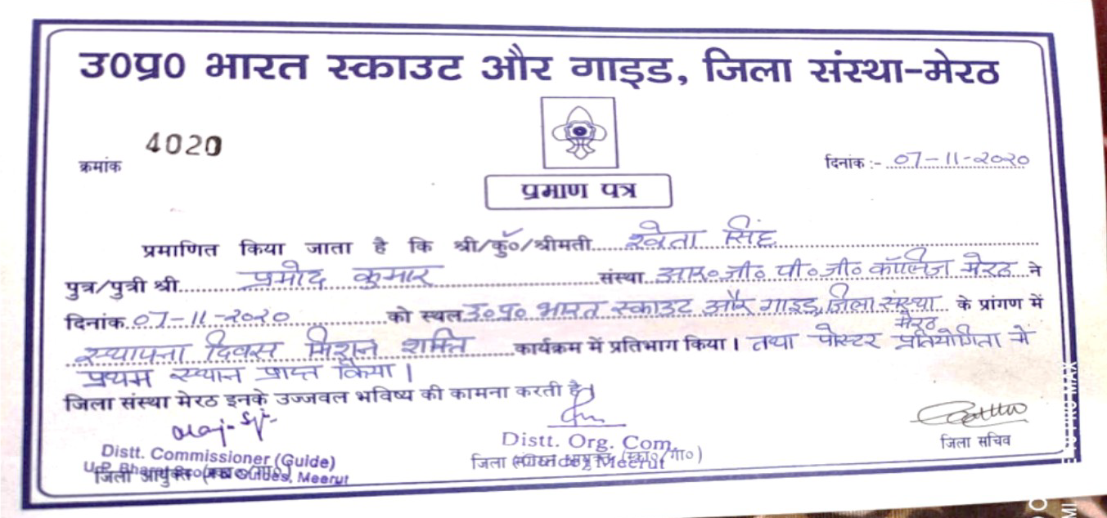
Plantation
70th Foundation Day of Bharat Scout and Guide was Celebrated on 20 July 2019
Ranger Leader Dr. Suman gave lecture on Women’s help line numbers
Ranger Km. Shweta got First Prize in Poster Competition.

Ranger Km Khushi got Third Prize in Art Competition held on 3rd March 2022
Organized by Environment Club under Wildlife Week Celebration from 27th February to 06th March.

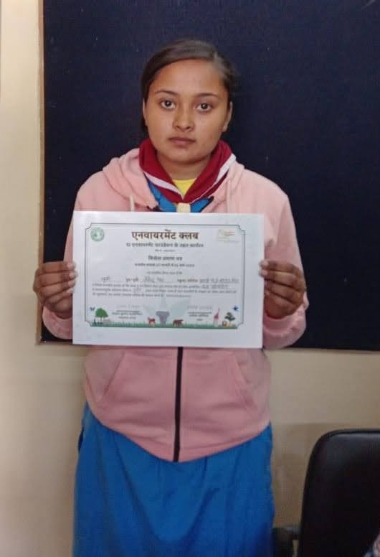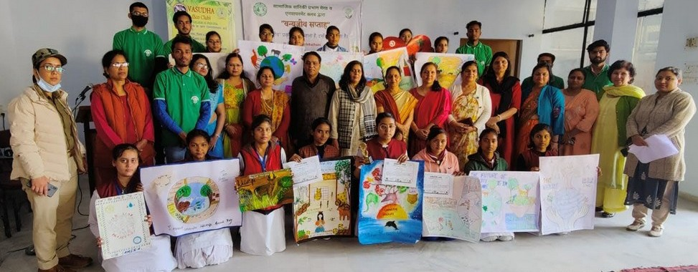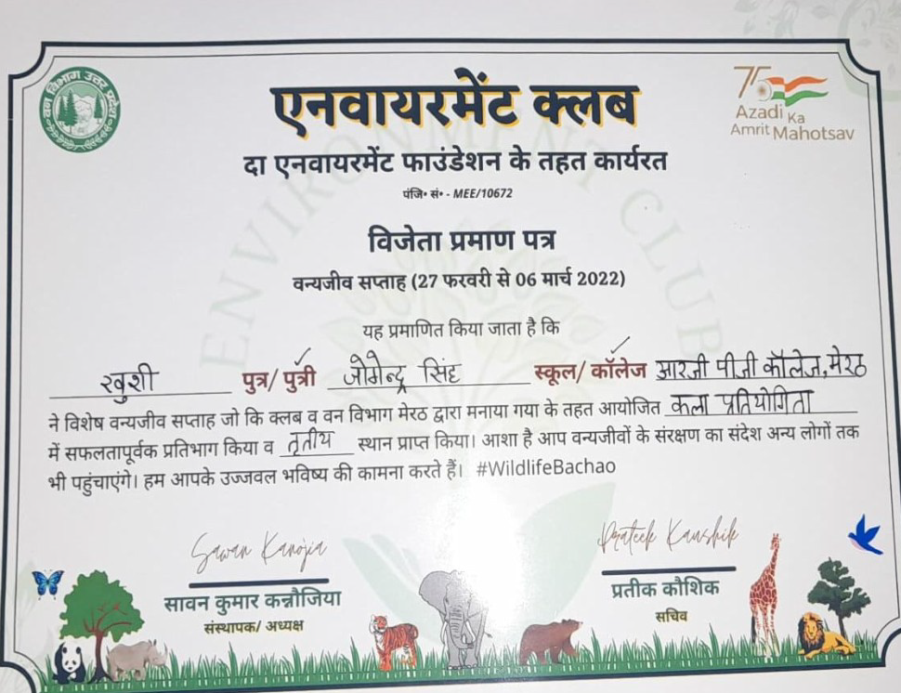


Special Achievement By Ranger Leader
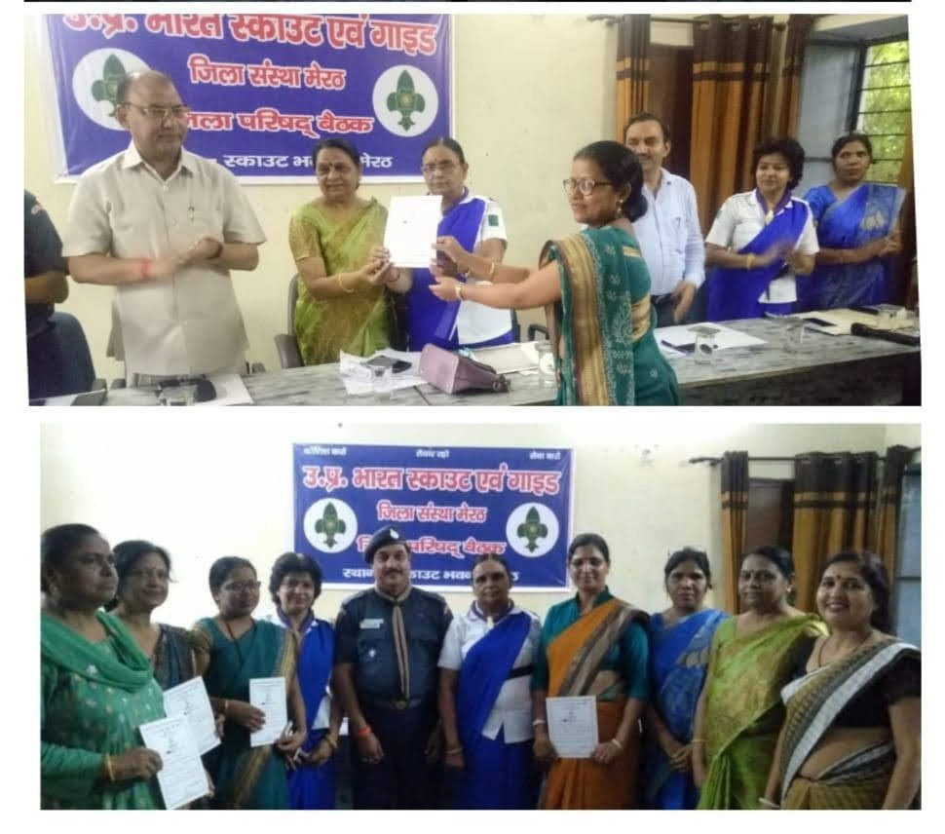
On the occasion of 70th Foundation Day of Scout and Guide Advance Ranger leader Dr. Suman was honoured by “Nari Shakti Samman” on 20th July 2019.


U-Report India: A International Forum for Scouts and Guides
U-reporter India Is The Community Engagement Platform Of UNICEF India. (WhatsApp Number : 9650414141)

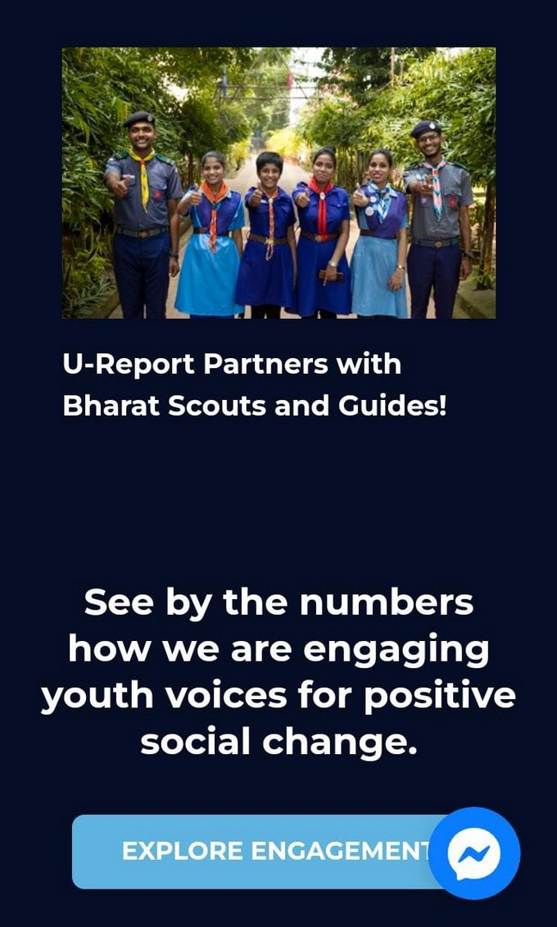
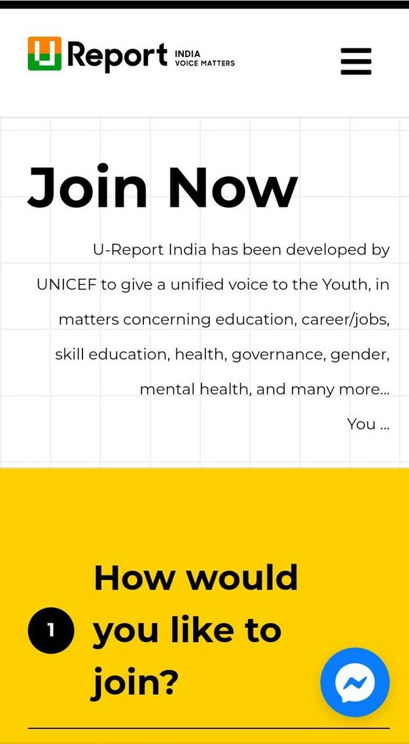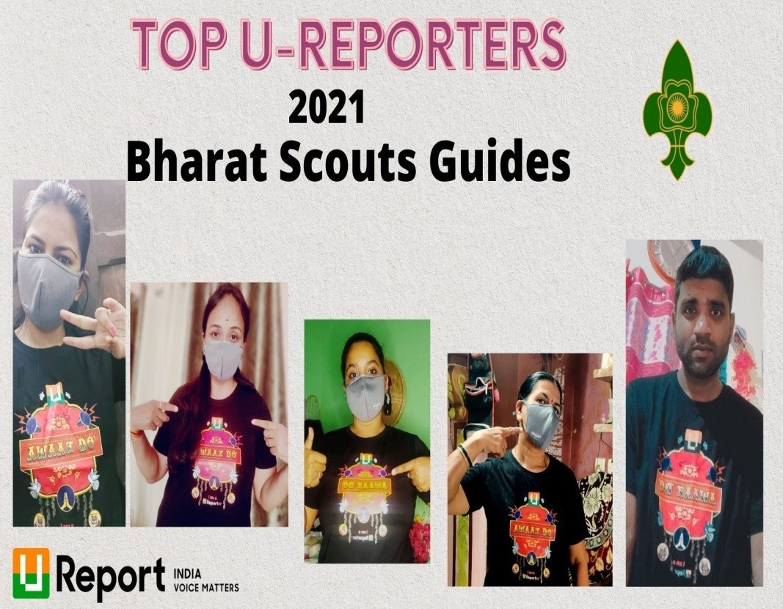

Till now 42 R. G. Rangers have registered on WhatsApp up U-Reporter and have U Reporter ID.
U-Reporter ID Number of R. G. Rangers

4803677 | 18859720 | 19932441 | 19977155 | 20255335 | 20240131
4838275 | 4969304 | 20240011 | 20247542 | 4836257 | 20260532
4835766 | 18860291 | 20240063 | 20240740 | 20255486 | 18861007
4871116 | 18860343 | 20240013 | 20240118 | 20255560 | 4969304
4848258 | 18861007 | 20240874 | 20240047 | 20255567 | 4839547
4839892 | 4836257 | 20240494 | 4839547 | 18859720 | 18860291
4841339 | 20239932 | 20240100 | 20239954 | 19924727 | 20240478

R. G. Rangers Team Members are also Registered in BSG Online Youth Membership Portal.
Till now 18 rangers are Registered and have UID.

BSG790527198 | BSG790513812 | BSG790528892 | BSG790530423
BSG794858389 | BSG790526633 | BSG790524276 | BSG794854160
BSG794848648 | BSG794855123 | BSG794861994 | BSG794862152
BSG790531677 | BSG794865930 | BSG794269711
BSG790514220 | BSG794852857 | BSG790536595



Community Services
&

Out Reach Activities By
R. G. Rangers’ Team

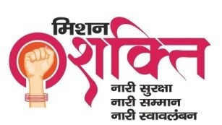
Rangers got one week Self Défense Training in Physical Department of
C.C.S. University under “Mission Sahasi” program
(01.11.2020 - 07.11.2020))

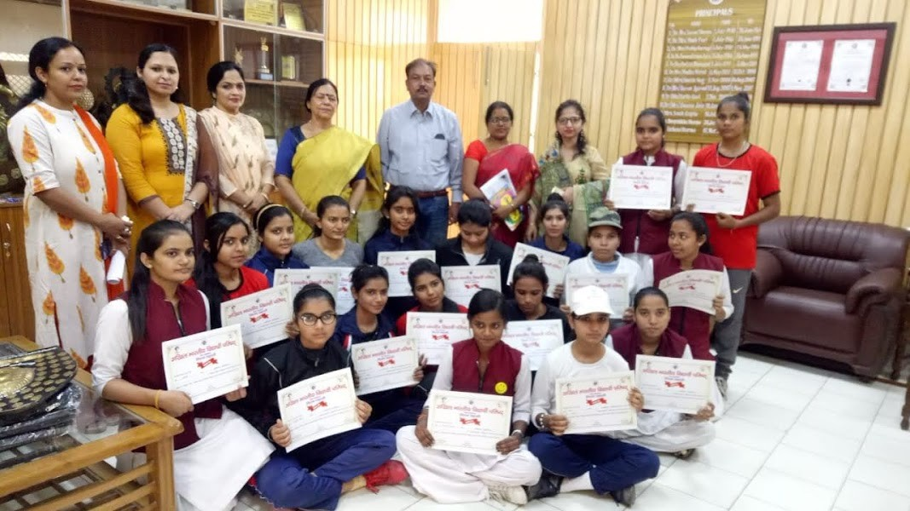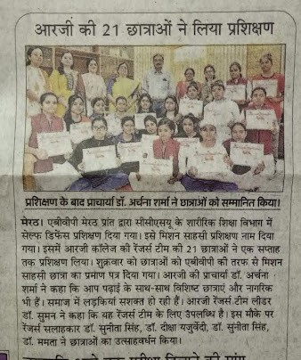


Trained Rangers Km. Shweta & Km Shivani gave Self Défense training in different
schools as well as in college

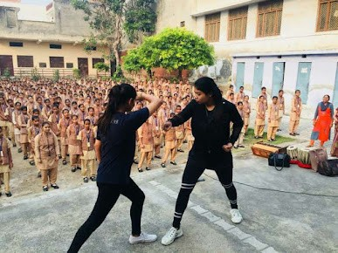

R. G. Rangers prepared hand made masks
and donate them to Bharat Scout & Guide Bhawan during Covid-19. (2020-21)
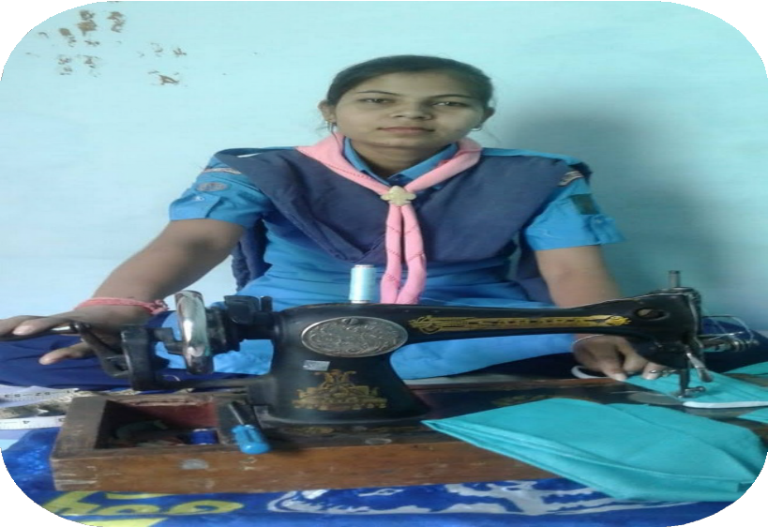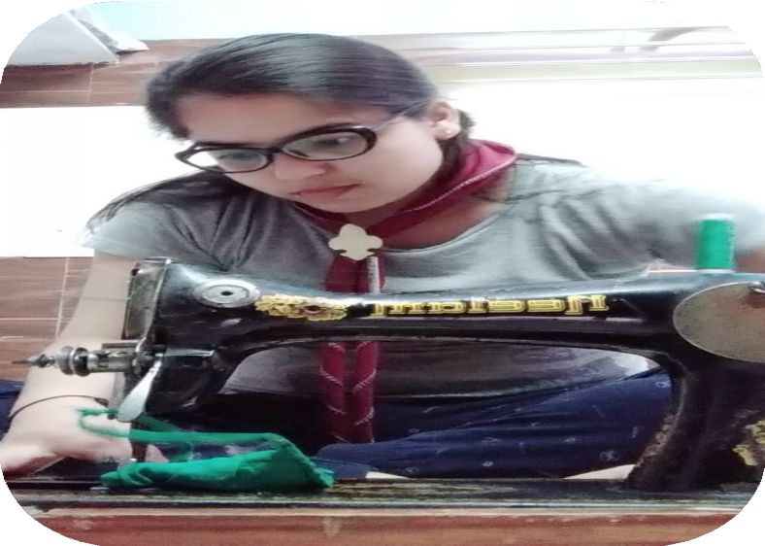
Ranger Km. Rakhi
Ranger Km. Shivani


Food & Mask Donation Camp During Covid - 19 Pandemic (2020-21)

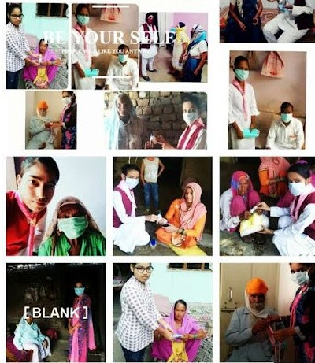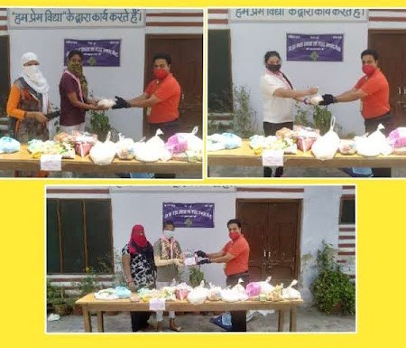


Rangers spread awareness through posters during lockdown period. (2020-21)

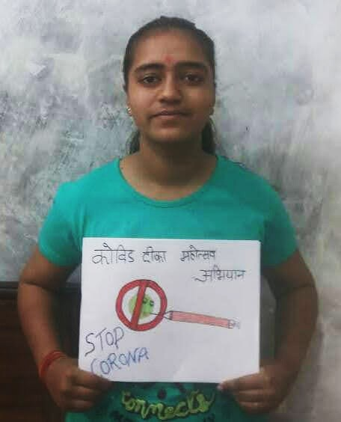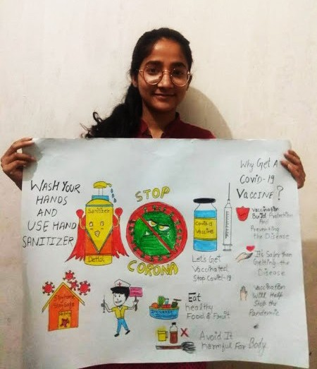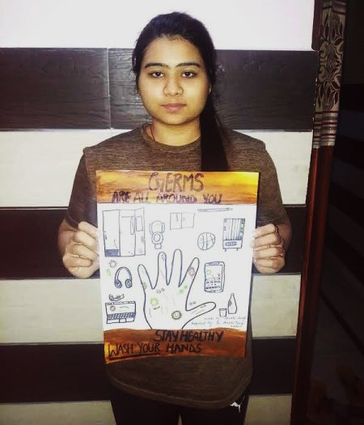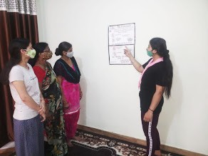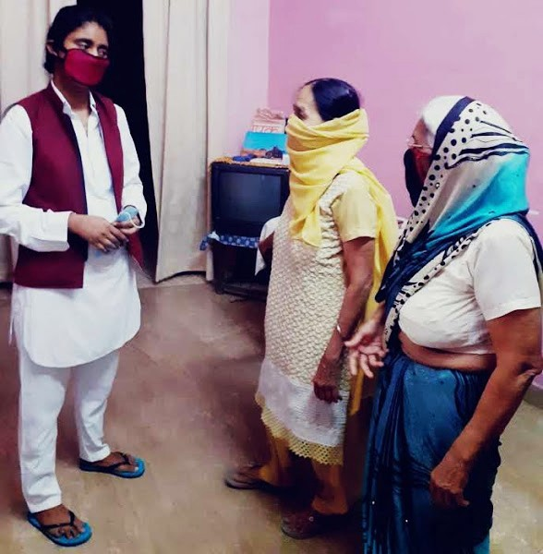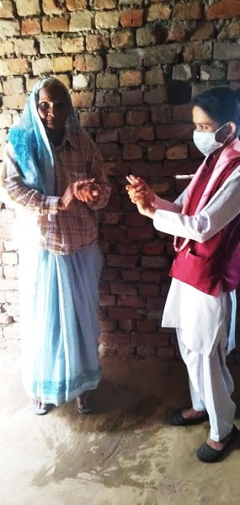
Km. Tanu
Km. Kanchan
Km. Shweta
Km. Chitra Sharma
Km. Nisha
Km. Shweta

R. G. Rangers participated in Mission Shakti Awareness Program on women safety & women helpline numbers
organized by Bharat Scout & Guide Bhawan Lalkurti Meerut on 27.02.2021.

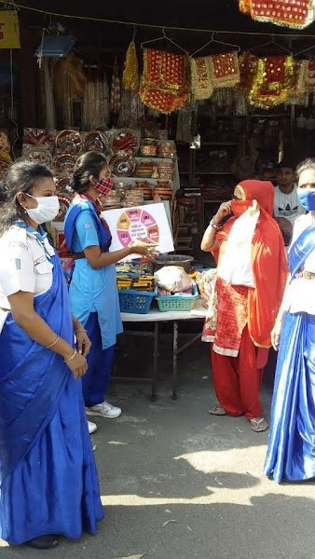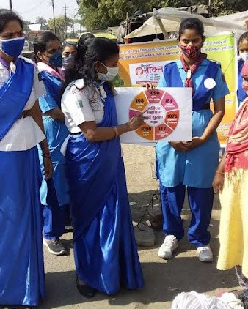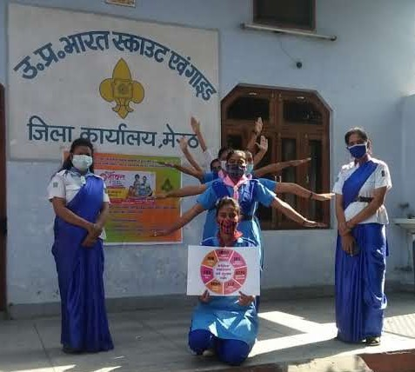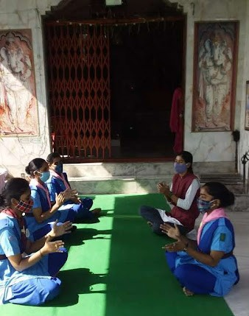

Rangers provide education to illiterate people and spread awareness for education under the campaign “Not Her Fault”.

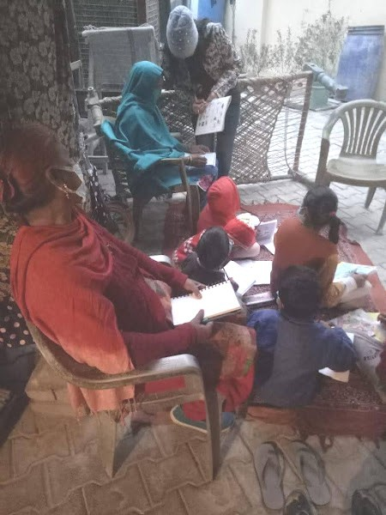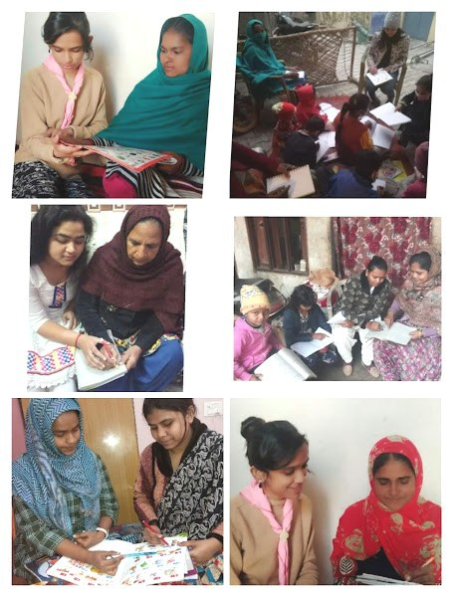

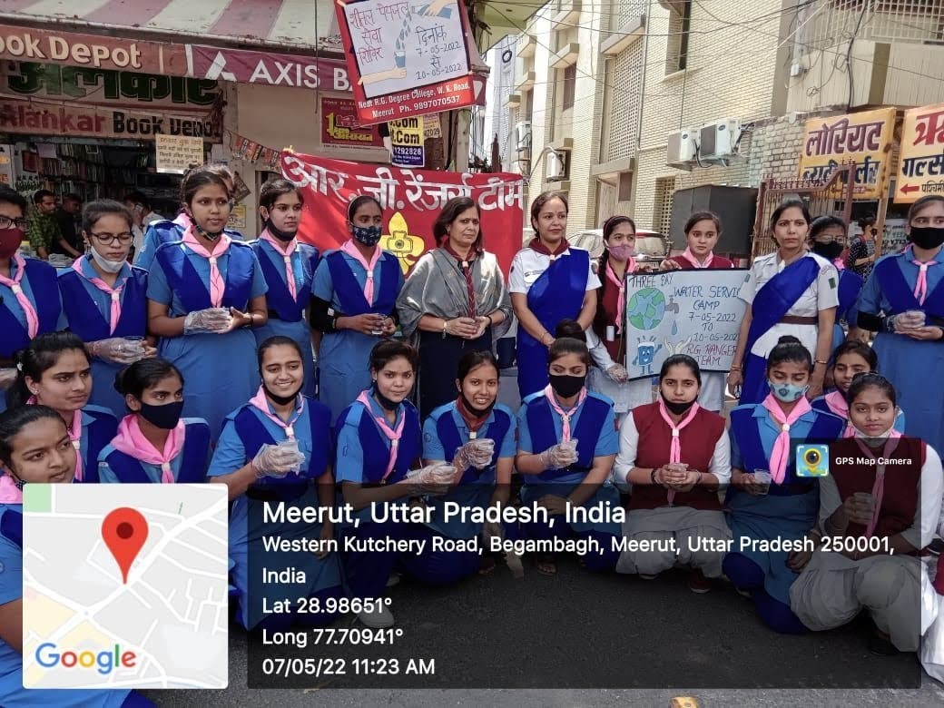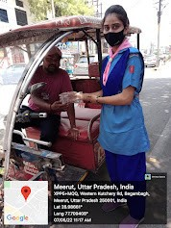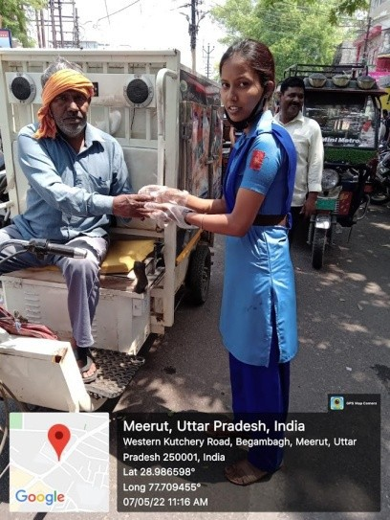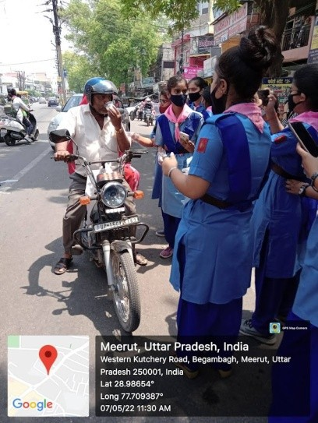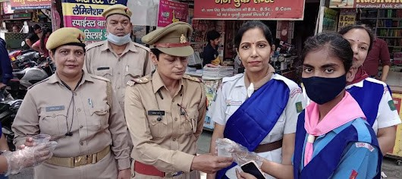
Three days water and sharbat distribution service camp in public Place from 07.05.2022 till 10.05.2022.
43 Rangers participated in the camp.


Participation in Service Camps organized in Bharat Scout and Guide
Bhawan, Lalkurti Meerut

- One Day Service :
25.01.2018
- Two days service :
24.12.2018-25.12.2018
- Two days service :
20.01.2019-21.01.2019
- Two days service :
03.01.2020-04.01.2020
- Three & Five Days Camp :

Service Certificates of Rangers from the session 2017-2018 & 2018-2019
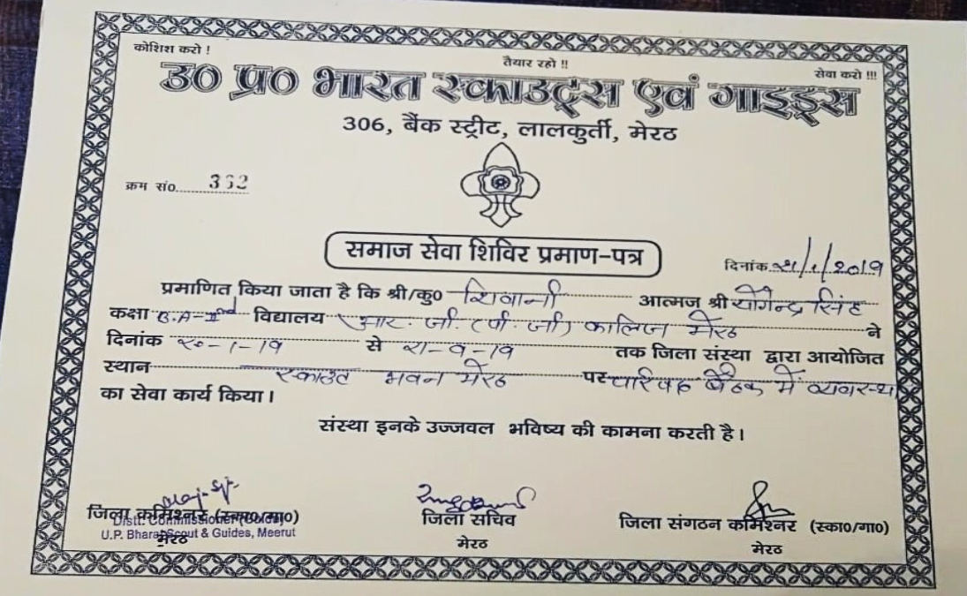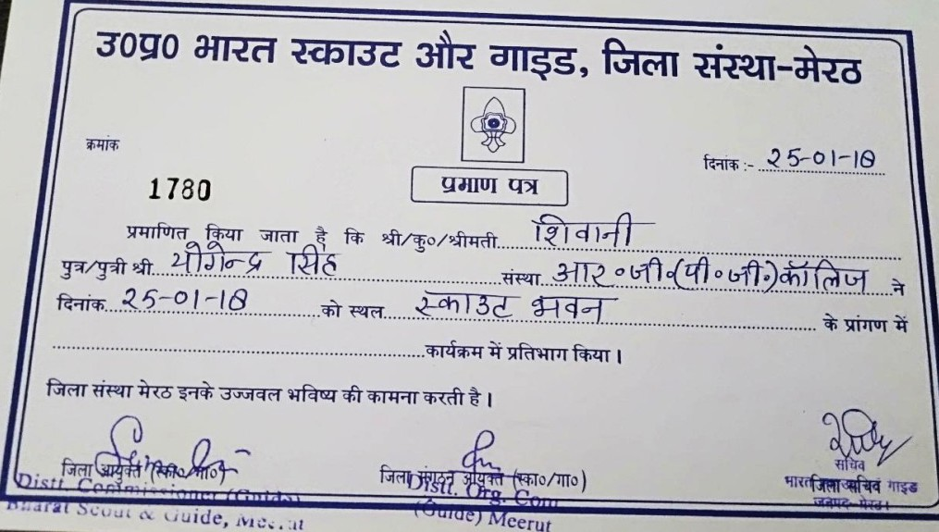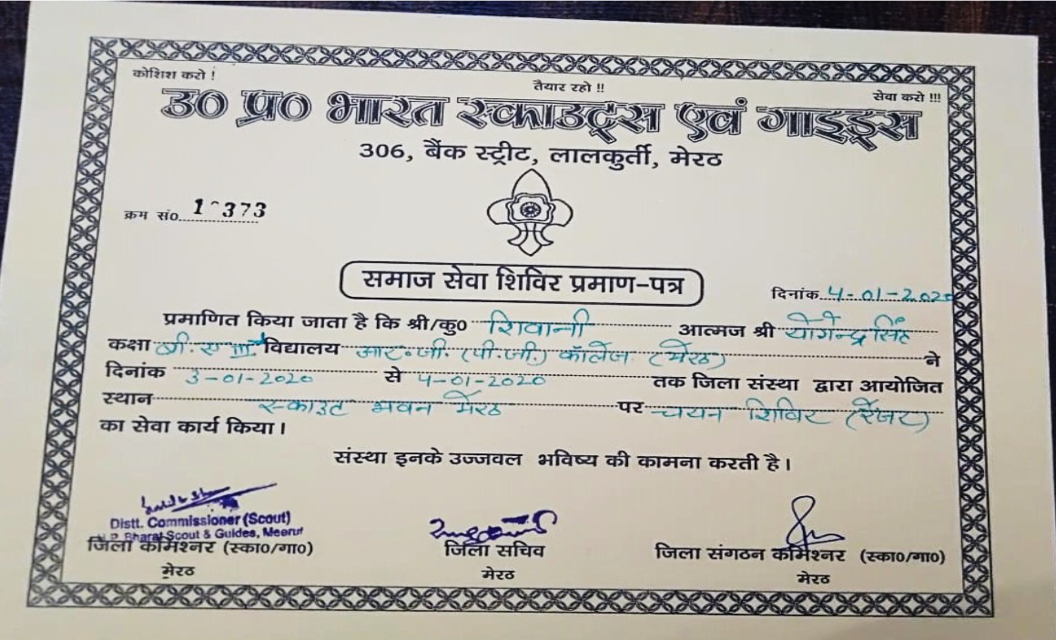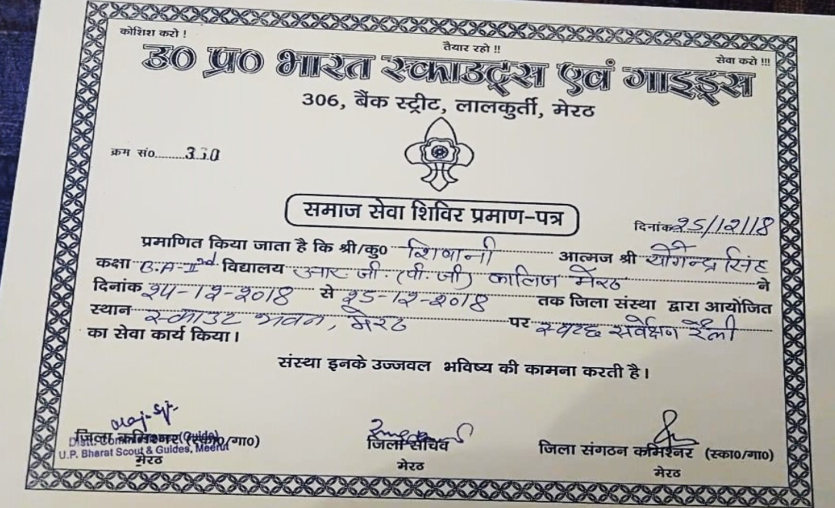

Ranger Km. Bhumika
Three & Five Days Service Camp Organized In Bharat Scout And Guide
Bhawan, Lalkurti Meerut
(07.03.2022-09.03.2022; 11.03.2022 To 15.03.2022) (03 Rangers Participated )

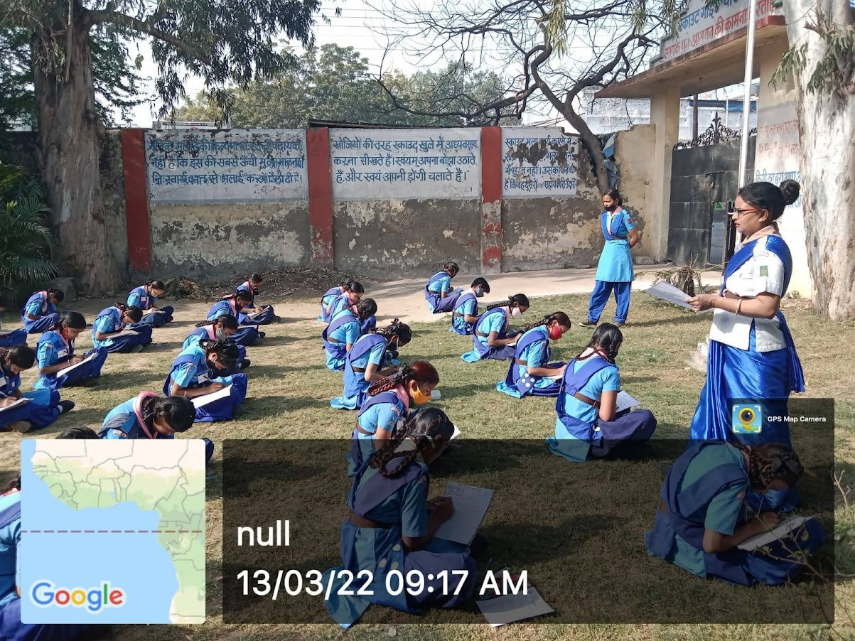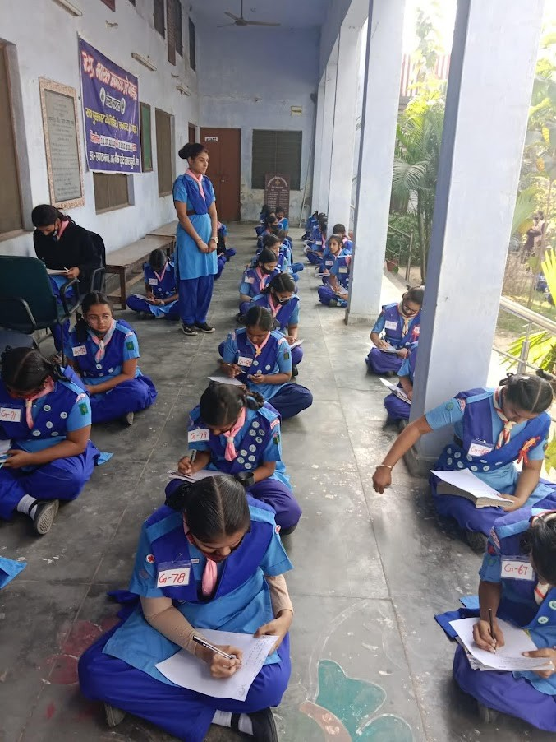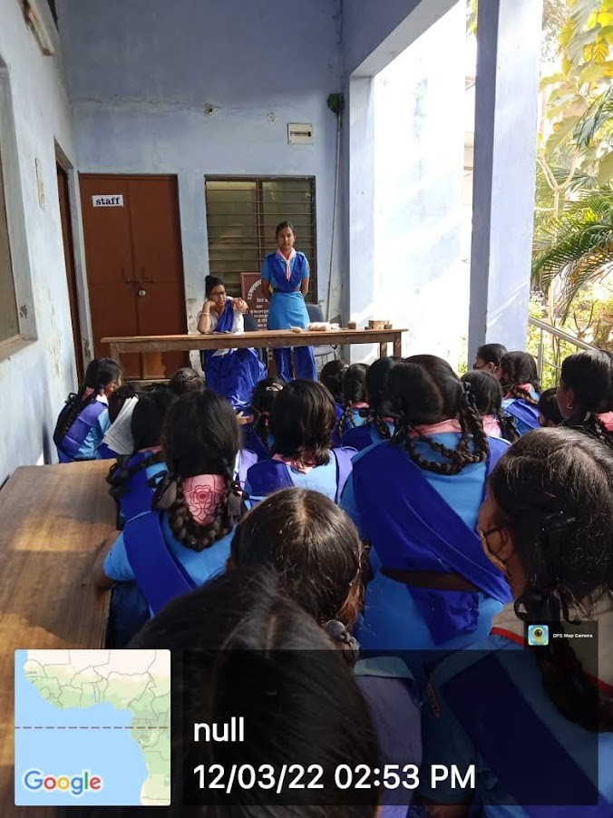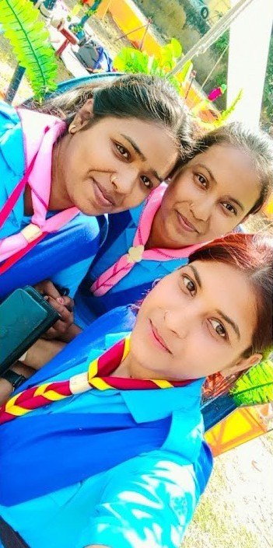
Ranger Km. Simran
Ranger Km. Naina Sharma

One Day Service Camp organized in Bharat Scout and Guide Bhawan, Lalkurti Meerut
One Day Camp 12.05.2022 (02 Rangers)
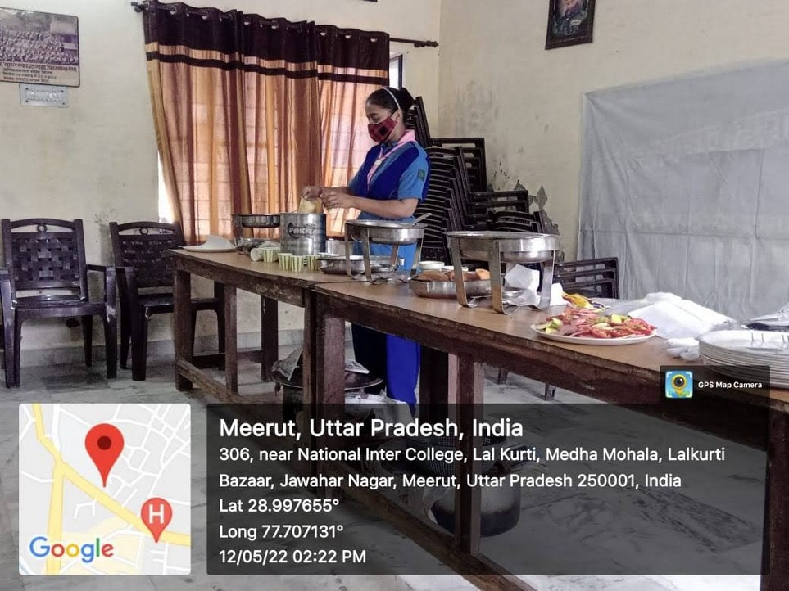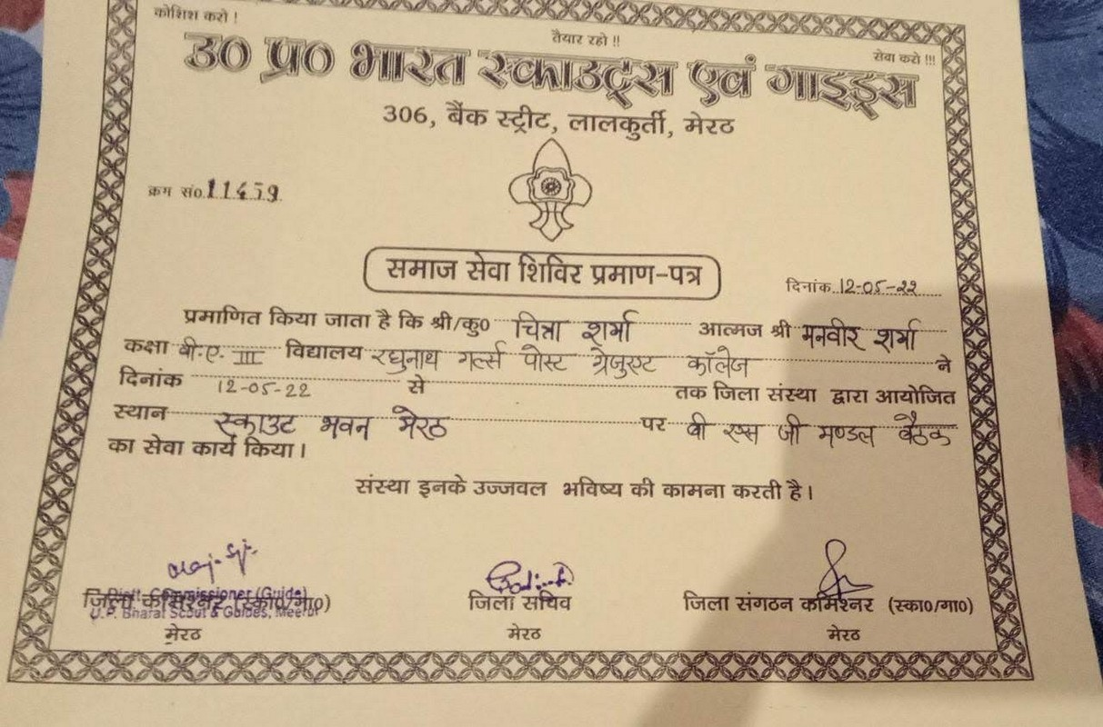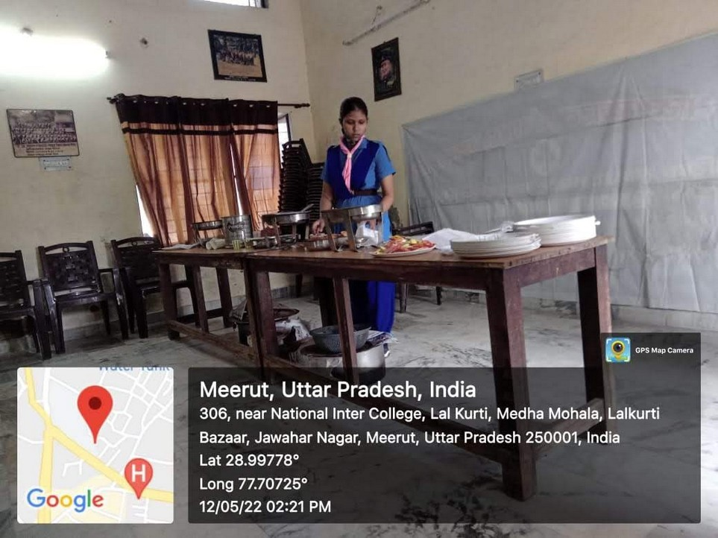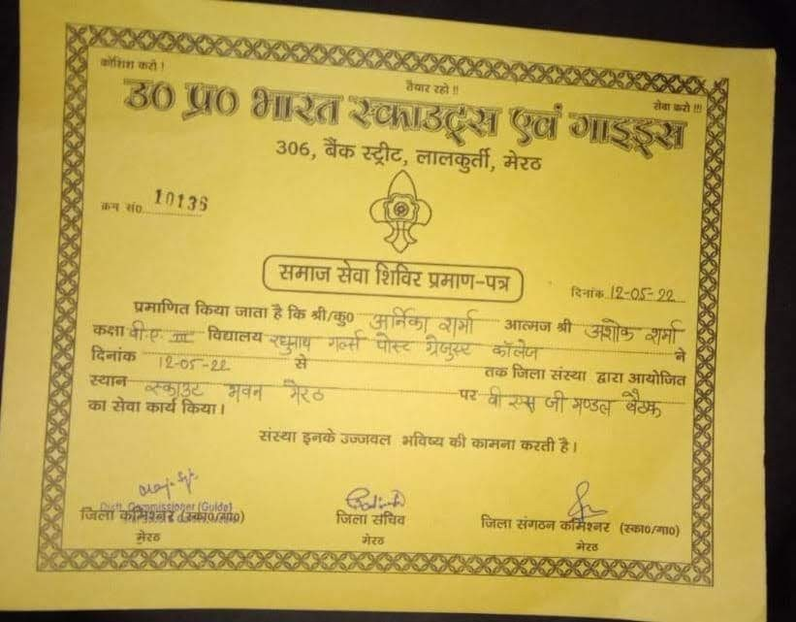


District Rallies

Rally | Date | Session
- Rally on Cleanliness (District Rally). | 09.11.2016 &  10.11.2016 | 2016-2017
Rally on Cleanliness organized from R. G. P. G. College to Jimkhana Maidan Budhana Gate, Meerut, ordered by City Development Department U.P. Lucknow. | 19.11.2018 | 2018-2019
- 60th District Scout and Guide rally in Jangathi, Meerut.  (04 rangers participated.) | 29.11.2018-  30.11.18 | 2018-2019
District Rally on “Amrit Mahotsav” organized by Bharat Scout and Guide Bhawan, Lalkurti, Meerut.  (08 Rangers participated.)  District Rally on “Cleanliness” on the occasion of Ganghi Jayanti, organized by Bharat Scout and Guide Bhawan, Lalkurti, Meerut.  (09 Rangers participated.) | 09.08.2021  02.10.2021 | 2020-2021  2020-2021
- Organized district Rally on “Her Ghar Jhanda, Her Ghar Tiranga” on the occasion of Amrit Mahotsav on 13.08.2022.  - (20 Rangers participated.) | 13.08.2022 | 2022-23

From R. G. P. G. College To Jimkhana Maidan Budhana Gate, Meerut, Ordered By City Development Department U.P. Lucknow

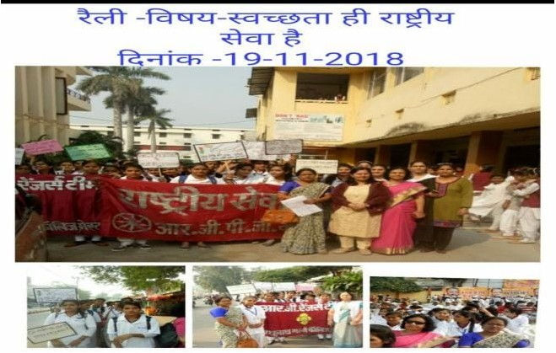


60th District Scout And Guide Rally In Jangathi, Meerut From 27.11.2018 Till 30.11.18 (2018-2019)

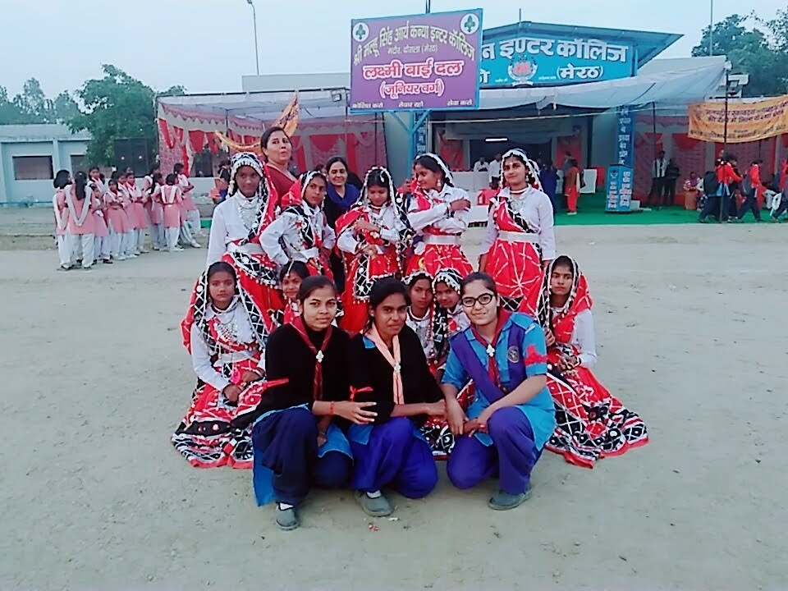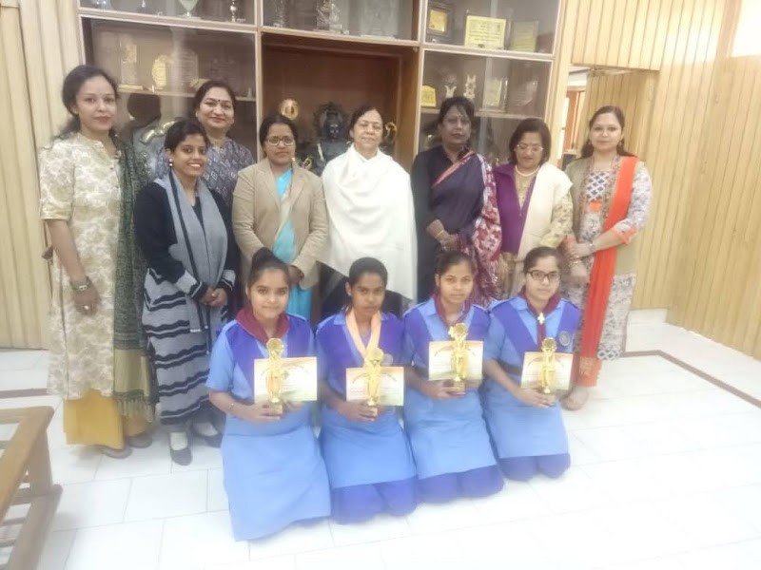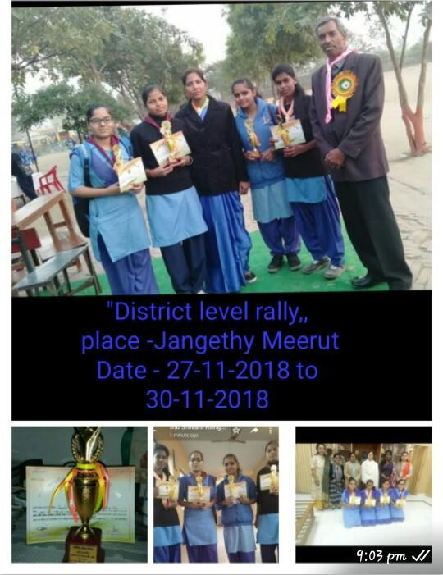


On The Occasion Of 75th Independence Anniversary , 8 Rangers Participated In The Amrit Mahotsav Rally Organizrd On 09.08.2021
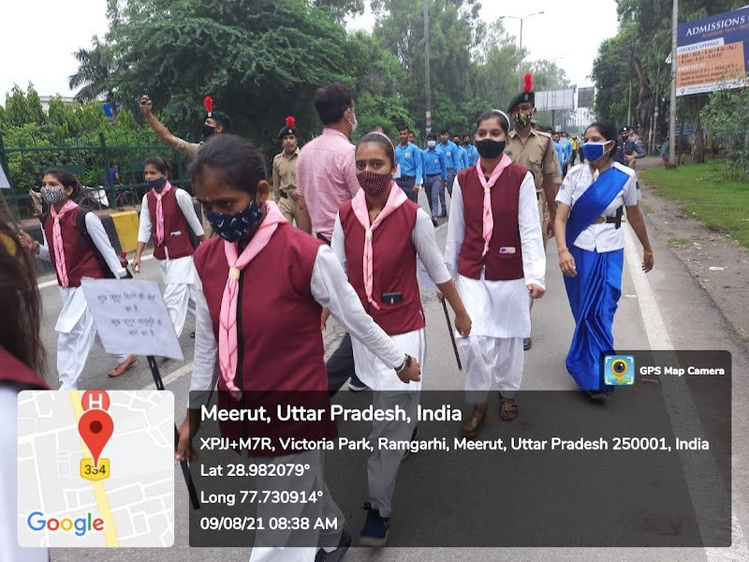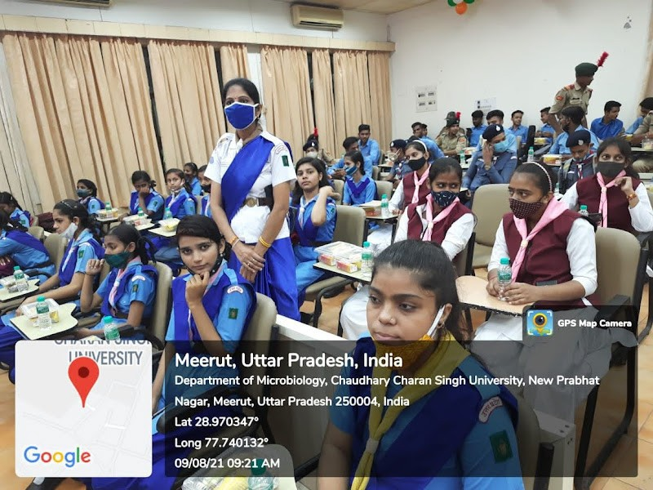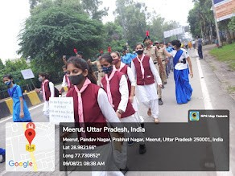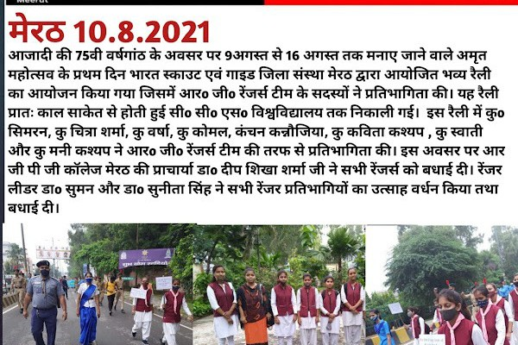


Organized Combined District Rally With NCC & NSS On “Her Ghar Jhanda, Her Ghar Tiranga” On The Occasion Of Amrit Mahotsav On 13.08.2022. (20 Rangers Participated.)

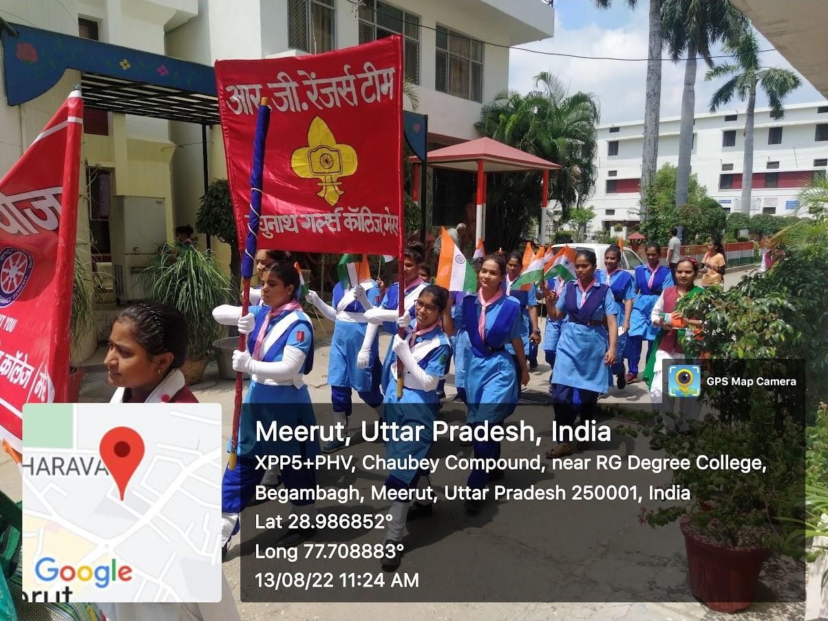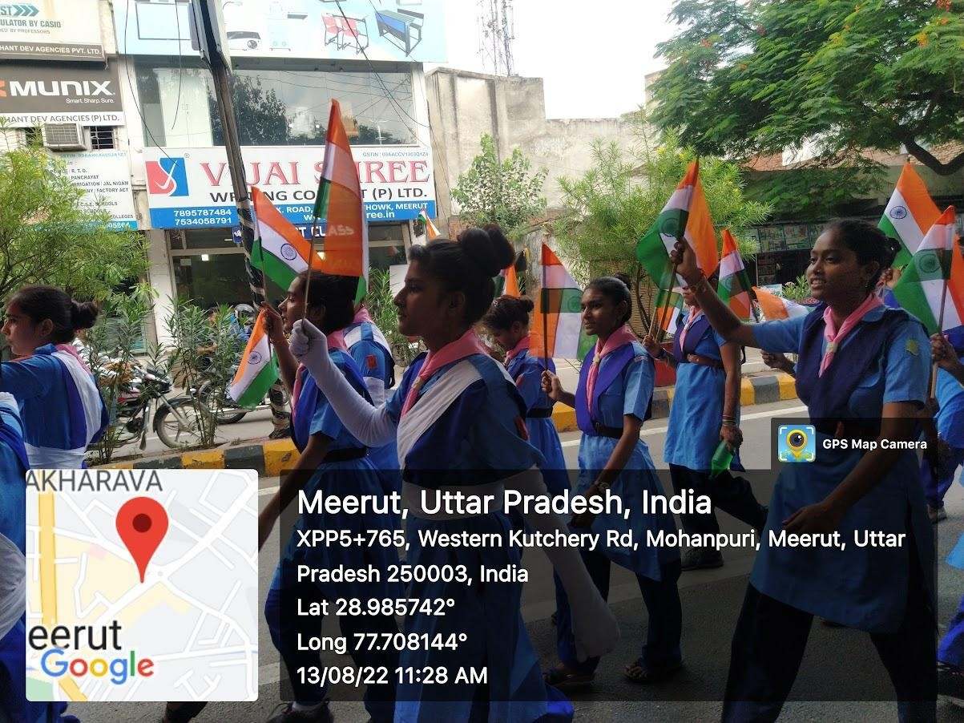

Service Camps in College
Three Days Service Camp was organized From 21.01.2020 till 23.01.2020 . (2019-2020)
Fire Rescue Demo
Oath For Voter Awareness

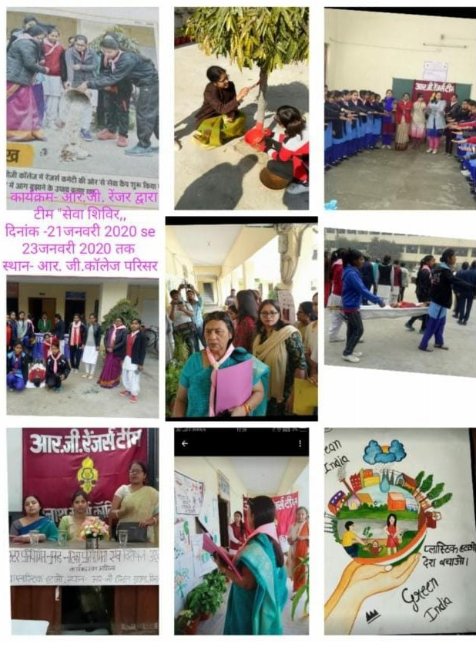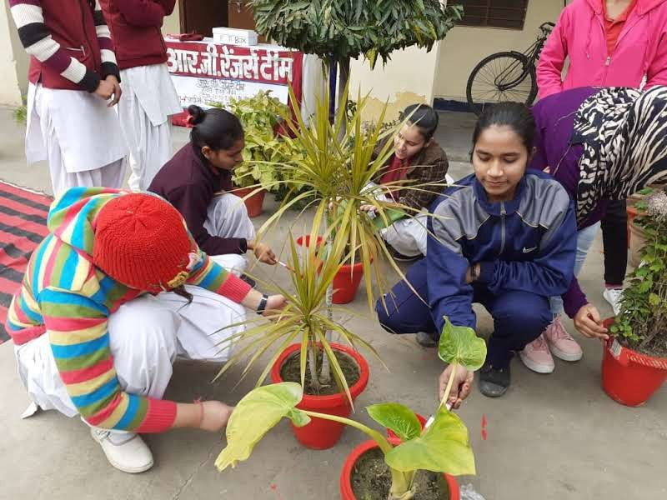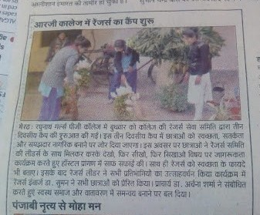Poster Making
Media Coverage
Painted Pots

First Aid

Voter Awareness

Training Camps


Ranger Leader Training
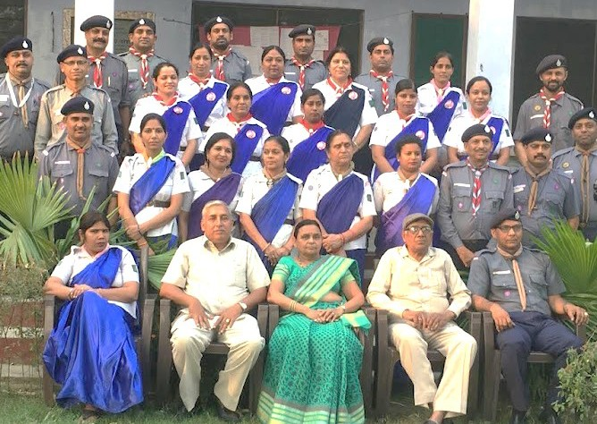
Dr Sunita Singh and Km. Meenakshi competed 7 days basic ranger training course from 07.05.2019 till 13.5.2019 from Bharat Scout and Guide Bhawan Lalkurti, Meerut.

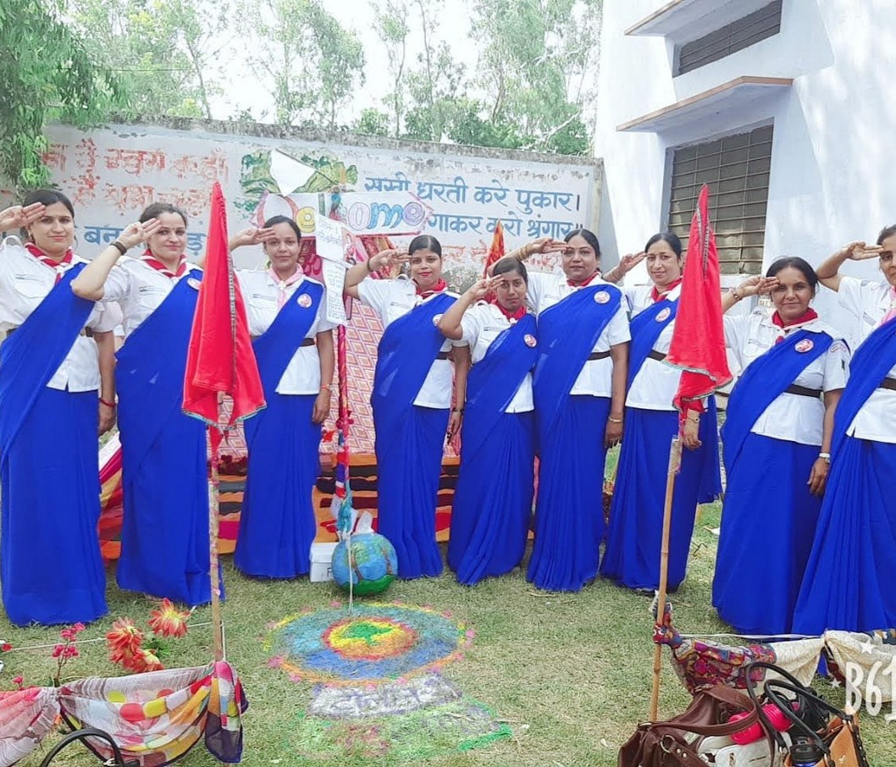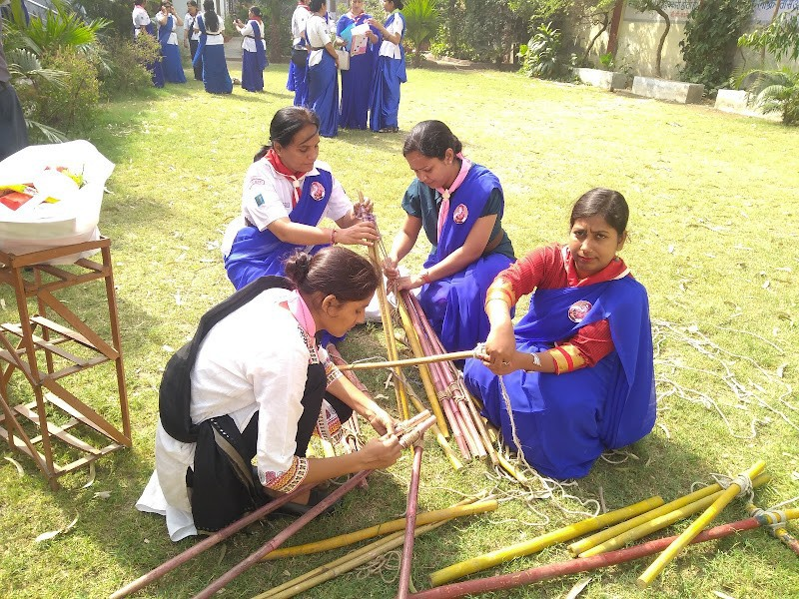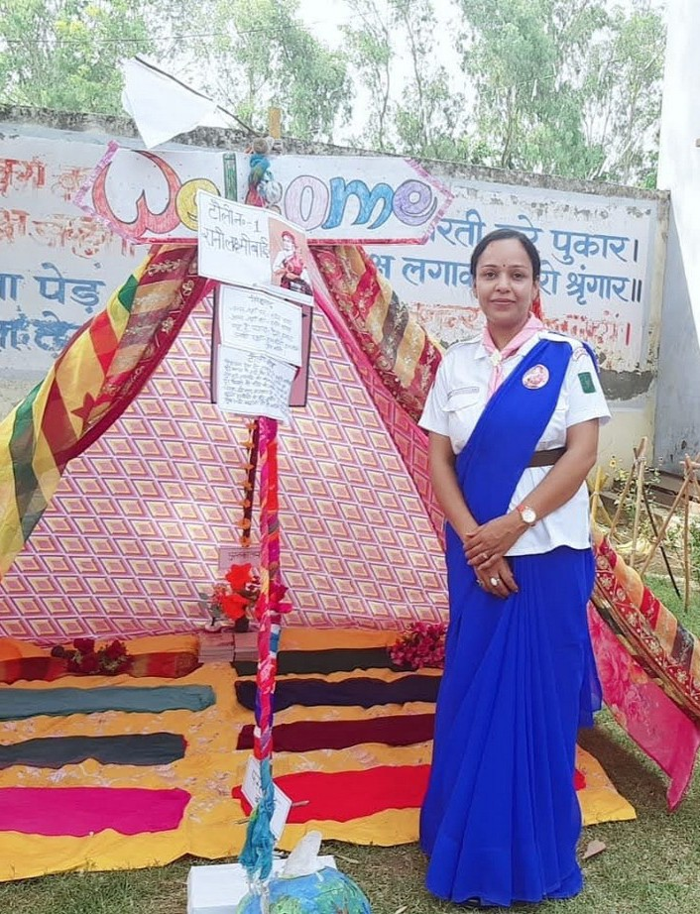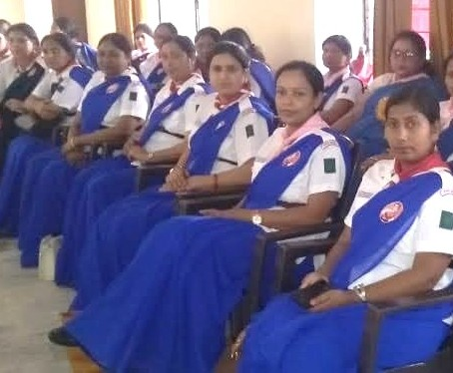
Activities During The Training


Ranger Training Scheme

The Rangers’ Training is in three tier stage i.e.

- 1st Stage : PRAVESH (Entry Level Training)

  - 2nd Stage : PRAVEEN (Second Level Training)

  - 3rd Stage : NIPUN (After “NIPUN” Ranger
are eligible for Vice
PRESIDENTIAL & PRESIDENTIAL” Training)

At District Level
“ Pravesh and Praveen Camps”

CAMPS | DATES | SESSION
PRAVESH PRAVEEN | - | 2016-2017
PRAVESH PRAVEEN | 29.01.2018 to 31.01.2018 | 2017-2018
PRAVESH PRAVEEN | 21.10.2018 to 23..10. 2018 | 2018-2019
PRAVESH PRAVEEN | 23.04.2019 to 25.04.2019 | 2019-2020
PRAVESH PRAVEEN | 14.03.2021 to 16.03.2021 | 2020-2021
PRAVESH PRAVEEN | 24.03.2022 to 26.03.2022 | 2021-22

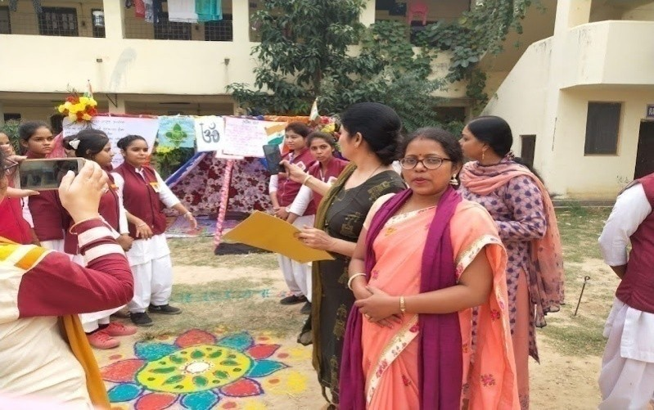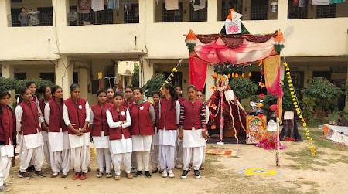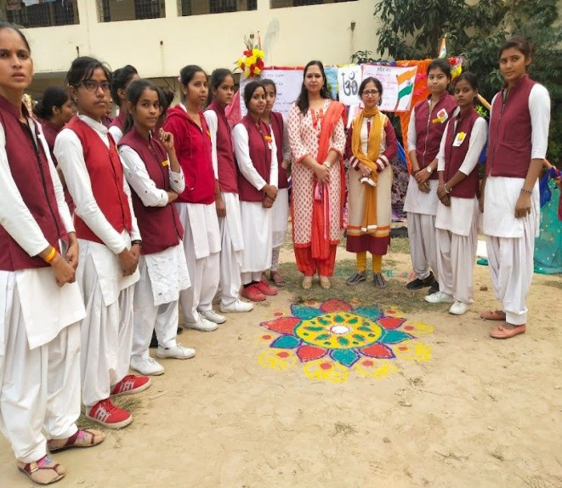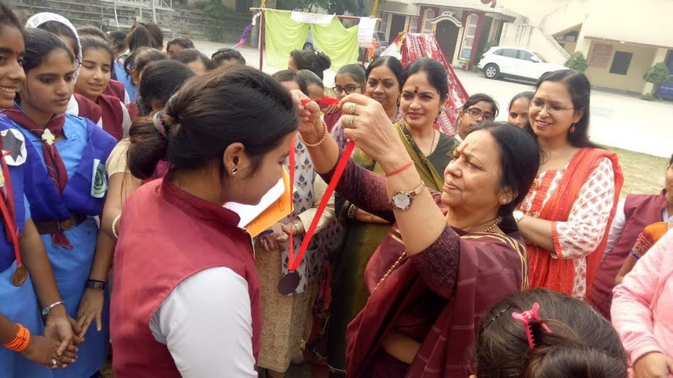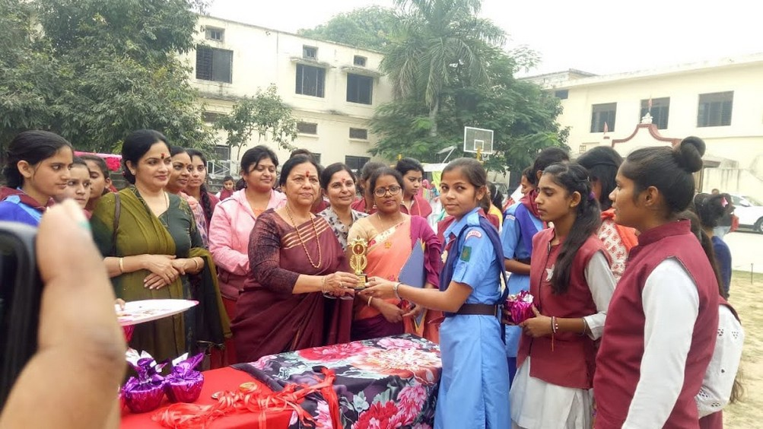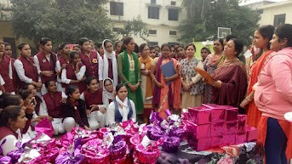
Pravesh Praveen camp in 2019-20
(21.10.2019-23.10.2019)

Closing ceremony of camp with prize distribution
Rangoli Making
Tent Making

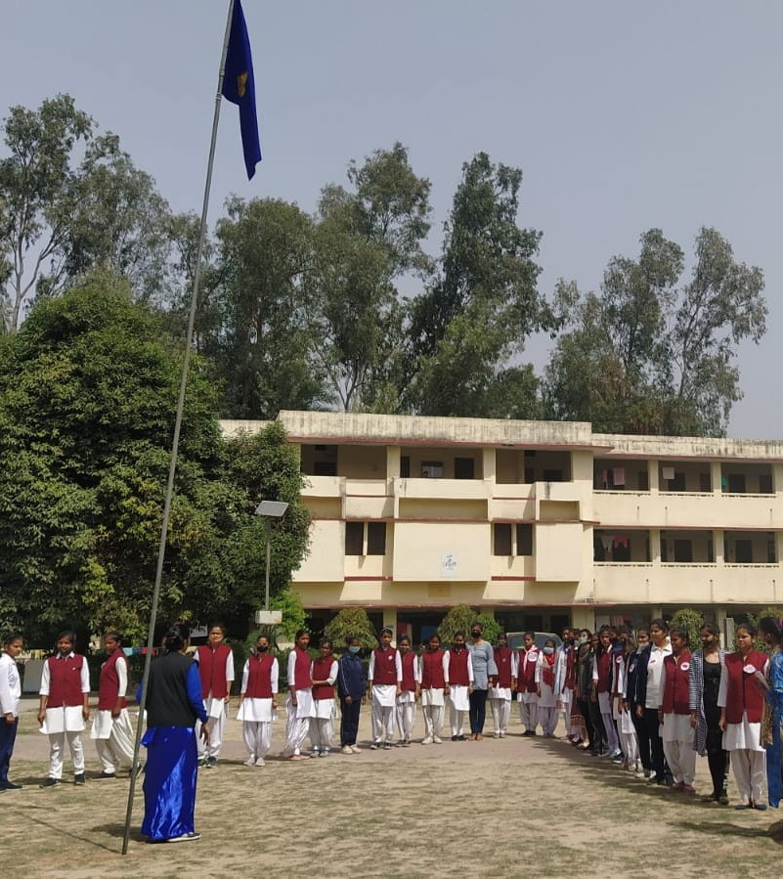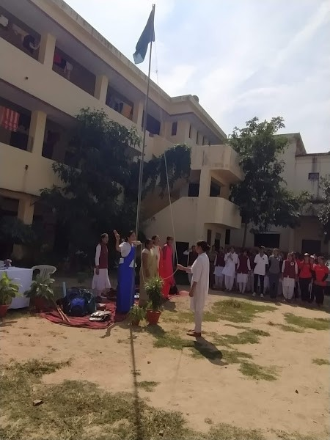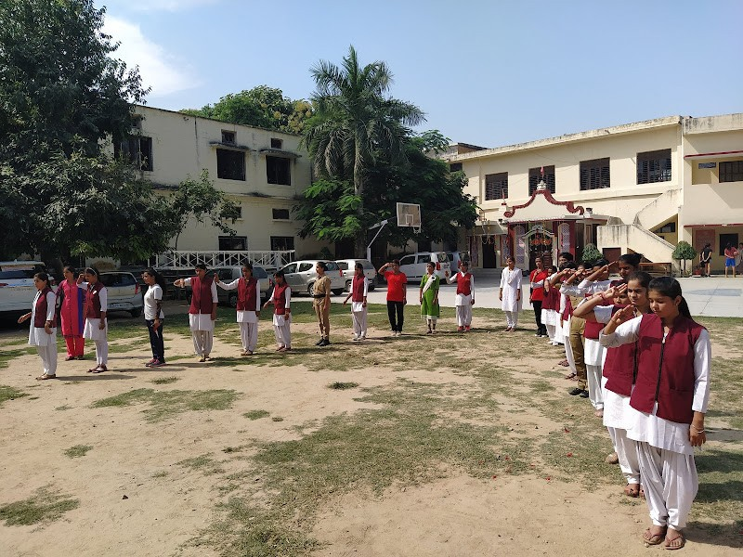
Pravesh Praveen Camp In 2020-21
(14.03.2021 To 16.03.2021 )
Flag Hoisting
Training Of ‘V’ Formation
Prayer Song & Flag Song


2020-2021
Stretcher Making & First Aid Box
Making Gazettes for Tent

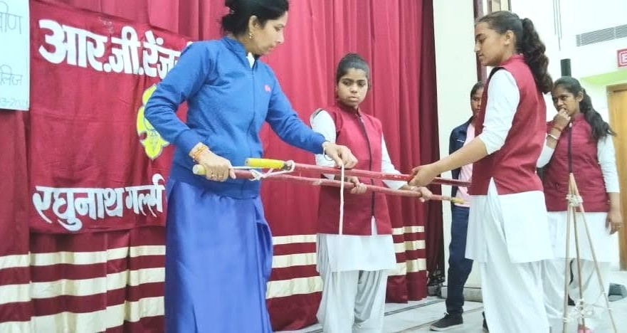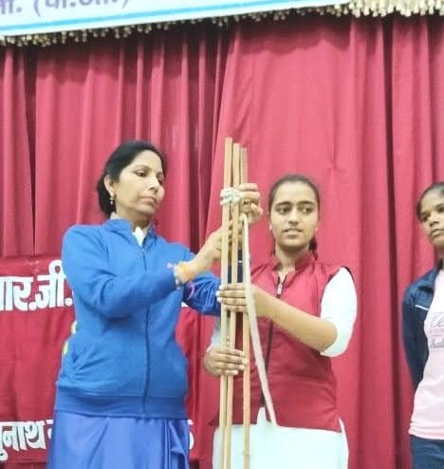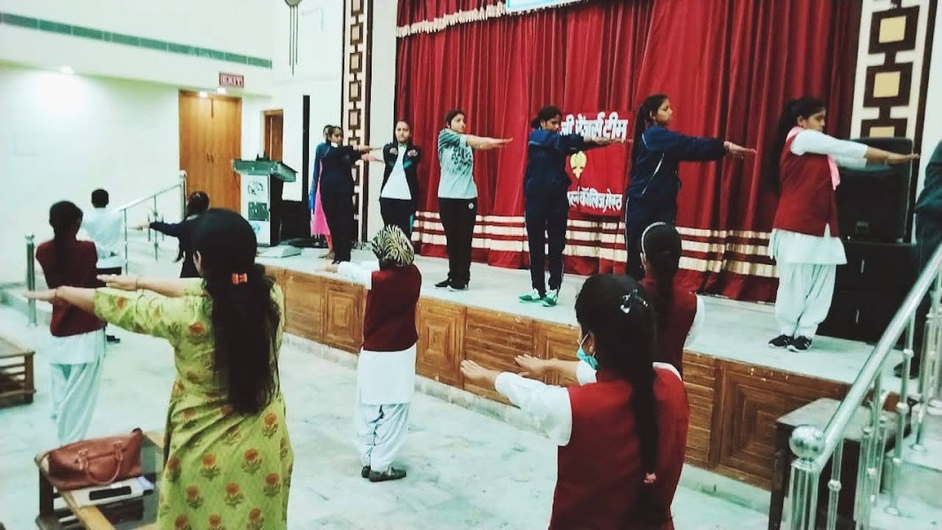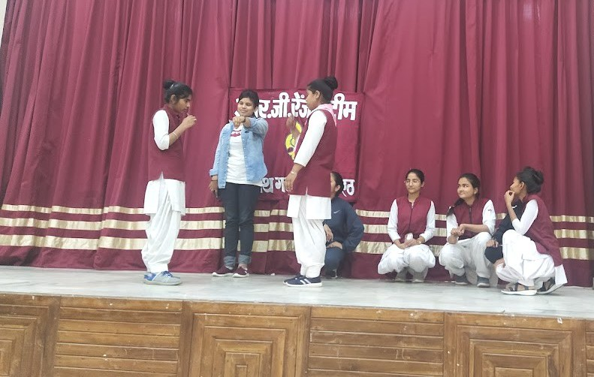
B.P. Six
Exercise
Camp Fire


Knot Making
Basic Information About Scout and Guide
2020-2021

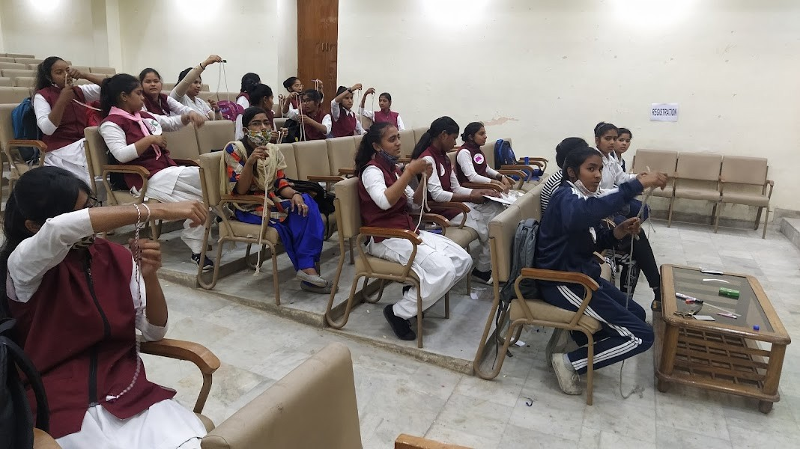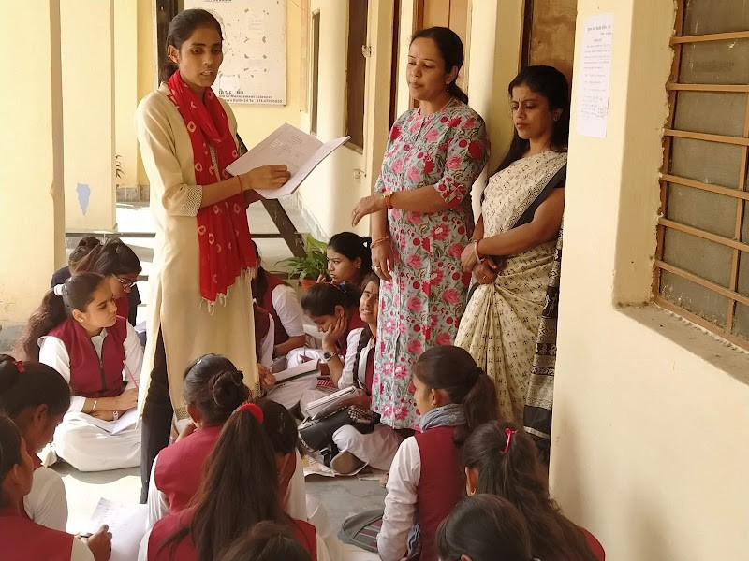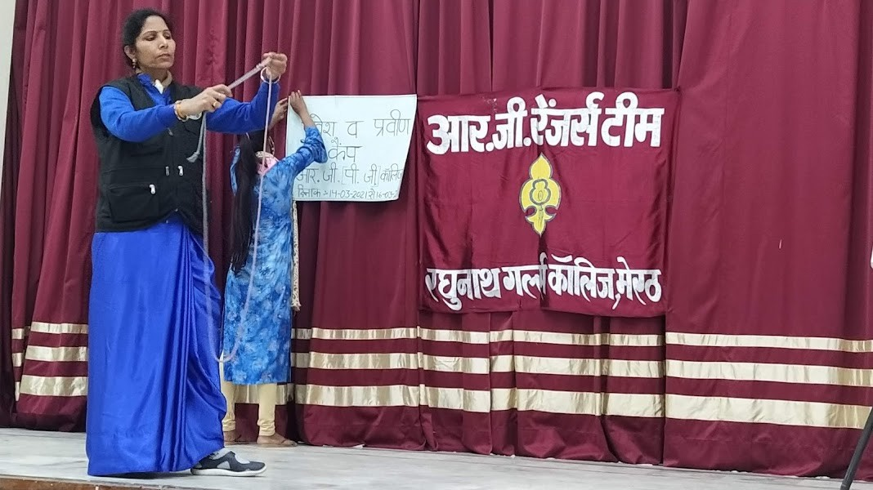

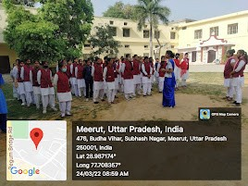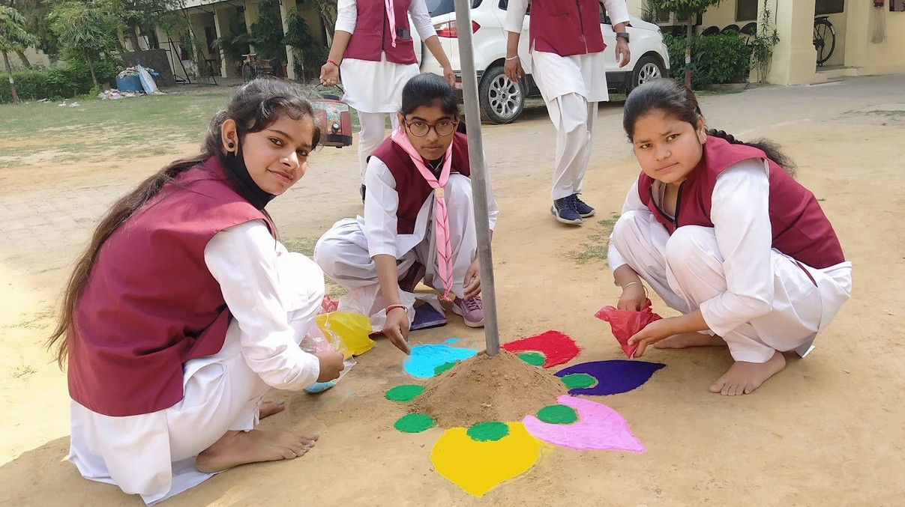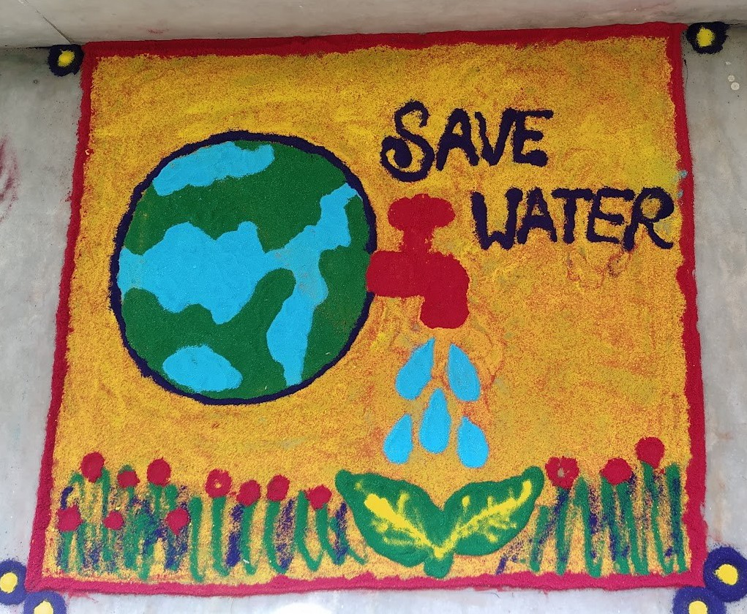
Pravesh Praveen Camp In 2021-2022
(24.03.2022 To 26.03.2022) (100 Rangers Participated)
Flag Hoisting
Rangoli

Welcome of Guest
2021-2022
‘V’ Formation
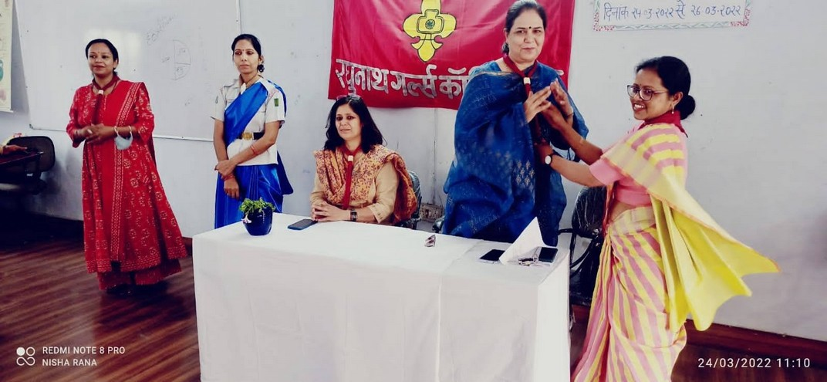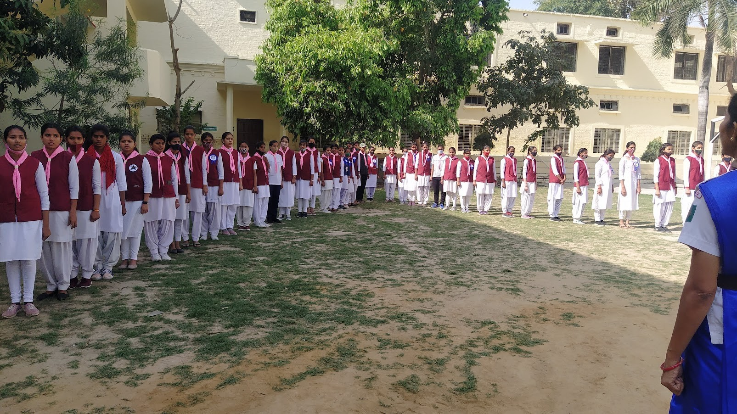

B.P. Six Exercise
Knot Making
2021-2022

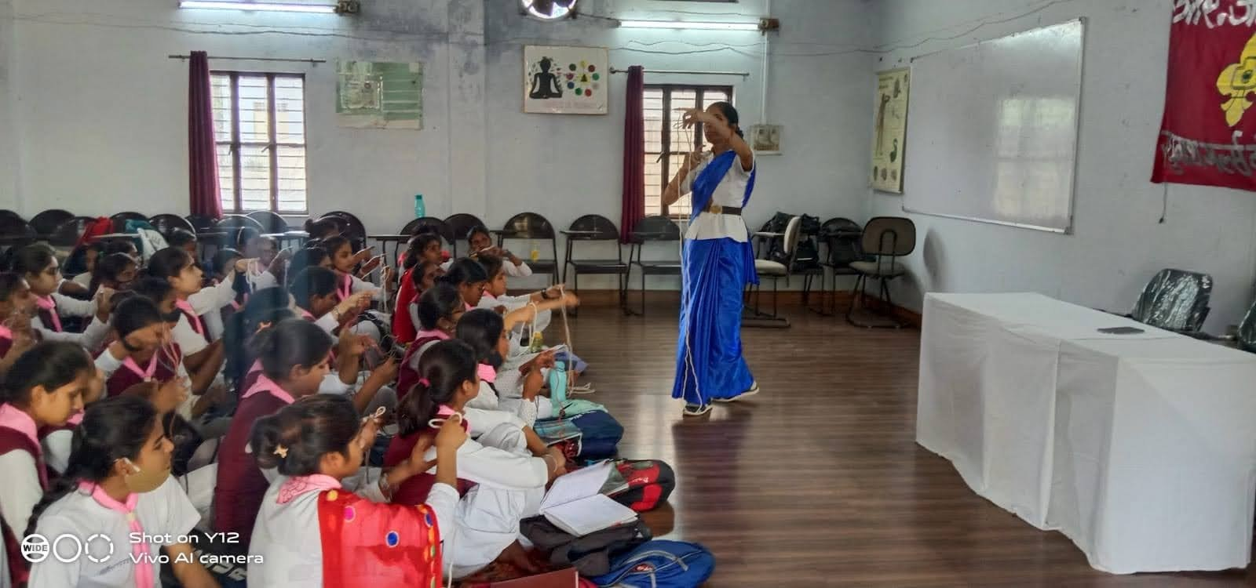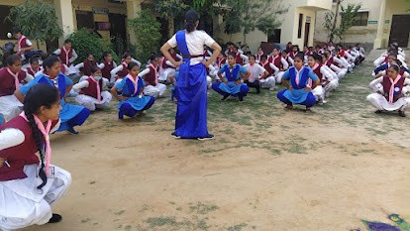


Yoga Session by Mrs. Shikha Sharma
Counselling
by Mrs. Gitika Singhal
Lecture on Colour Therapy by Mrs. Gitika Singhal
2021-2022

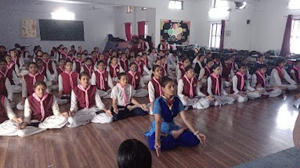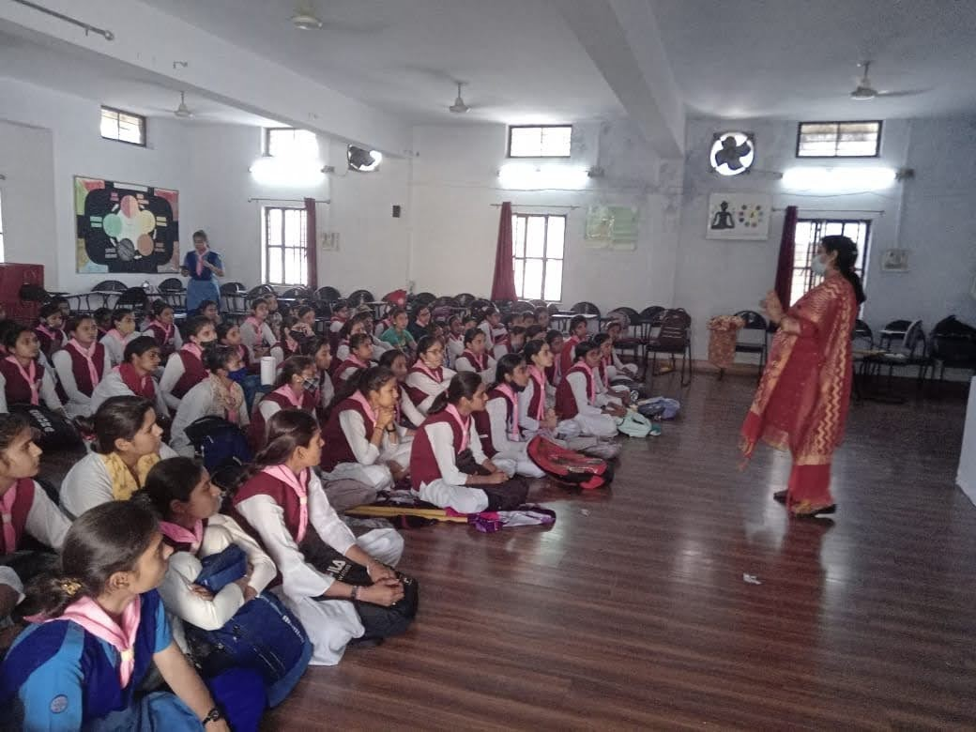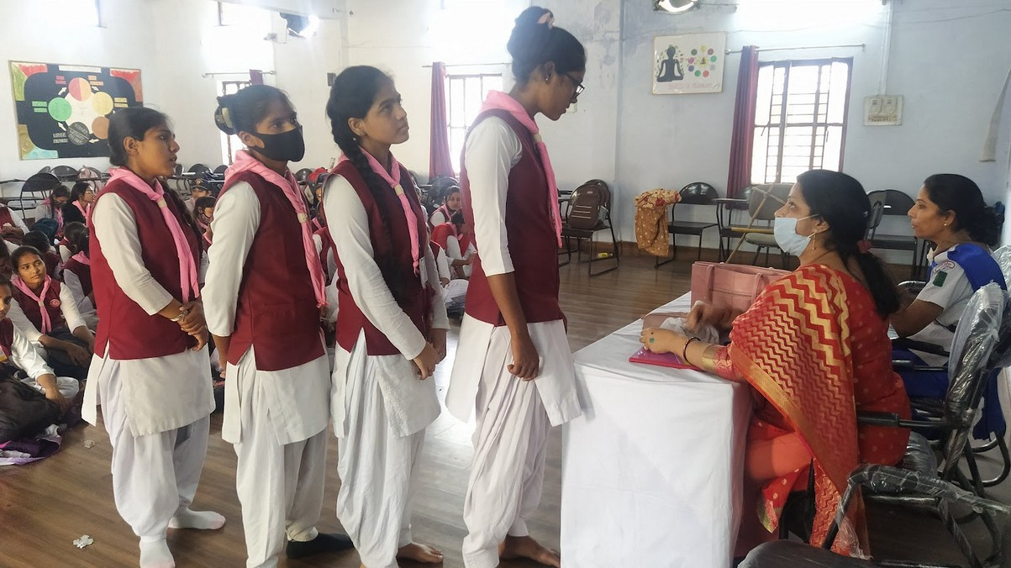


2021-2022

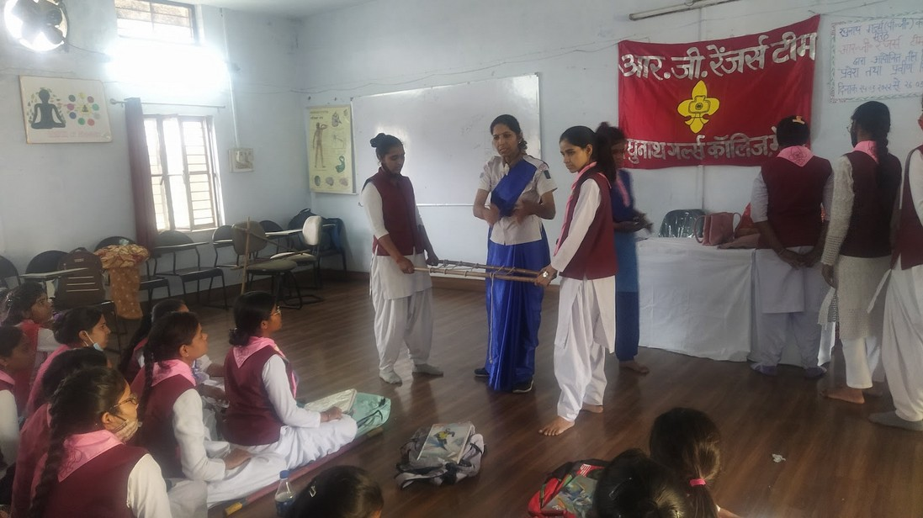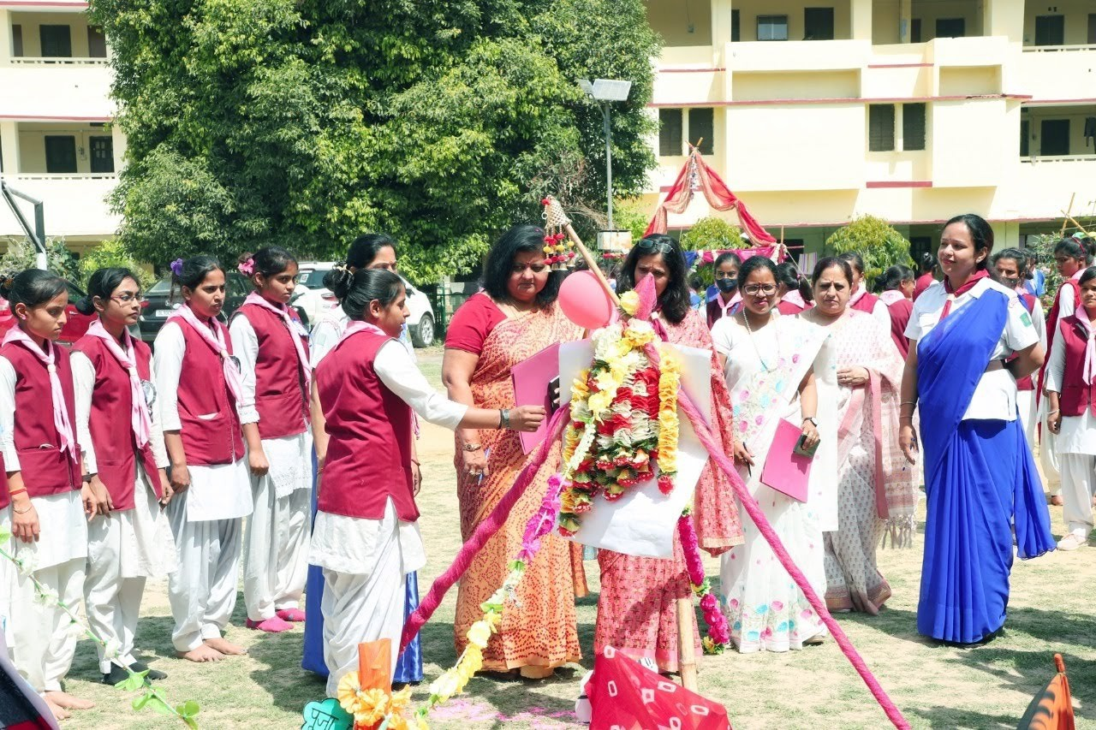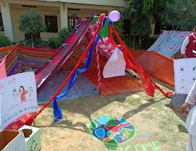
Stretcher Making
Observation of Tent
Tent Decoration

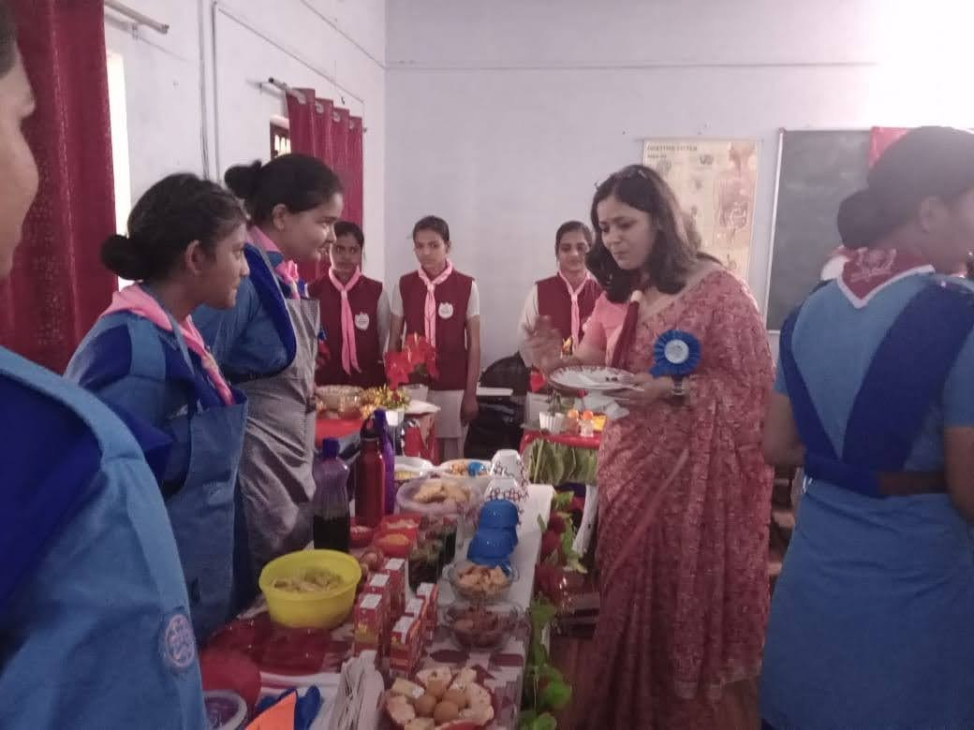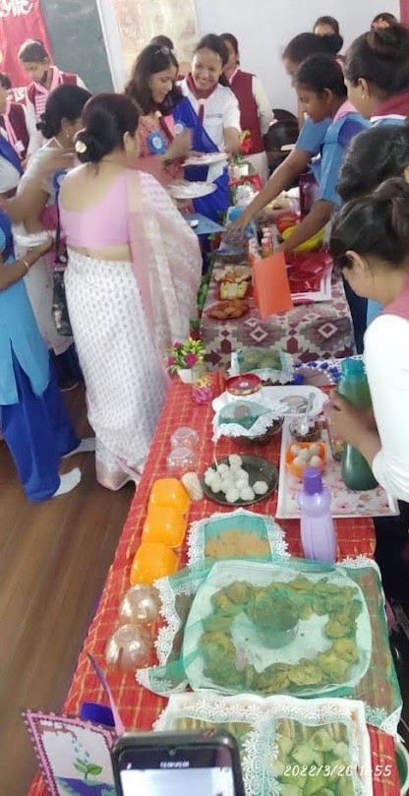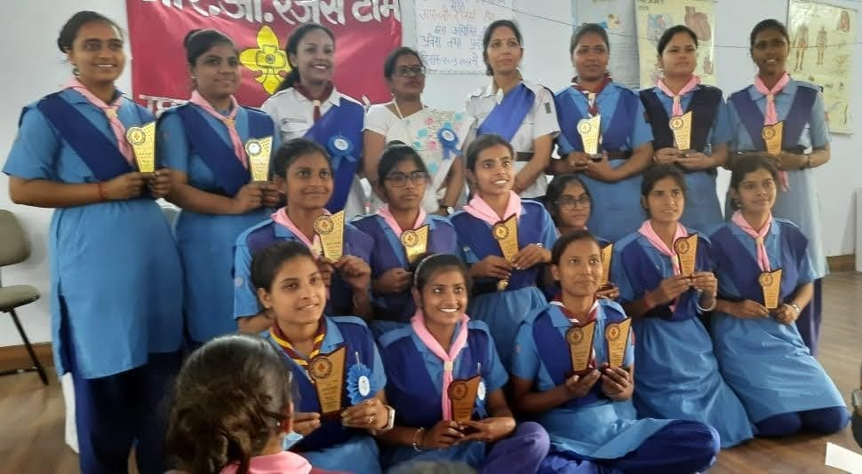
2021-2022
Prize Distribution
Food Plaza


Nipun Training Camps

Nipun camp | DATES | SESSION
Nipun Training Camp | 25.10.2017-27.10.2017 | 2017-2018
Nipun Training Camp | - | 2018-2019
Nipun Training Camp | 30.12.2019- 03.01.2020 | 2019-2020
Nipun Training Camp | 01.02.2021 -05.02.2021 | 2020-2021


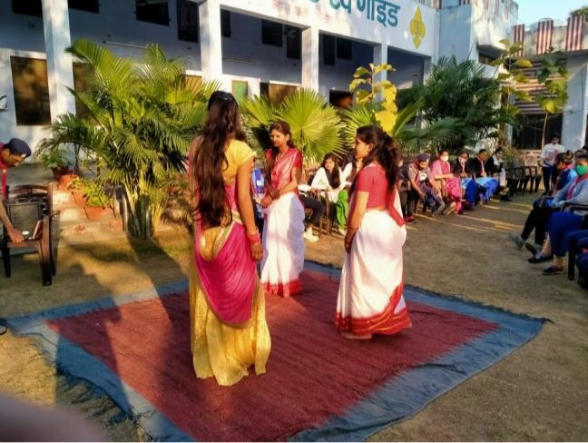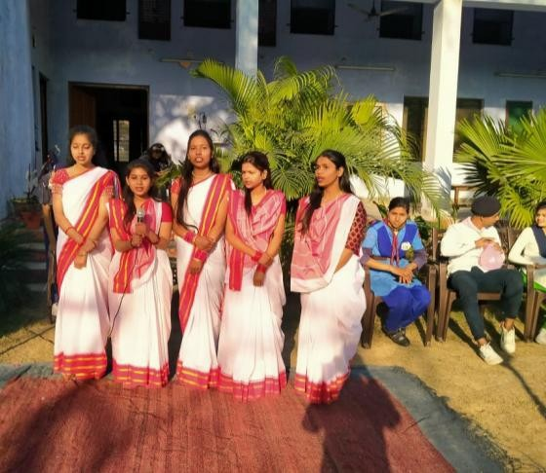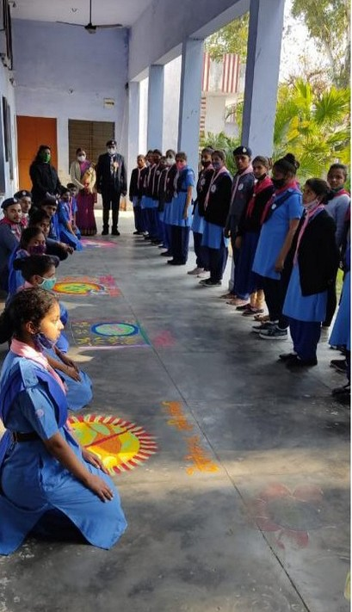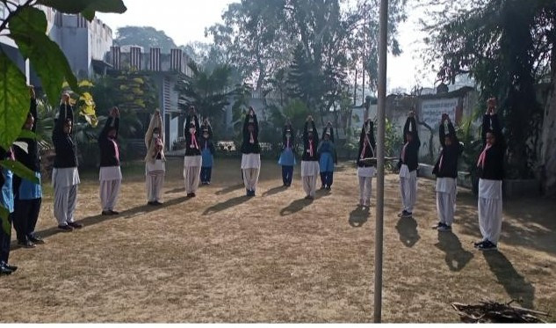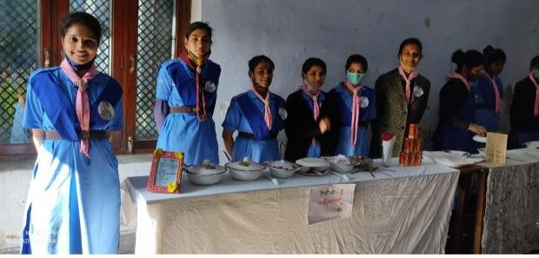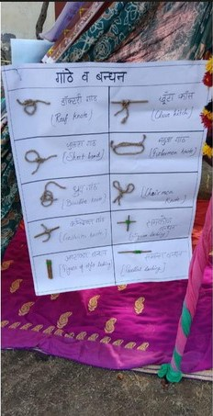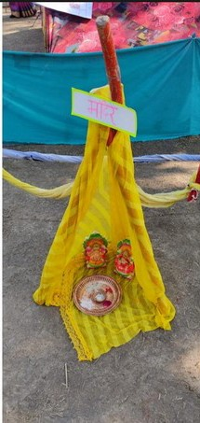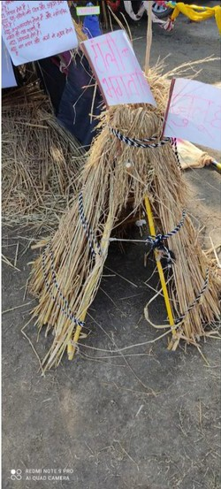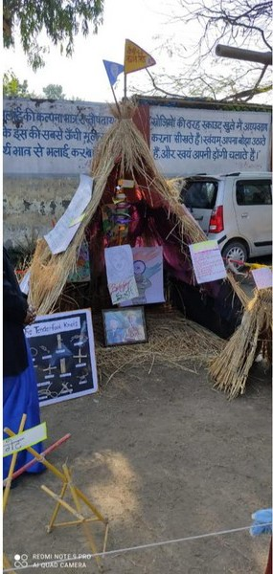
Camp Fire Participation
B. P. Six Exercise
Rangoli Competition
Food Plaza
Tent Making
Gazettes & Knots Making
Nipun Training Camps 2019-2020
26 Praveen Rangers participated
R. G. Rangers team got first position in competition.

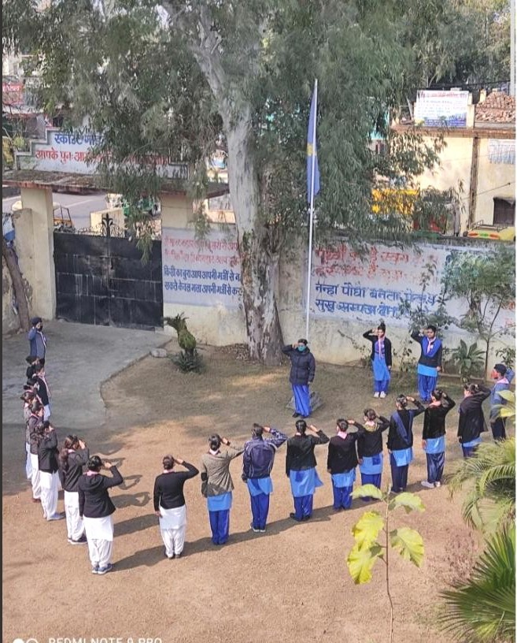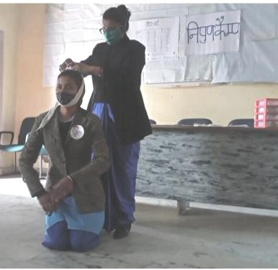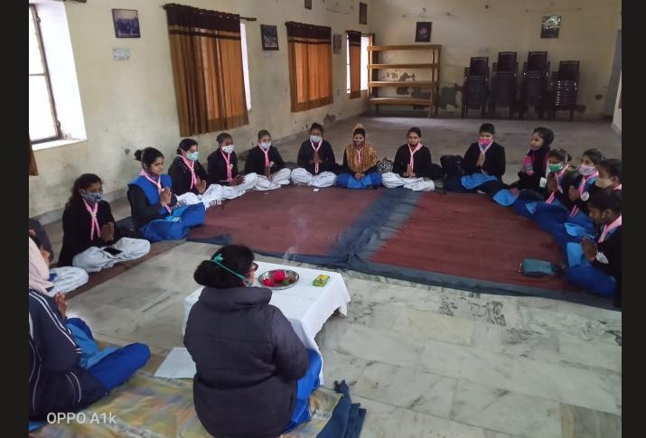
Nipun Training Camp (2020-2021)
01.02.2021 -05.02.2021 (06 Rangers Completed The Camp)

‘V’ Formation
First Aid
Prayer Meet

Rangers participated in Republic Day Parade on 26.01.2020
(Session 2019-2020)
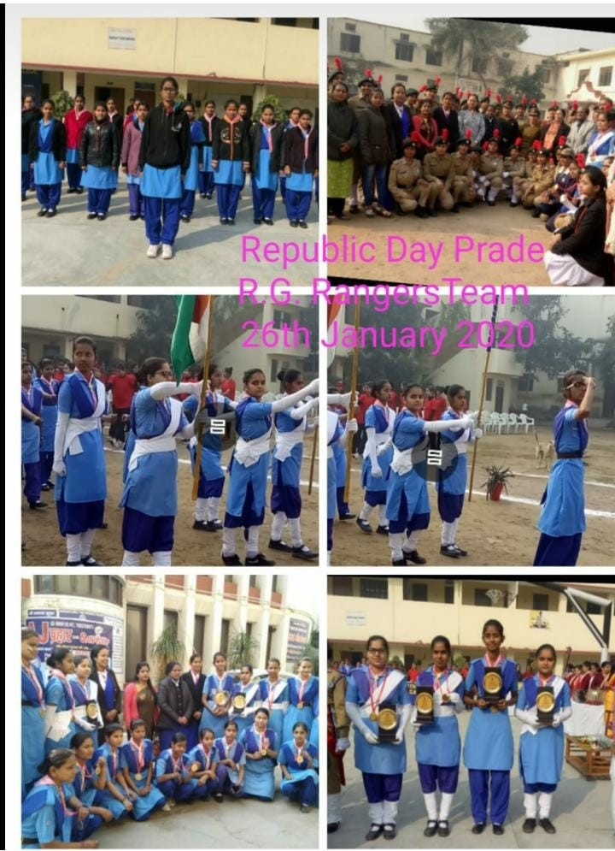

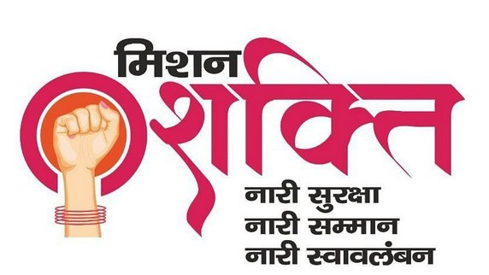
Mission Shakti Programs

Total 21 rangers got seven Days Training Under Mission Sahsi Program Organized By ahhil bhartiya vidhyarthi parishad, conducted by Physical Education Department Of C.C.S. University Meerut. | 01.11.2020 -  07.11.2020.
Poster competition, self defence training , seminar on acupressure and counselling sessions were organized in college premises. | 01.03.2021 to  8.03.2022
Online symposium was organized on the topic Women Self Defence and Cyber Crime | ON 25TH OCTOBER 2020.
13 rangers participated in essay competition on the title “ महि ला"ओं म& उद्यहिमता" का" हि+का"स “ on the occasion of “महि ला" सम"नता" दि/+स” on 26.08.2021 organized by Mission Shakti Team. | on 26.08.2021

Mission Shakti Programs

- R. G. Rangers team organized counselling session on “Menstrual Cycle and Personal Hygiene” by Dr. Pallavi Rastogi (Acupressure & Naturopathy expert) under mission Shakti Campaign. (10 Rangers participated) | on 28.08.2021
- 15 days computer training program was organized by R. G. Rangers team for Rangers under Mission Shakti Campaign. 28 Rangers participated | from 20.09.2021 till  06.10.2021
- R. G. Rangers team organized invitation card and poster competition on the topic “चु1प्पी4 ता5ड़ो5 खु1लाकार बो5ला5 “ under Mission Shakti. 12 + 13 Rangers participated. | on 28.10.2021

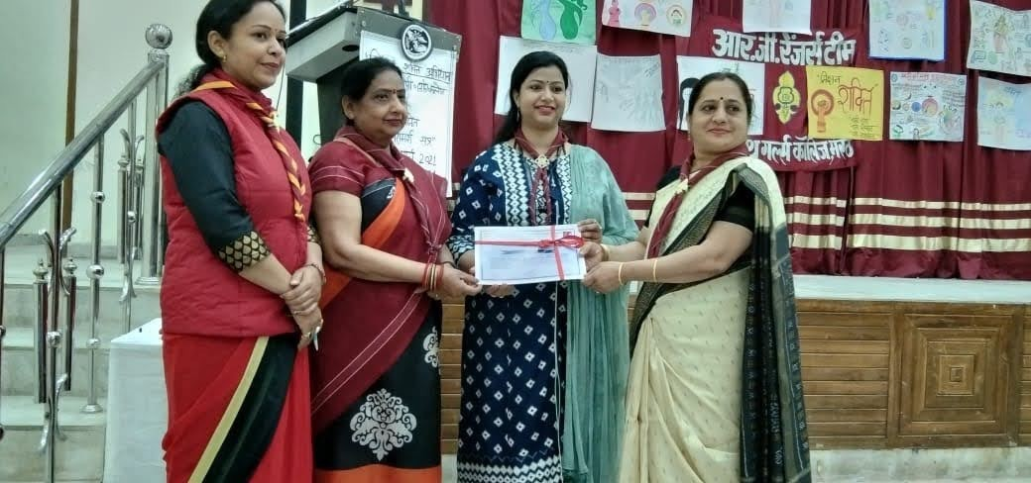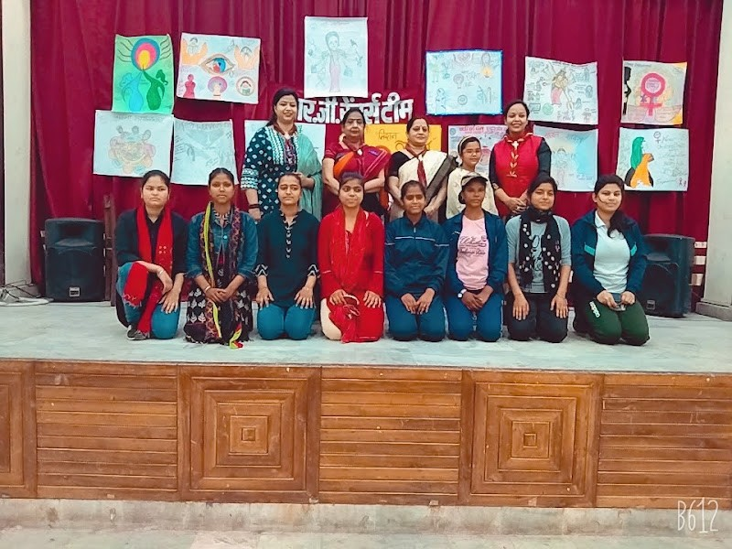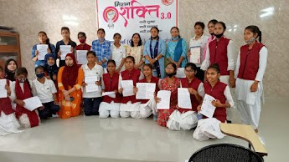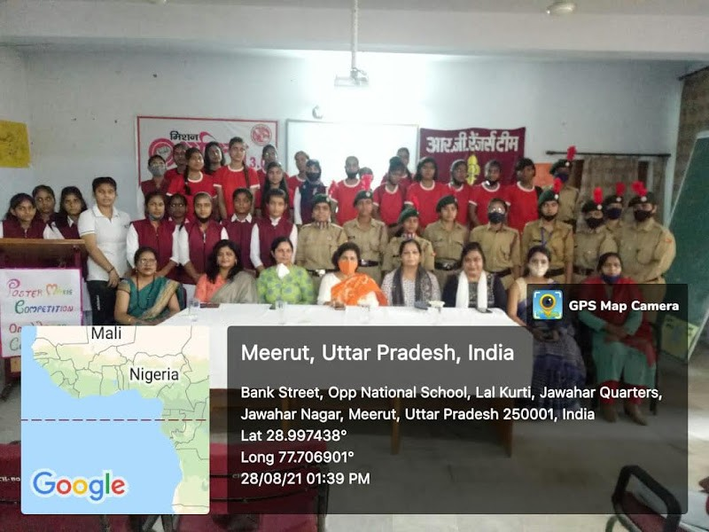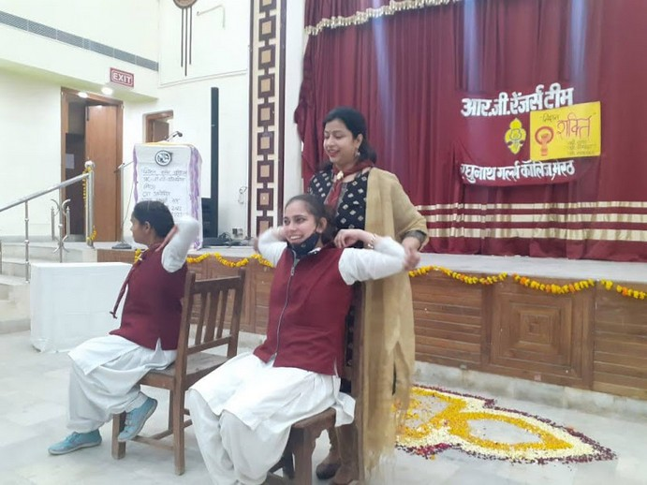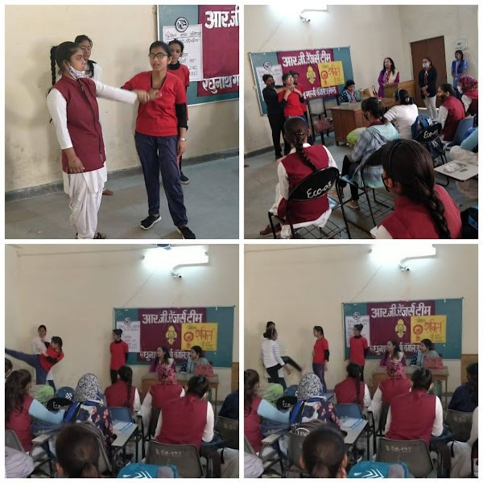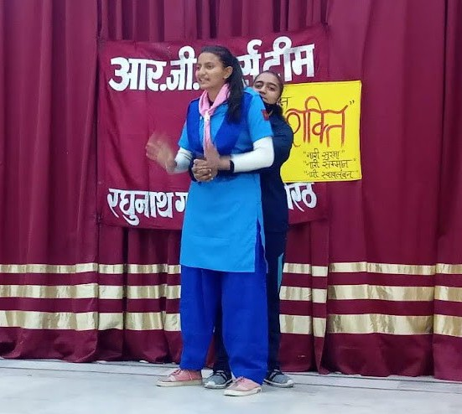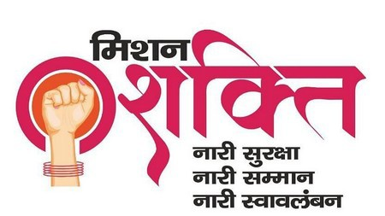
Organized from 1 March to 8th March 2021

POSTER COMPETITION

SEMINAR ON ACCUPRESSURE AND COUNSELLING SESSIONS

SELF DEFENCE TARAINING

ESSAY COMPETITION


MEDIA COVERAGE
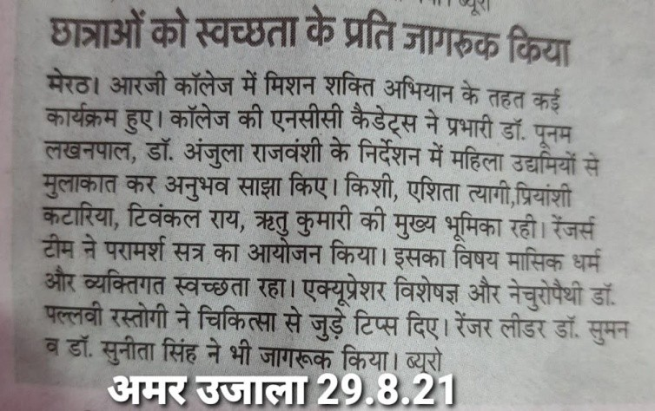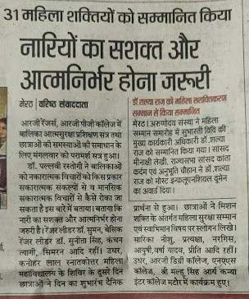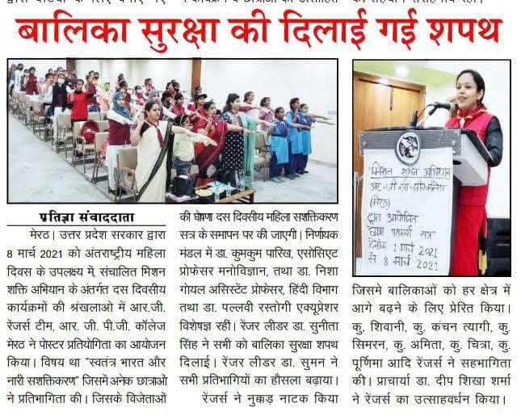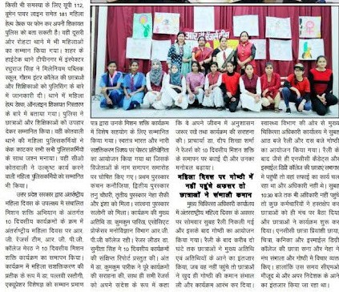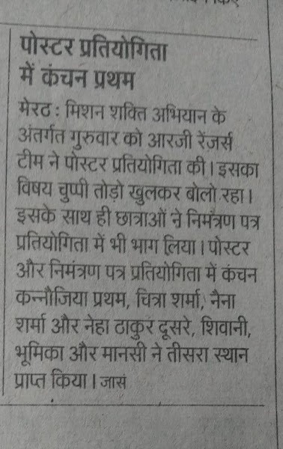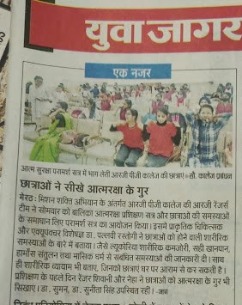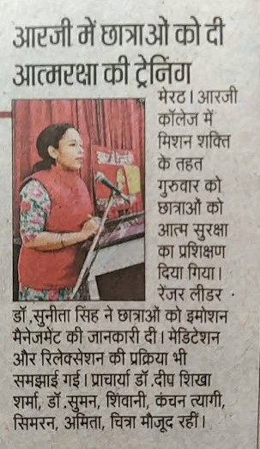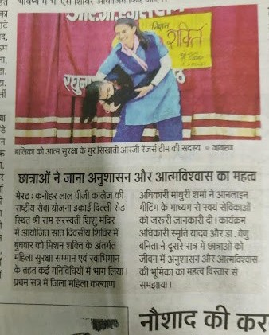

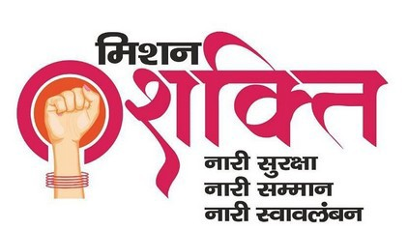
Online symposium was organized on the topic “Women Self Defence and Cyber Crime’ on 25th October 2020.

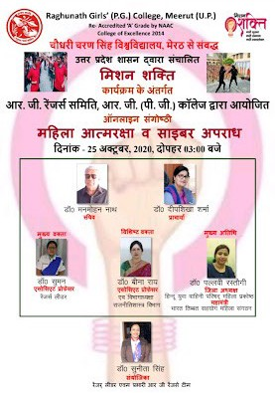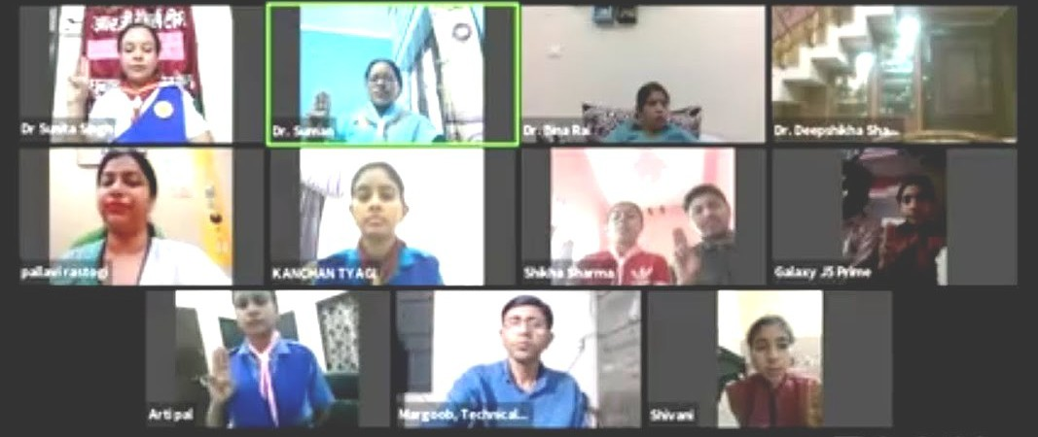


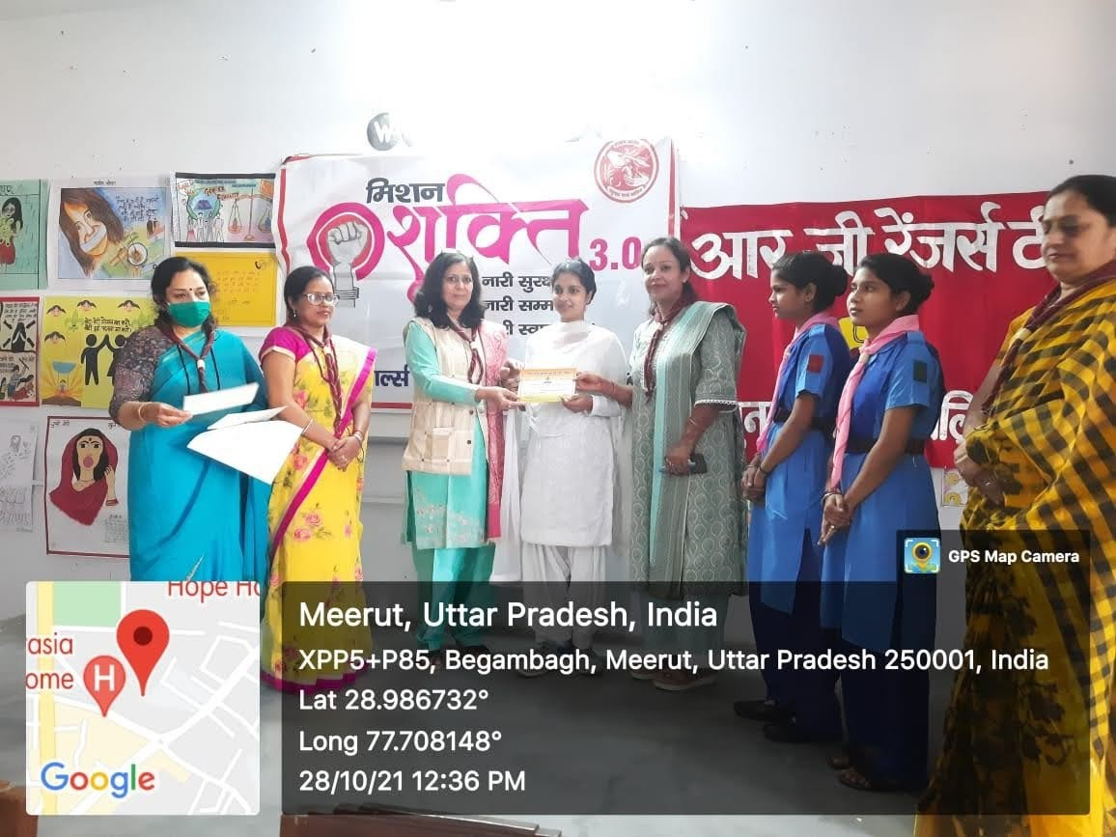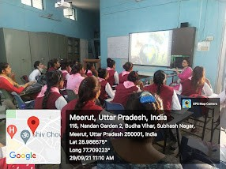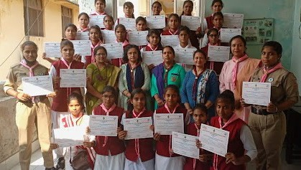
15 days computer training program was organized for rangers from 20.09.2021 till 06.10.2021
Invitation
card
and
poster
competition on the topic “चु1प्पी4
ता5ड़ो5 खु1लाकार बो5ला5 “ under Mission Shakti On 28.10.2021


R. G. Rangers’ Team at State Level

Program | Date | Number of Rangers
State Guide Rally | (20.2.2017 & | 06 R. G. Rangers
(Moradabad). | 24.2.2017) | participated in the Rally

R. G. Rangers’ team organized National level Essay Competition on 03.02.2020

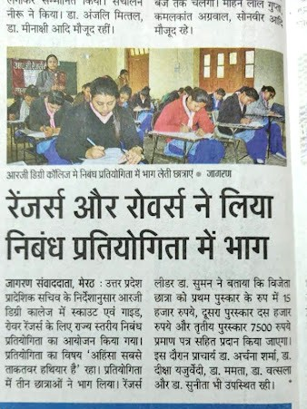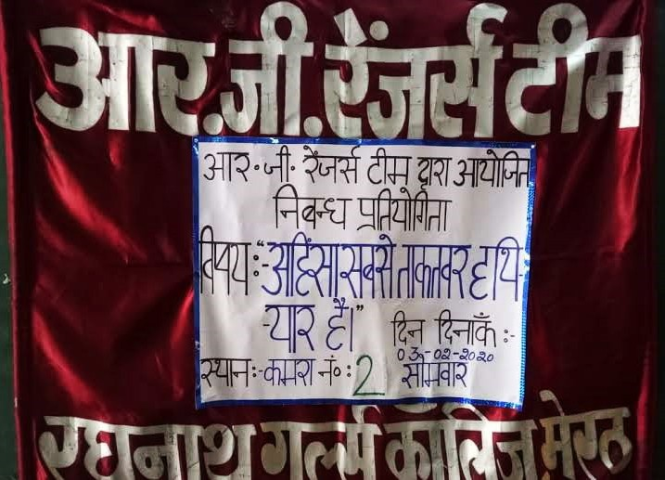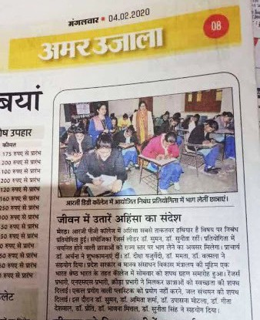

Organized International Camp on The Occasion of “International World Peace Day” on 21.09.2021

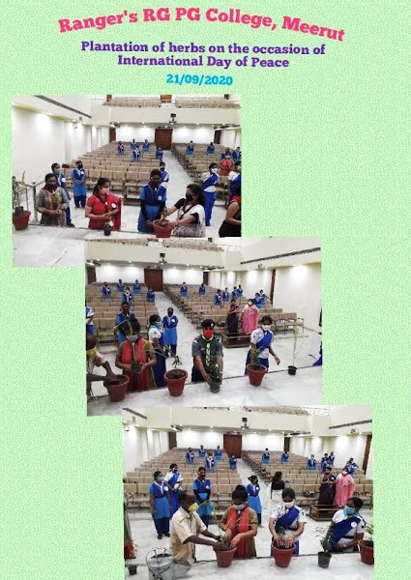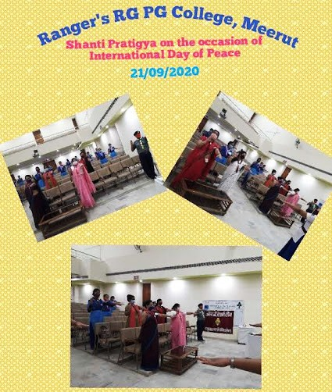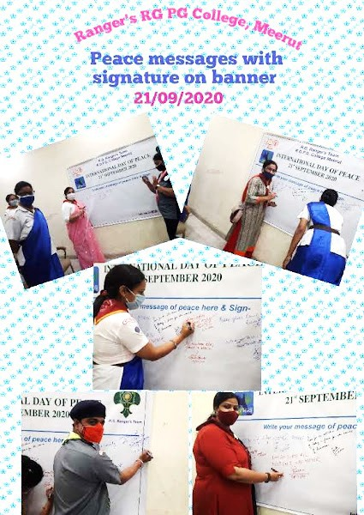

Ranger Ms.
Chanpreet Sang Shanti Geet.
Online symposium on Peace Starts from Us.
Peace Message was broadcasted on 90.4 FM radio on 22.09.2021.
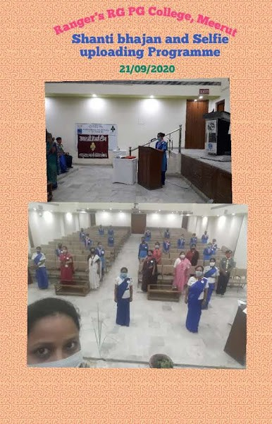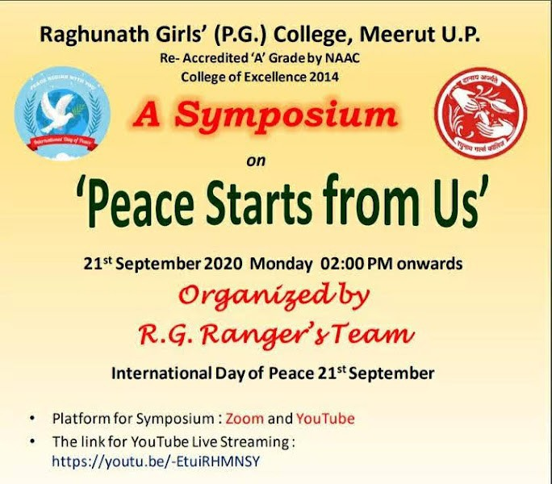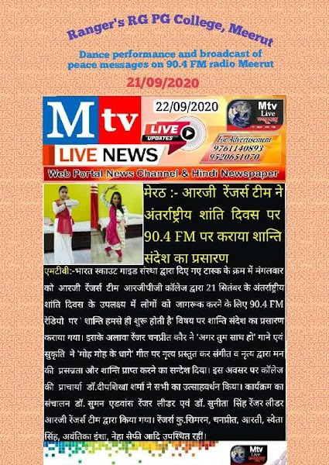

Online talk was organized on “Yoga and Stress” by Acharya Himanshu Gupta on 24.09.2020

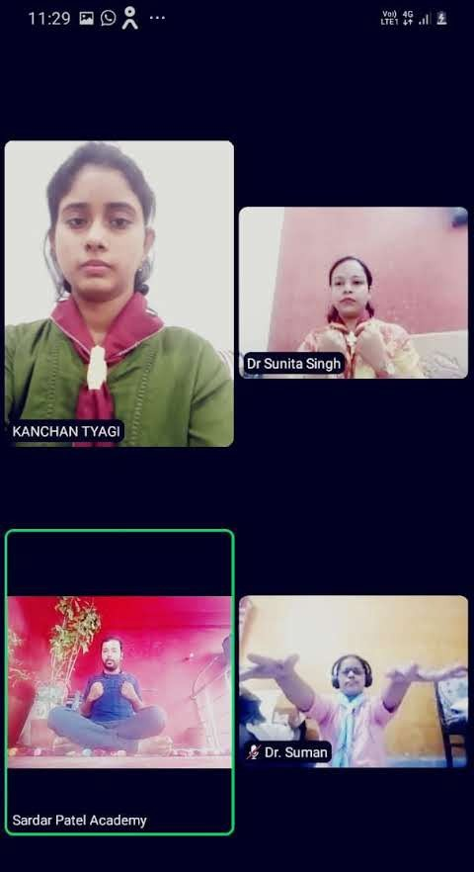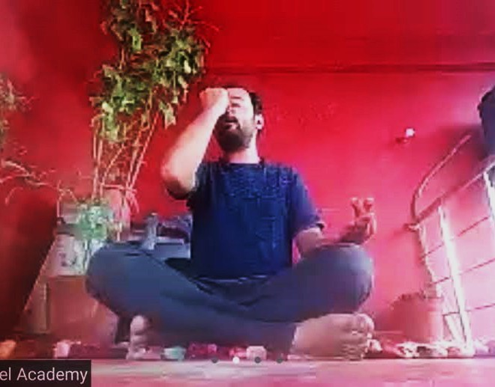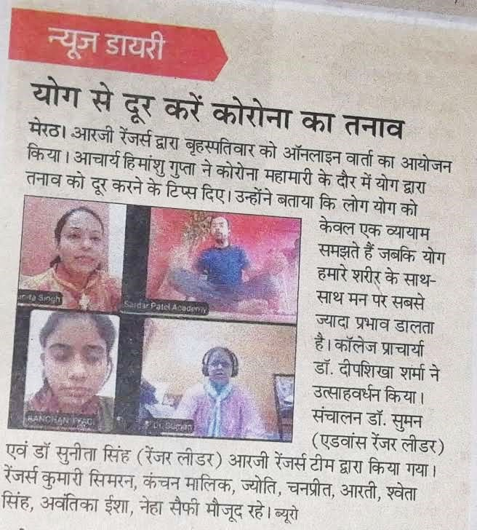

Ranger Km Kanchan and Km. Saloni participated in the International Online Activity Program conducted by Bharat Scout And Guide National Headquarter on 29th December 2020
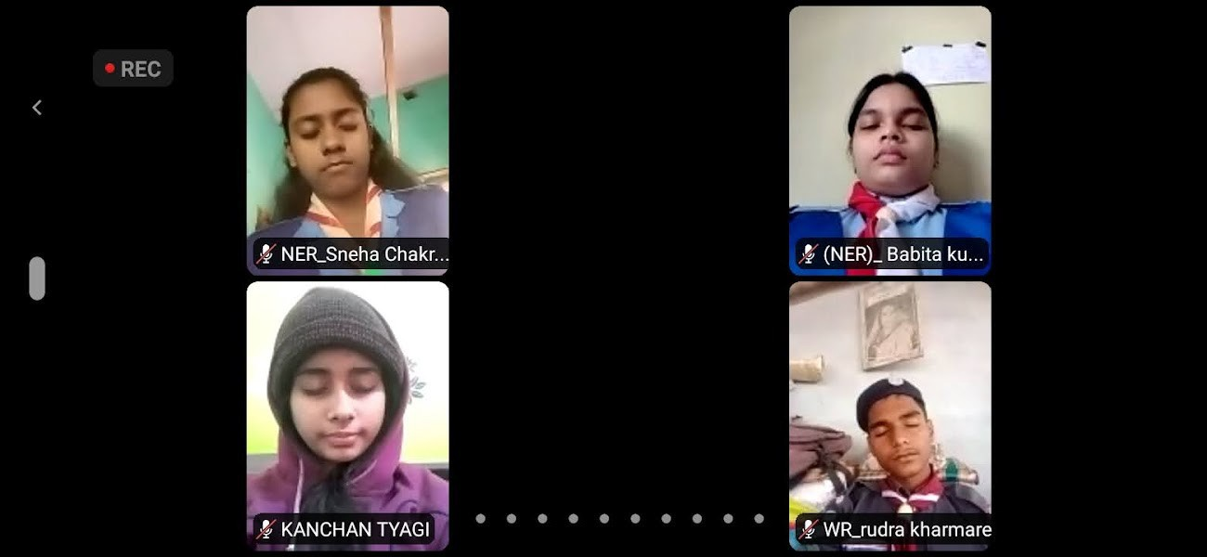
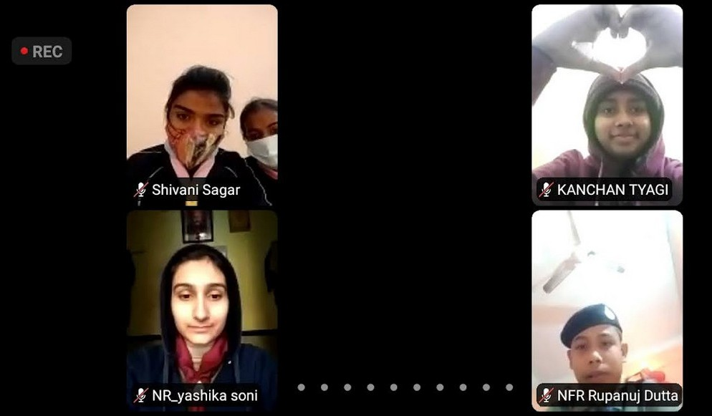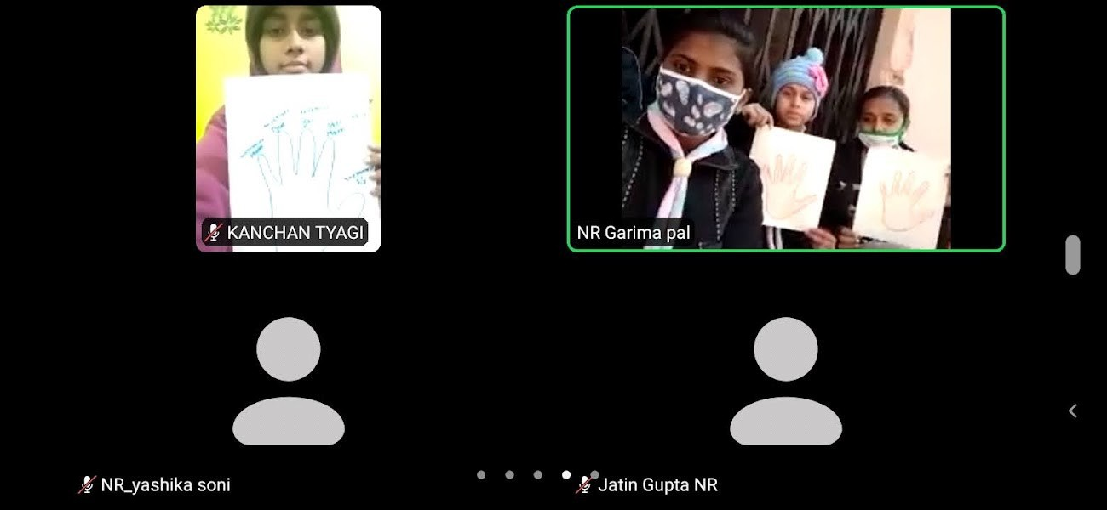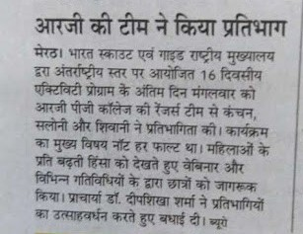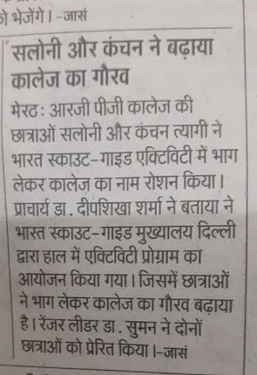

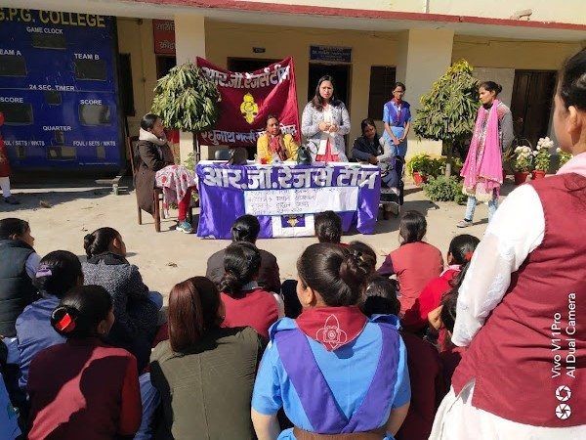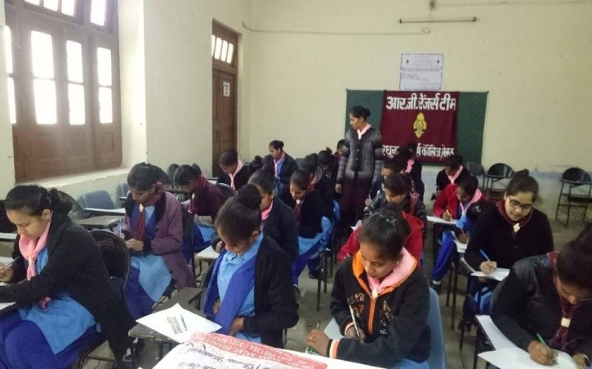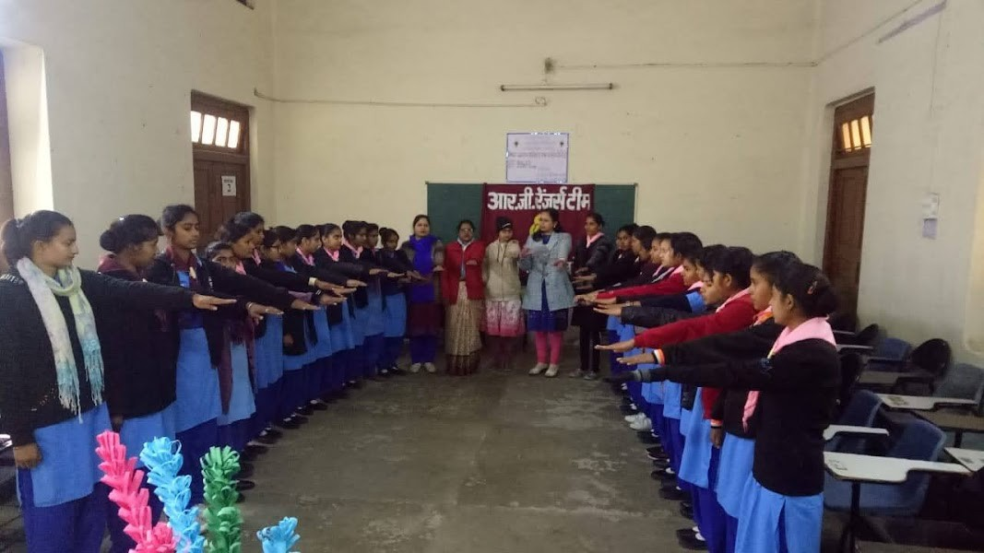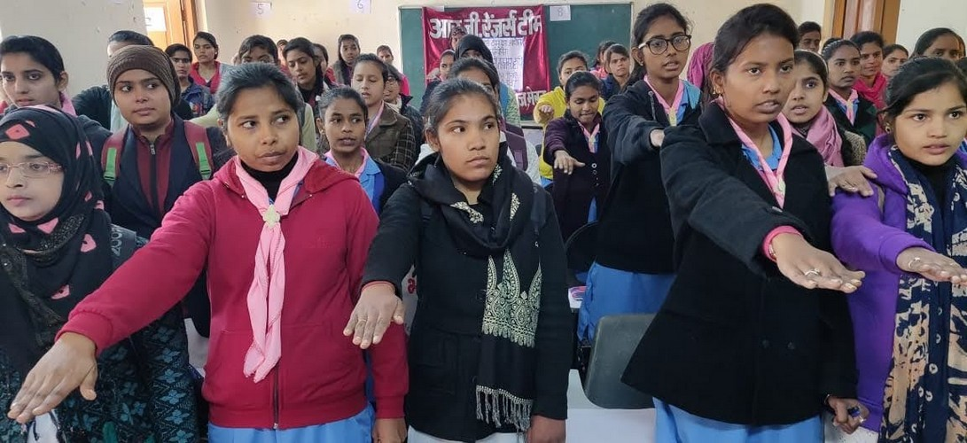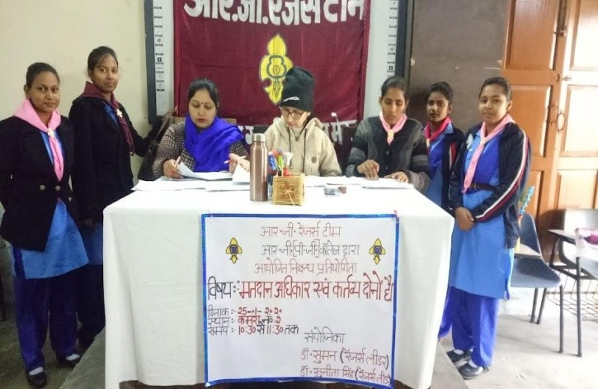
Talk 23.01.2020
Essay competition 25.01.2020
Oath 25.01.2020
Voter Awareness Programs




Awareness Programs for Environmental Safety

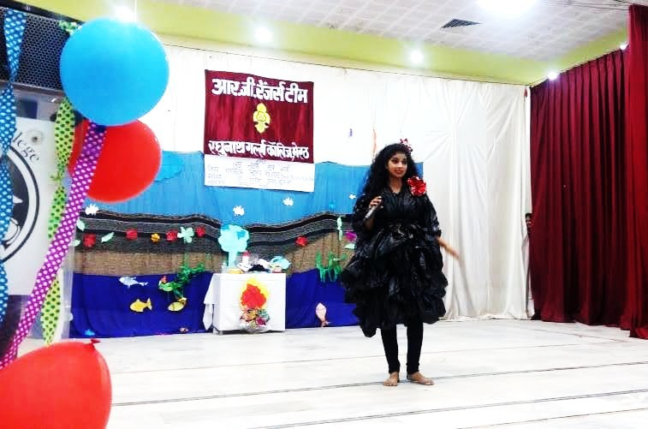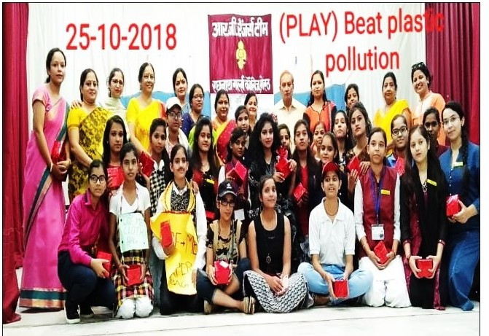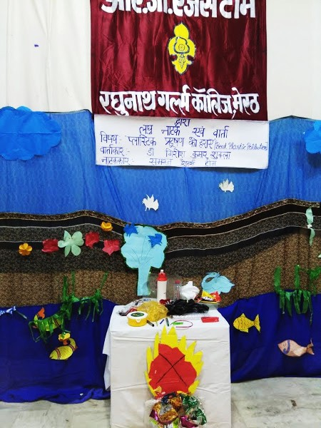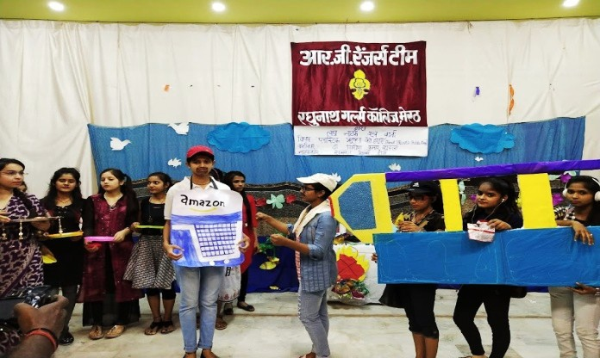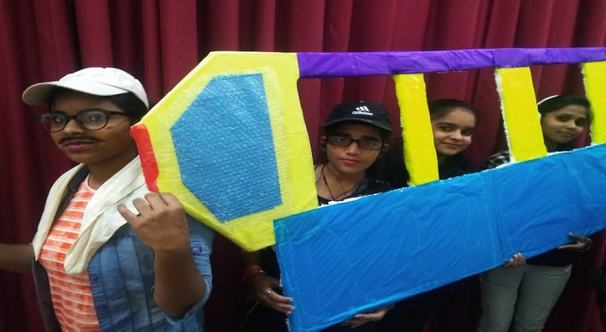
Play on ‘Beat Plastic Pollution’ on 25.10.2018.

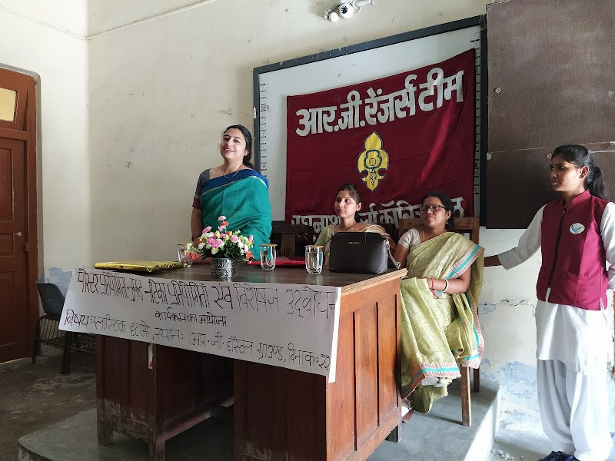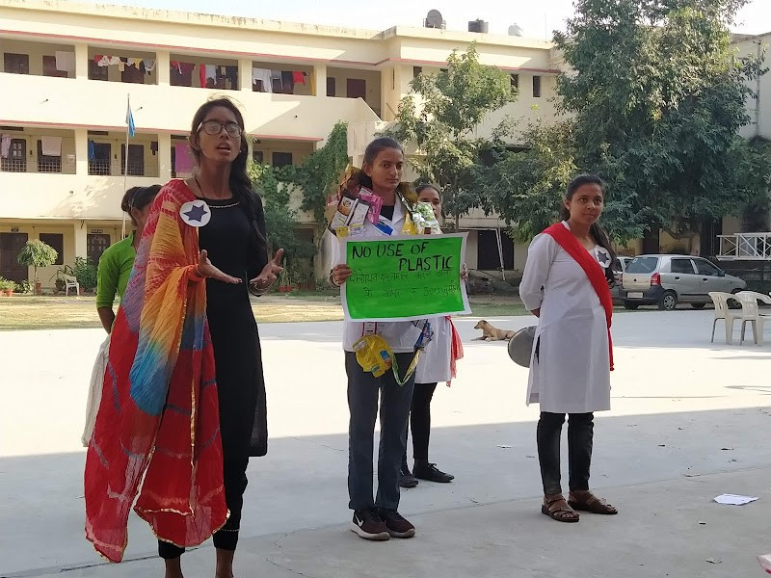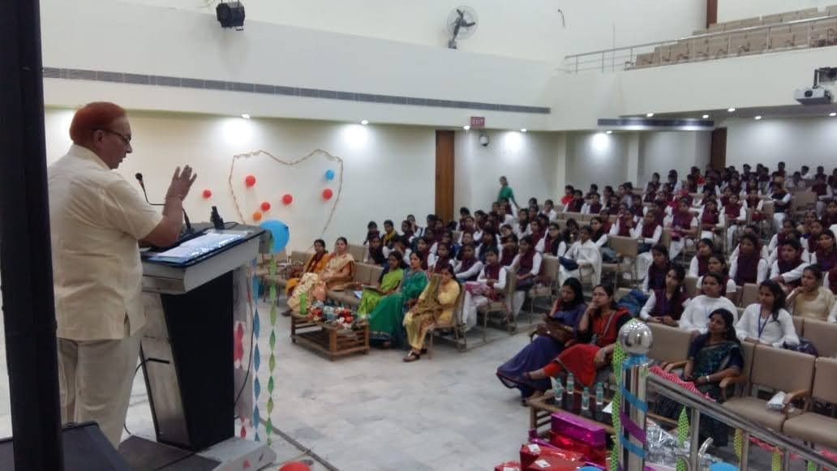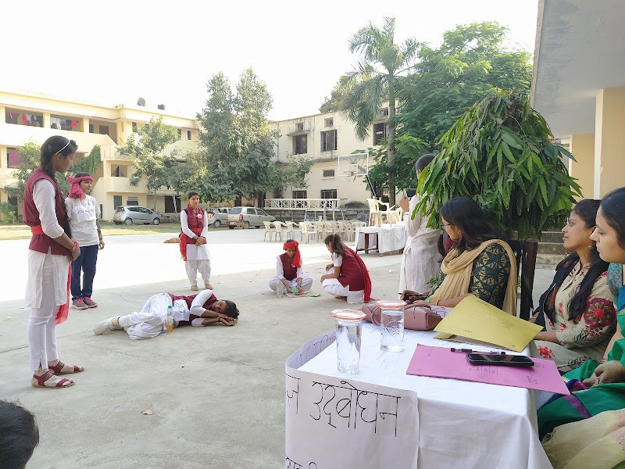
Talk on Stop Using Plastic (25.10.2018)
Nukkad Natak on ‘Stop Using Polythene’

Talk on Stop Plastic


Environmental Safety Awareness Programs from 5.7.2019 till 9.8.2019

Plantation

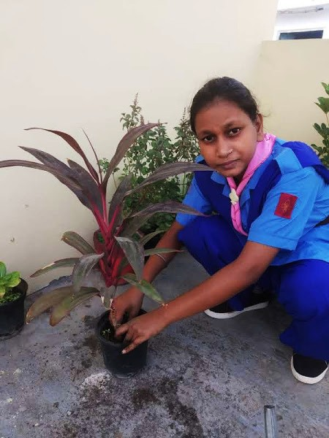 | 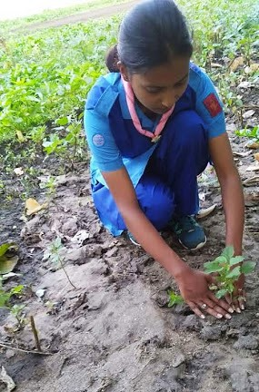 | 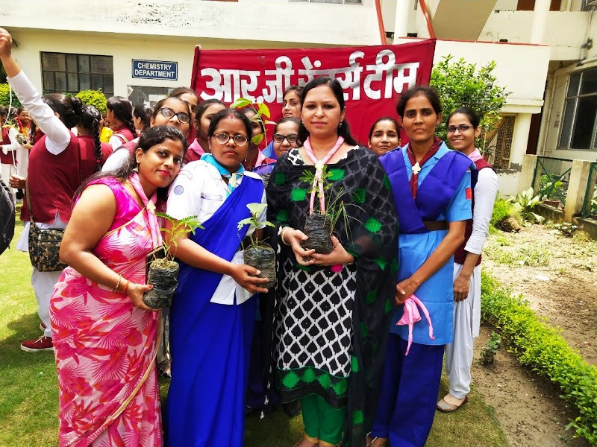 | 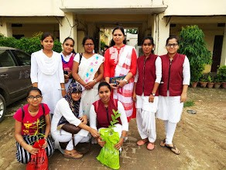


Plantation Distribution Program
05.07.2022
34 Rangers Received Plants and did Plantation.
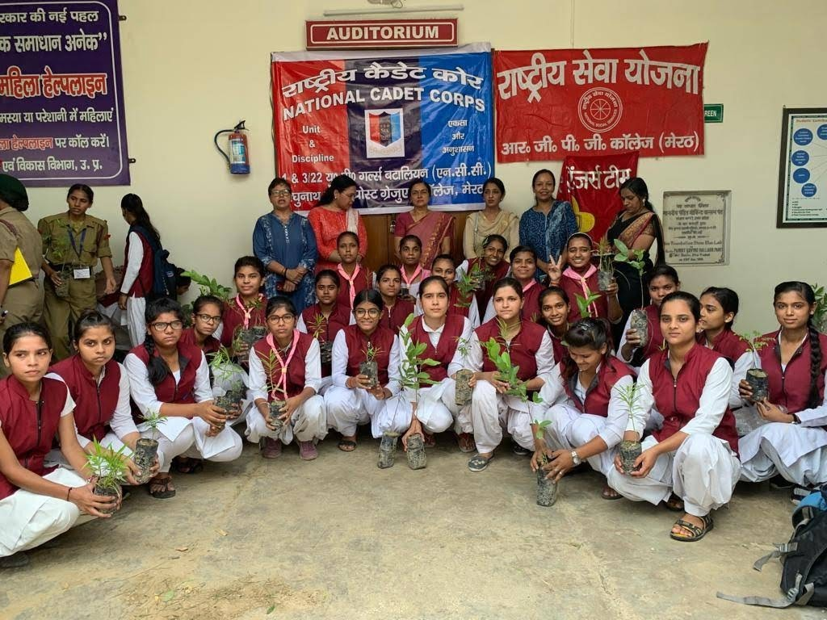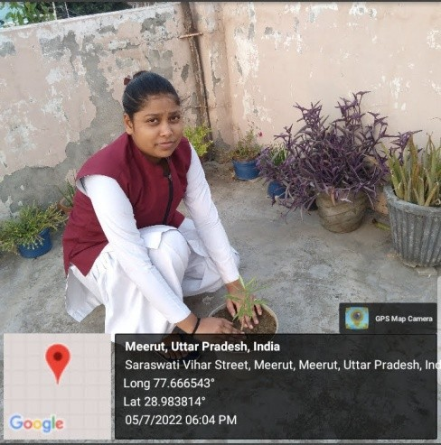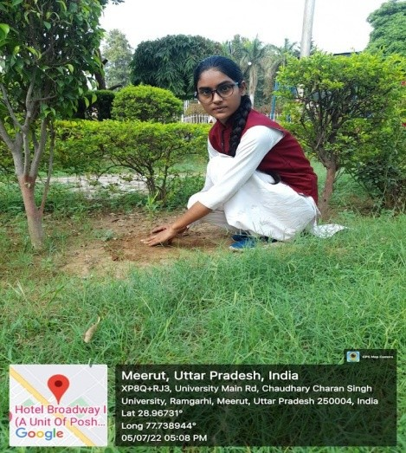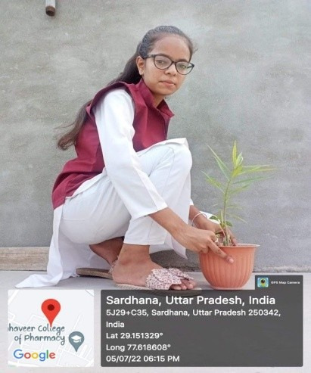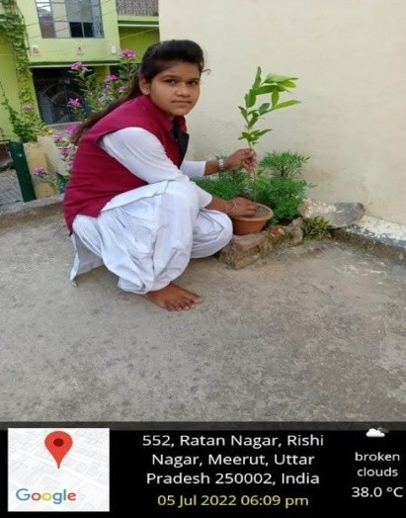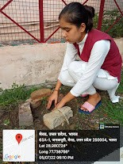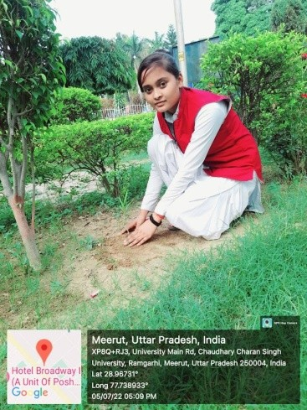

Future plans
- Trained Rangers have great potential to achieve Rastrapati award , National and International awards.

- To provide technology based training programs for updating rangers .

- Rangering is already a student centric co-curricular activity but efforts would be to reframe rangering activities (NEP 2020).

Message : Spread Peace On Earth





THANK YOU

