Curriculum vitae
Photo 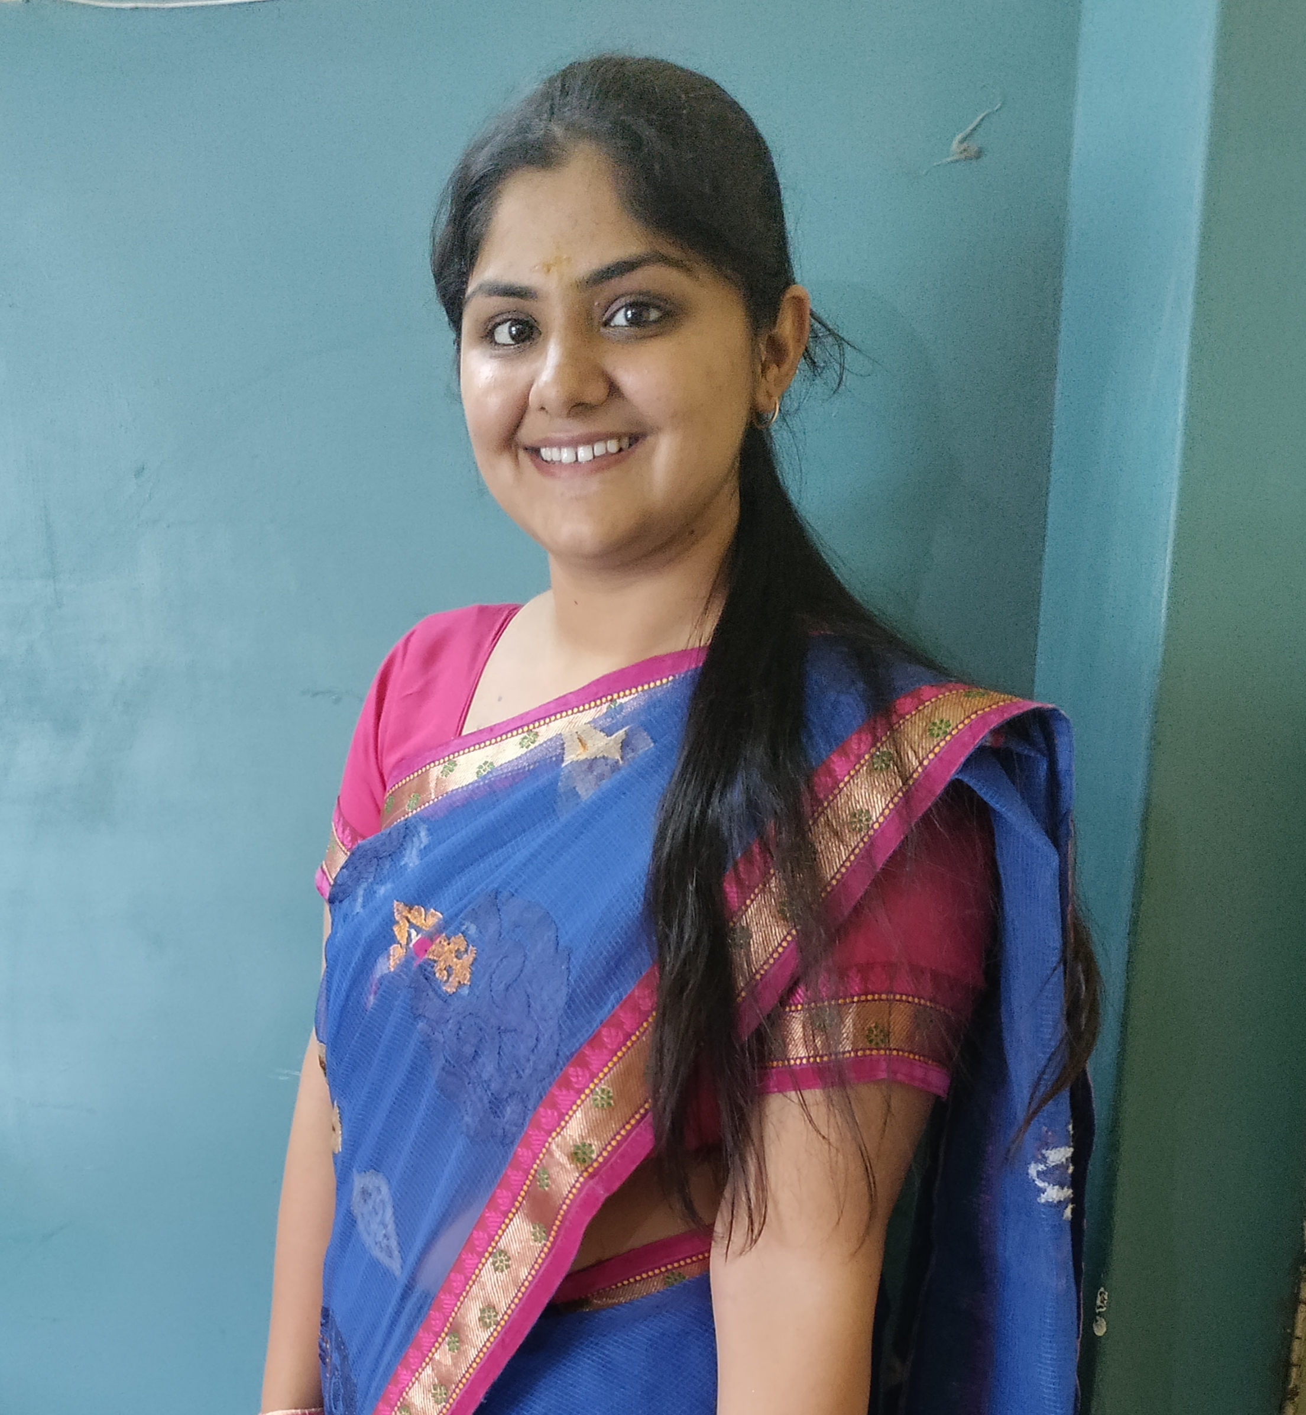

1.Name: MS. DIVYA BHARDWAJ
2.Designation: ASSISTANT PROFESSOR
3.Subject: GEOGRAPHY
4.Academic Qualifications: M.A. ; B.Ed.
5.Areas of interest/Specialization: ENVIRONMENTAL GEOGRAPHY, RESOURCE MANAGEMENT
6.Date of Birth: 04-10-1998
7.Date of Joining: 07-08-2023
8.Experience:
9.Official Address: 459/7 NEHRU NAGAR , GARH ROAD, MEERUT.
10.Contact no. : +917668341837
11.Email: bhardwajdivya0410@gmail.com
12.Areas of research: STUDY OF URBAN SPRAWL OF GHAZIABAD CITY.

27. Seminar/ Workshop/ Conference Attended:
S.No | Detail of the Conference/ Seminar | Organizer & Sponsor | Date(s) of the event | Venue of the event | International/National/ State/ University
1. | G-20: INDIA’S ACHIEVEMENTS IN INTERNATIONAL POLITICS | MAA SHAKUMBHARI UNIVERSITY,SAHARANPUR | 27-09-2023 | ONLINE | STATE

32.Future plans:
My future plans include having a job that I enjoy in working ,maintaining a good work, -life balance, fostering good relationship in both work and personal life and enjoying the up comings and goings of each day. Ofcourse, I plan to continue working on my language skills, because I want to become better at my work.

