**Curriculum vitae**

1. Name: Dr.Sushma Gaur 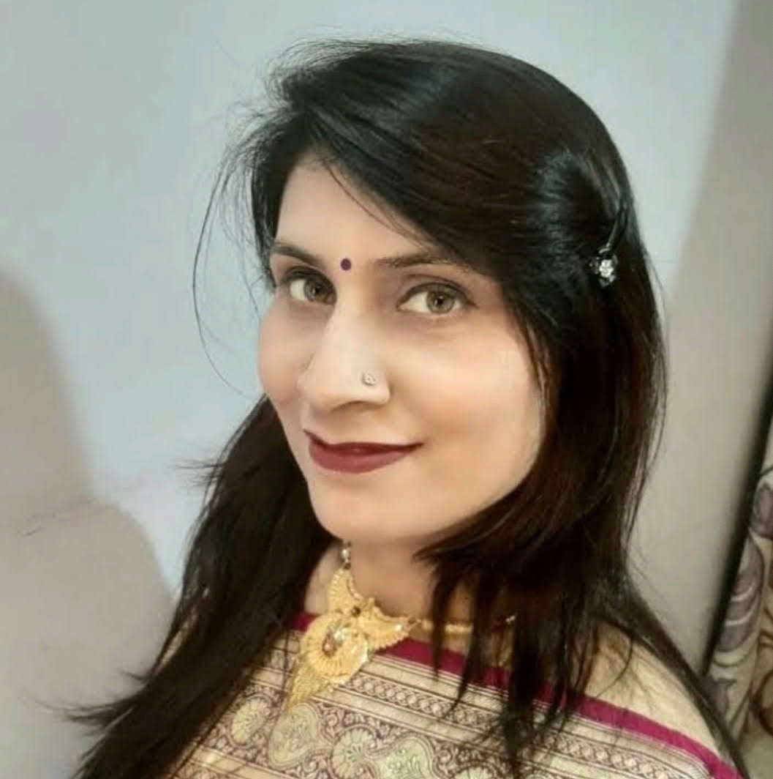

2. Designation: Asst.Professor (S.F.)

3. Subject: Geography

4. Academic Qualifications: B.A. M.A.Ph.D. Diploma in G.I.S

5. Areas of interest/Specialization: Urban Geography

6. Date of Birth:30/06/1977

7. Date of Joining:05/09/2018

8. Experience: 05 Year

9. Official Address:Dr.sushms gaur h.n.370 sheel kunj Meerut

10. Contact no. :7983395380

11. Email:sushmagaur2255@gmail.com

12. Areas of research:Urban land use

**13. Achievements: Presently working on research project ''Title-**Evaluation of millets consumption pattern in india (An empirical study of selected disctricts of uttar pradesh,utrakhand,punjab and Haryana

**14. Research Papers published:-**

|  |  |  |  |  |  |  |
| --- | --- | --- | --- | --- | --- | --- |
| *S.No* | *Title of the paper published (with Page no.)* | *Research Journal (withVol.no.)* | *Year* | *ISSN* | *Whether peer reviewed ,UGC listed, Impact Factor if any* | *Digital Link, if any* |
| 1.    2.  3.  4. | Bijnor Janpad ke Krishi kshetra vinyas ka Bhaugolik Adhyan [p.n.222 to 224]  Jananaankey adhyayan ke antargat Bijnor janpad ke saksharta ka vishlehan  Role of E-Governance in India ;concept ,issues  Geographical Disaster In Himachal Pradesh ;A spatial perspective | Pragya shikshan shodh RachnaVol.II No.6  Samaj Vigyan shodh patrika  Journal of Socio-Economic Review  Journal of Socio-Economic Review | 2022  2018  2018  2022  2022 | 2319-8079  0973-7626  2321-8479  2321-8479 | Research Journal no.48216  UGC listed  UPBIL/2005/16107  Peer Reviewed and refered nation research Journal  Peer Reviewed and refered nation research Journal | [www.ccsujser.com](http://www.ccsujser.com/)  [www.ccsujser.com](http://www.ccsujser.com/) |

**15.** **Research** **Projects:**

|  |  |  |  |  |  |
| --- | --- | --- | --- | --- | --- |
| *S.No.* | *Title* | *Type* | *Funding Agency* | *Amount* | *Time-Period* |
| 1 | Evaluation of millets consumption pattern in india (An empirical study of selected disctricts of uttar pradesh,utrakhand,punjab and Haryana | special call - Major collaborative project | Indian council of social science research ,New Delhi | 17.5 lakhs | 6 months |

**16. Faculty Enrichment Programme Attended:**

|  |  |  |  |  |
| --- | --- | --- | --- | --- |
| *S.No* | *Detail of the FDP/FEP* | *Date(s) of the event* | *Organizer &Sponsor* | *International/National/ State/ University* |
| 1.  2.  3. | FDP  FDP  FIP | 29 April to 5 May 2023  01-02-2022 to 07-02-2022  20/06/2020 TO 30/06/2020 | Jointly organized,Raghunath Girls Post Graduate college ,Meerut,U.P.and Guru Angad Dev Teaching learning Centre.  National Faculty Development Program on 'Re-learning soft skills related to personality development ofteachers in highter eduction institution  Research Methodology for Science and Social science | PMMMNMTT national University  Rabindranath Tagore University M.P,  Institute of law  Advanced research institue for development of social science [ARIDSS],MEERUT  Organized by Meerut college Meerut |

**17. Seminar/ Workshop/ Conference Attended:**

|  |  |  |  |  |  |
| --- | --- | --- | --- | --- | --- |
| *S.No* | *Detail of the Conference/ Seminar* | *Organizer & Sponsor* | *Date(s) of the event* | *Venue of the event* | *International/National/ State/ University* |
| 1. | seven days workshop | department of psychology ,R.G.P,G,College Meerut | 15 April to 21 April 2023 | ''Universal Human Value and Ethis'' | State University |

**18. Seminar/ Workshop/ Conference/ Exhibitions Organised:**

|  |  |  |  |  |  |
| --- | --- | --- | --- | --- | --- |
| *S.No* | *Detail of the Conference/ Seminar/Exhibitions*  *(including Sponsor)* | *Date(s) of the event* | *Venue of the event* | *International/National/ State/ University* | *Role* |
| 1'  2.  3.  4.  5.  6.  7. | women-Led enterepreneurship;Barriers and oppourtunity  National Faculty Development Program on 'Re-learning soft skills related to personality development ofteachers in highter eduction institution    Spatial Dimensions of environment ploblem and natural resource law  Violance Against Girl Child and women ;Issues and Concerns ''  India-Pakistan Relation ;Past Present And Future  enviorment , climate change and sustanable  development  Green chemistry and sustanable developement | 9-12-2023  01-02-2222 to 07-02-2222  3-4 September 2019  21 March  11-12 March  18 to 19 march 2018  25th february-2018 | Amity Uni.Greater noida  Rabindranath Tagore University M.P,  Institute of law  Shaheed Bhagat Singh college  University of Delhi  Shri K.K.JAIN [P.G.]College Khatauli department of pol.science  Department of higher eduction ,goverment of Utter Pradesh  C.P,E.EW Delhi ICSSR New Delhi Org.by Department of defence studies ,Meerut College Meerut  goverment degree collige , Nanauta Saharanpur  Department of chemistry Meerut College Meerut.  Advanced research institute for developement social science meerut | Sate university  National uni.  National uni.  National uni.  National uni.  Sate university  National uni. | Participated  Participated  Participated  Participated  Participated  Participated  Participated |

**32. Future plans:**

my future plan involve continuing to develop my skill gain more experience in my project work ,I am open to new chanllege and responsibilities .i myself eventually taking on a leadership role and mentoring others in industry.