**Curriculum vitae**

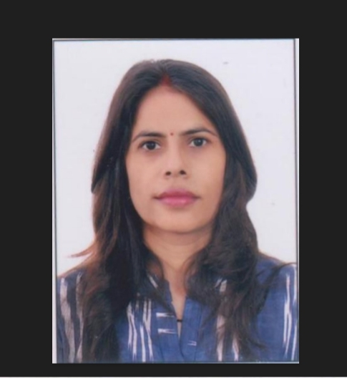

1.Name: Dr. Sangita

2.Designation: Assistant Professor (S.F.)

3.Subject: Geography

4.Academic Qualifications: NET, Ph.D.

5.Areas of interest/Specialization: Pilgrimage Tourism, GIS & Remote Sensing

6.Date of Birth: 12/02/1985

7.Date of Joining: 05/09/2018

8.Experience: Five Year

9.Official Address: Village &Post Oledha district Bulandshahr

10.Contact no. 7417286607

11.Email : sangita.chaudhary85@gmail.com

12.Areas of research: Spatial & Temporal dynamics of Pilgrimage Tourism in Uttarakhand Region

13.Digital Profile, if any (Research Gate, LinkedIn, SSRN, Twitter, YouTube etc): LinkedIn-sangita.chaudhary85@gmail.com

**14.Achievements:** GIS & RS From CDAC NOIDA

**17.Research Papers published:-**

|  |  |  |  |  |  |  |
| --- | --- | --- | --- | --- | --- | --- |
| *S.No* | *Title of the paper published (with Page no.)* | *Research Journal (withVol.no.)* | *Year* | *ISSN* | *Whether peer reviewed ,UGC listed, Impact Factor if any* | *Digital Link, if any* |
| *1*  2  3  4  5 | *Geographical disaster in Himachal Pradesh:A Spatial perspective(201-207)*  *Regional variation of ecological vulnerability with reference to tourism in Himachal Pradesh(132-140)*  *Role of Remote Sensing as an integrated Management tool of coral reef of Karumbhar Island in the Gulf of kutch(127-136)*  *Pilgrimage Tourism potential regions in Uttarakhand(19-27)*  *Regional and Temporal Analysis of fair and festivals in uttarakhand(37-41)* | *Journal of socio-economic and review*  *The Geographical Observer*  *VOL.NO 49*  *The Geographical Observer*  *VOL.NO 46*  *The Geographical Observer*  *VOL.NO 44*  *The Geographical Observer*  *VOL.NO 43* | *2022*  *2019*  *2016* | *Ix NO.II April2022*  *2321-8479*  *0072-0925*  *0072-0925*  *0072-0925*  *0072-0925* | *Peer reviewed&referednational journal*  *Ugc care list*  *Refereed research journal*  *Refereed research journal*  *Refereed research journal*  *Refereed research journal* |  |

**26.Faculty Enrichment Programme Attended:**

|  |  |  |  |  |
| --- | --- | --- | --- | --- |
| *S.No* | *Detail of the FDP/FEP* | *Date(s) of the event* | *Organizer &Sponsor* | *International/National/ State/ University* |
| *1*  *2*  *3*  *4* | Faculty Development Programme&workshop  Faculty  Development  program  Faculty Induction Programme  Faculty  Development  program | 14-11-22/18-11-22  09-12-2022  25-02-2023/27-03-2023  1-02-2022/07-02-2022 | Organized by Plant Conservation Society Department of Botany & IQAC , R.G (P.G.),  Meerut  Organized by AMITY  University Greater  Noida.  Guru Angad Dev Teaching  Learning Centre, SGTB  Khalsa College, University of  Delhi and Raghunath Girls’  Post Graduate College,  Meerut.  Organized by  Rabindranath tagore university | *State*  *State*  *State*  *State* |

**27. Seminar/ Workshop/ Conference Attended:**

|  |  |  |  |  |  |
| --- | --- | --- | --- | --- | --- |
| *S.No* | *Detail of the Conference/ Seminar* | *Organizer & Sponsor* | *Date(s) of the event* | *Venue of the event* | *International/National/ State/ University* |
| *1*  *2*  *3* | Workshop  Workshop  National Conference | Organized by International Quality Assurance cell (IQAC)& Teachers ’Re-skilling Cell  Organized by Department of  Psychology, R.G (P.G.),  Meerut  Organized by R.G (P.G.)  College Meerut | 19-08-2023  15-04-23/21-04-23  21-12-2022/22-12-2022 | *Raghunath girl’s (p.g.)College*  *Meerut*  R.G (P.G.)  College Meerut  R.G (P.G.)  College Meerut | *State*  *State*  *State* |

**32.Future plans:** My future plans include having a job that I enjoy doing, maintaining a good work-life balance, fostering good relationship in both work and personal life, and enjoying the comings and goings of each day. Of course, I plan to continue working on my language skills, because I want to become better at my work.